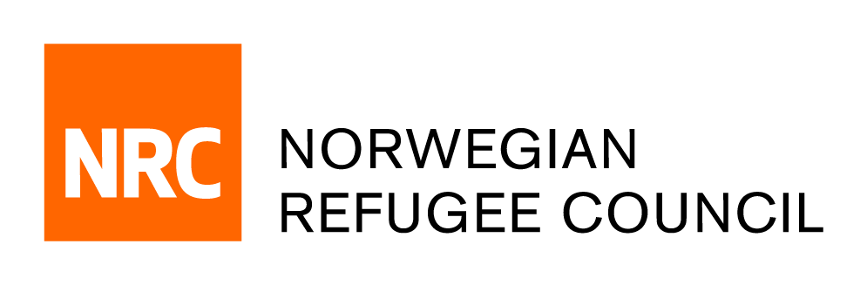

Tender Notice

Invitation to Tender for " Consultancy to support NRC’s Housing, Land and Property (HLP) needs assessment in Iraq
IRAQ/RFQ/2019/073

NRC – IRAQ office is soliciting bids from companies or Individual Service Provider for the provision of consultancy to support NRC’s Housing, Land and Property (HLP) needs assessment in Iraq.
Information, Counselling and Legal Assistance (ICLA) programme, NRC is a major provider of legal aid to displaced people in Iraq. Further development of programming to support vulnerable persons’ housing, land and property rights, with a particular focus on women’s HLP rights, is one of NRC’s strategic objectives for 2020-21. Expanding of the currently available evidence base will be critical in achieving that objective. To that end, NRC has recently concluded the data collection stage of an in-house HLP assessment comprising both a quantitative and a (smaller) qualitative component. The data collection was undertaken in twelve sites across four governorates of Iraq. NRC Iraq now requires an expert HLP consultant to carry out the data analysis and report on findings in order to finalize the assessment. The deliverables will be used in programme development, the ongoing advocacy initiatives (such as the upcoming report on Women’s HLP rights in Iraq), targeted HLP interventions (NRC – MAG project), as well as coordination (NRC co-coordinates the HLP Sub-cluster with the National Protection Cluster of Iraq).

Obtain of Tender package:
Complete tender documents can be obtained by e-mail, free of charge from the 12th of Nov 2019 until the 17th of Nov 2019. The tender documents should be requested by emailing:
iq.procurement@nrc.no. The email title should clearly indicate (IRAQ/RFQ/2019/073 – HLP Consultancy)

Deadline for the tender:
The deadline for submission of tenders is 15:00 on the 17th of Nov 2019. Individual/Companies who do not submit their quotation by this deadline will not be considered.

