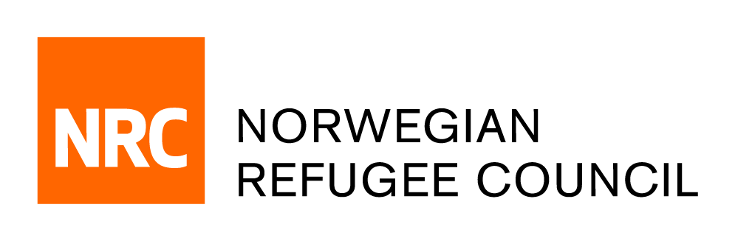

Tender Notice

Invitation to tender for the provision of ‘External Evaluation of NRC Teachers in Crisis Contexts Projects’ services in IRAQ
IRAQ-ITB-2019-011

An estimated 2.6 million Internally Displaced Persons (IDPs), returnee and refugee children aged 3-17, including 1.2 million girls, will need emergency education services in Iraq in 2019. Some 775,000 internally displaced children residing in and out of camps and 1.5 million returnees are in need of assistance to return to learning. OCHA’s Iraq Humanitarian Profile (2018), the Iraq Education Cluster Secondary Data Review (2018) and REACH Iraq Multi Cluster Needs Assessment (MCNA) Preliminary Findings (2018) identified the highest number of children in need of emergency education services in Ninewa and Anbar. 28% of IDP children in camps and 21% of returnee children still go without access to formal education. On average, 25 % of children (aged 6-18) have limited or no access to formal learning opportunities in former conflict-affected governorates. Adolescents and girls are particularly affected by economic, physical, psychological, cultural and policy barriers to accessing education. Schools are often in poor condition, unsafe and inadequately equipped to serve large numbers of students. The quality of instruction is also a concern, with teacher shortages, unequal distribution of teachers between schools, low and irregular salaries and teachers who are not adequately trained in terms of subject matter or effective pedagogy. Schools often lack sufficient teaching and learning materials to support effective learning, while learners do not master the basic literacy and numeracy skills they need to survive, thrive and rebuild their communities.
According to the Iraq Humanitarian Needs Overview (HNO), barriers to accessing education include inability to pay for education related expenses (30 %), lack of interest in school (10%), disability or health concerns, and the need to contribute to family income. 68 % of those Out of School (OOS) are adolescent boys and girls between 12 and 17, with parents and caregivers reporting child labour (11%), child marriage (2%) and psychosocial distress (13%) as major concerns. Disengaged adolescents are more likely to engage in negative coping mechanisms like forced recruitment by armed groups and employment in higher risk occupations, early marriage, and withdrawal from education. Educational barriers disproportionately affect girls as statistics indicate that by 6th grade girls represent under half of students.

Obtain of Tender package:
Complete tender documents can be obtained by e-mail, free of charge from the 2nd of Nov 2019 until the 17th of Nov 2019. The tender documents should be requested by emailing:
iq.procurement@nrc.no. The email title should clearly indicate (IRAQ-ITB-2019-011 – Education External Evaluation Consultancy).

Deadline for the tender:
The deadline for submission of tenders is 15:00 on the 17th of Nov 2019. Individual/Companies who do not submit their quotation by this deadline will not be considered.

