 | NEGOTIATED PROCEDURE
 | INVITATION LETTER
 | KU-MSL-LOT-10-2019-616 Total station

To : | “To whom may concern”

TRIANGLE GENERATION HUMANITAIRE (TGH) - Office
KURDISTAN, Erbil, on 8th December 2019.

Dear Madam, dear Sir,

Your company has been selected to participate to a call for tender concerning:

- Purchase of total station
- For the area of: Ninewa Governorate.

Please find attached the tender document.

Your offer must be submitted before 4:00pm the 17th December 2019.

Best regards
Acknowledge of Receipt
Jean-Marc RUAUX
Logistic Coordinator Received by:
+ 964 (0) 783 496 05 18
iraq.log@trianglegh.org Signature, date and Stamp:

 | NEGOTIATED PROCEDURE
 | Invitation to tender
 | KU-MSL-LOT-10-2019-616 Total station

General conditions and list of necessary documents to participate in the tender

TRIANGLE GENERATION HUMANITAIRE (TGH) - Office
KURDISTAN, Erbil
237/7/5, Almashriq Street, Ainkawa
Phone number: + 964 (0) 783 496 05 18
Email: iraq.log@trianglegh.org

SUPPLY CONTRACT NOTICE

- Publication reference:
KU-MSL-LOT-10-2019-616

- Procedure:
Local Open Tender

- Contracting Authority:
TRIANGLE GENERATION HUMANITAIRE (TGH) - Office
KURDISTAN, Erbil
237/7/5, Almashriq Street, Ainkawa

- Short contract description:
Purchase of one total station type Leica Nova TS60, Leica TS13 or Topcon GT-500

- Intended time of publication - Submission and presentation of tenders - Exclusion, selection and award criteria:
The entire tender document can be obtained by contacting:
Narmin HAMKAFLO:
TGH Deputy Logistics Coordinator
Phone number: +964 (0) 783 496 0517
Email: deputy.log.iraq@trianglegh.org

Jean-Marc RUAUX:
TGH Logistics Coordinator
Phone number: +964 (0) 783 496 0518
Email: iraq.log@trianglegh.org

Tender starts at the date of 8th December 2019

All tenders will have to be submitted by email or hard copies no later than the 17th November 2019 at 4:00pm to the following address:

By email:

Email: deputy.log.iraq@trianglegh.org
iraq.log@trianglegh.org
Within the mail object, the reference: KU-MSL-LOT-10-2019-616

By hard copies:

TRIANGLE GENERATION HUMANITAIRE (TGH) - Office
KURDISTAN, Erbil
237/7/5, Almashriq Street, Ainkawa

For information concerning exclusion, selection and award criteria, please consult the administrative stipulations of the tender document.

The tender will be selected taking into account:
- The price of the tender
- The quality of the service (including compliance of the proposed service with required technical specifications)
- The duration of warranty.
- The payment terms
- The delivery time
- Transportation

- Additional information:
Any demand for additional information should be addressed to:

Narmin HAMKAFLO:
TGH Deputy Logistics Coordinator
Phone number: +964 (0) 783 496 0517
Email: deputy.log.iraq@trianglegh.org

Jean-Marc RUAUX:
TGH Logistics Coordinator
Phone number: +964 (0) 783 496 0518
Email: iraq.log@trianglegh.org

PARTICIPATION
All participants should have a record of at least one (1) year of working experience in the general contracting business.

SUBJECT
TGH is looking to purchase one total station in the frame of a PERMA projects.

VARIATIONS IN QUANTITIES
The indicated quantities may be modified by Triangle Generation Humanitaire to a degree of +/- 10% depending on the proposed unit price. In this case, the unit price of the tender shall be applicable to the quantities ordered within the limit of these variations. All requested prices will have to be indicated and filled out by the supplier.

Depending on the unit and total price, Triangle Generation Humanitaire will determine the final order at a later point. Moreover Triangle Generation Humanitaire may order additional material if the price remains the same.

DOCUMENTATION, PACKING AND MARKING
The supplier should imperatively handover all technical documentation related to the goods, such as user manual or installation notice, and this in the following language: (English/Arabic).
Materials should be packed in such a way that they are protected from any damage during transportation. The packaging shall become property of the final destination. All packages must be labelled in English and Arabic. The labels must stipulate the name of the product, quantity, weight and the place of delivery.

PLACE OF FINAL DESTINATION AND DELIVERY PERIOD
The exact final destination of purchased supplies is:
- TGH Erbil Office.
The delivery of purchased supplies should be finalized after signing the Purchase Contract and upon the request of TGH within seven (15) calendar days maximum.

RECEPTION
Receipt of the goods will be made thanks to waybill and/or receipt note signature. The receipt note will be produced by the client in two copies, one for the supplier and one for the client, and will have to be signed by both parties.

TGH reserves the right to refuse any damaged good or any good not compliant to quality and quantity criteria. Goods refused by the client at the receipt will need to be replaced by the supplier at its own expense in a defined delivery period of time. Replacement products will be once more subjected to rules presented in this contract.

The final receipt can be done only when the whole goods will have been delivered and accepted by the client.

LATE CHARGES FOR DELAY IN DELIVERY
After delivery date a late delivery penalty of 1% of the total value of the contract will be applied for each late day. This amount will be subtracted from final payment.

CALCULATION OF PRICES
The price(s) shall:
- Correspond to the quantities mentioned in quotation request (annex 4) and shall include any supplementary services.
- Include all costs related to any destinations mentioned under Article 6 above.
- Include transport insurances guaranteeing the delivery of supplies in flawless conditions
- Be calculated in USD.
- Be calculated according to the above-mentioned conditions and no subject to any revision.

Bidders must fill out the detailed Quotation request Form provided in Annex 4.

The quotation or financial bid shall present the following information:

- Name and address of bidder.
- Unit price and total price.
- Date and validity of the quotation / financial bid.
- Warranty
- Cost of transportation
- Currency
- Payment terms

TAXATION
The materials shall be exempt from import duties and tax.
Whatever the origin of the supplies, the contract shall be free of any stamp and registration duties.

SUBMISSION OF TENDERS
Tenders must be delivered to:
Narmin HAMKAFLO:
TGH Deputy Logistics Coordinator
Phone number: +964 (0) 783 496 0517
Email: deputy.log.iraq@trianglegh.org
Jean-Marc RUAUX:
TGH Logistics Coordinator
Phone number: +964 (0) 783 496 0518
Email: Iraq.log@trianglegh.org

TRIANGLE GENERATION HUMANITAIRE (TGH) - Office
KURDISTAN, Erbil
237/7/5, Almashriq Street, Ainkawa

Submissions by electronic mail will be considered.
Tender starts at the date of 8th December 2019.
Tenders must reach the above-mentioned address no later than 17th December 2019 at 4:00pm

CONTENTS OF TENDERS
Tenders shall be presented in a sealed envelope with the address of Triangle Generation Humanitaire mentioned above or by email with the tender reference in the email subject.

Please, note that neither company name, brand name or logo, nor any other information about the bidder shall appear on the external envelope or email.

The envelope shall contain required (1) administrative documents in Envelope N°1 signed and stamped, and (2) the tender itself containing Technical Specifications (annex 3) and the Financial Offer (Quotation request - annex 4) in Envelope N°2 signed and stamped.

- Envelope N°1 Administrative Documents:
  - A copy of a valid registration to the Chamber of Commerce and Trade of Iraq
  - A copy of a valid identity card of the bidder,
  - Copy of valid commercial ID card, delegation of signature if necessary
  - Copy of certificate of Taxation Clearance,
  - A signed and stamped copy of the present tender document including the “Ethics Clauses” , “Exclusion criteria” and “AFD Statement of Integrity, Eligibility and Social and Environmental Responsibility” (‎Annex 1, Annex 2 and Annex 3 respectively)

- Envelope N°2 Tender Documents (all signed and stamped):
  - Tender Commitment form Article (21)
  - Technical & Financial offer, presented as per templates provided in Annex 5 bellow.
  - If needed, an additional detailed description of the characteristics, specifications of proposed offer.

Suppliers should note that the administrative selection will be done first. If some administrative documents are missing, TGH evaluation committee may eliminate the supplier without any consideration for its commercial offer (Technical Offer).

TGH reserves the right not to attribute (award) the market and to cancel the procedure if the offers are superior to the budget or not technically compliant.

CURRENCY
The price of the tendered supplies is to be calculated in USD. Payments will be made in USD by cheque or bank transfer.

PAYMENT PROCEDURES
Invoicing shall be provided by the Contractor (winning bidder) on a valid invoice bearing all the necessary information about the Contractor/Company name, address, phone number, purpose, date, signature and stamp.

Payment will be settled monthly after receiving bidder’s invoice, by cheque or bank transfer.
Any penalties assessed during the validity of the contract will be deducted from the final payment.

VALIDITY
Bidders shall remain bound by their tenders for a period of thirty (30) days as from the final date of submission of Tenders.

CANCELLATION OF THE OFFER
Any offers given by the Contractor to TGH for Local Open Tender is considered as definitive. If the awarded company cancels its offer for any unjustified reason, this company will be kept out from TGH list of suppliers, for a minimum period of one year.

OPENING OF TENDERS
Tenders will be opened by the committee responsible for the examination of the Tenders on the 18th December 2019 in TGH Office, KURDISTAN, Erbil, 237/7/5, Almashriq Street, Ainkawa.

COMPARISON OF TENDERS
The selection of the winning bidder(s) will be made based on the following criterion and coefficients:
  - Respect of administrative requirements
  - Technical and financial criteria:

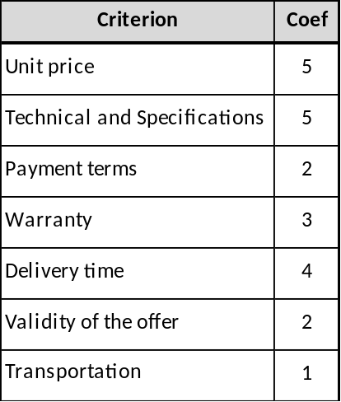

Analysis grids are presented in Annex 5 and Annex 6.

TGH reserves the right not to consider any incomplete offer or offers which do not comply with any or all of our tender conditions. TGH reserves the right to accept or reject any part of your offer.

CONTRACT EXTENSION
In case of additional needs the contract could be extended if the technical specifications and propositions of the initial offer are not substantially modified.

JURISDICTION AND APPLICABLE LAW
Where disagreement arises in the course of performance of the contract that would not come to an amicable agreement, all disputes shall be legally governed by the international chambers of the competent courts within the jurisdiction of the Paris Court of Appeal.

Signature of the candidate or bidder:

Stamp and Date:

TENDER COMMITMENT FORM

Procedure Ref.: KU-MSL-LOT-10-2019-616

Object: Total station

In response to your invitation to tender, I, the undersigned, hereby declare that I have examined and accept in full the content of the dossier for invitation to tender referred as KU-MSL-LOT-10-2019-616.
I hereby accept its provisions in their entirety, without reservation or restriction.
I offer to deliver, in accordance with the terms of the tender file, the supply(s)/service(s) described in Annex 4 bellow.
The price of our tender is: ……………………………………………………………………………………..

This tender is valid for a period of 30 days from the final date for submission of tenders.
I agree to abide by the Ethics clauses listed in Annex 1 bellow.
In the event that my tender is successful, I undertake, if required, to provide the usual proof under the law of Iraq that I do not fall into any of the exclusion situations listed in Annex 2 bellow.
I agree to abide by the Statement of Integrity, Eligibility and Social and Environmental Responsibility listed in Annex 3 bellow.

I will inform Triangle Génération Humanitaire immediately if there is any change in the above circumstances.

I note that Triangle Génération Humanitaire is not bound to proceed with this invitation to tender and that it reserves the right to award only part of the contract. It will incur no liability towards us should it do so.

The present tender includes:
- LOT Publication.
- General conditions
- Requirements described in Article 12 above.
- Tender Commitment form
- ‎Annex 1 - Ethics clauses
- Annex 2 - Exclusion criteria
- Annex 3 - Statement of Integrity, Eligibility and Social and Environmental Responsibility
- Annex 4 - Quotation Request
- Annex 5 - Administrative evaluation grid

Yours faithfully

Name and first name: …………………………………………………………………………………………..

Duly authorized to sign this tender on behalf of: …………………………………………………………….

Place and date: …………………………………………………………….……………………………………

Stamp of the firm/company

ETHICS CLAUSES
Any attempt by a candidate, applicant or tenderer to obtain confidential information, enter into unlawful agreements with competitors whose aim or effect is to impede, restrain or distort competition in a given market, or influence the evaluation committee or the contracting authority during the process of examining, clarifying, evaluating and comparing tenders and applications will lead to the rejection of its candidacy, proposal or tender.
Without the contracting authority's written authorisation, a contractor and its staff or any other company with which the contractor is associated or linked may not, even on an ancillary or subcontracting basis, supply other services, carry out works or supply equipment for the project. This prohibition also applies to any other programmes or projects that could, owing to the nature of the contract, give rise to a conflict of interest on the part of the contractor or grant beneficiary. The contractor must at all time act impartially and as a faithful adviser in accordance with the code of conduct of its profession. It must refrain from making public statements about the project or services without the contracting authority's prior authorisation. It may not commit the contracting authority in any way without its prior written consent.
The contractor and its staff must comply with human rights and undertake not to offend the political, cultural and religious mores of the country(ies) where the action is implemented. In particular and in accordance with the applicable basic act, tenderers and applicants who have been awarded contracts must comply with core labour standards as applicable and as defined in the relevant International Labour Organisation conventions (such as the Conventions on freedom of association and collective bargaining; Elimination of forced and compulsory labour; Abolition of child labour).
The contractor may accept no payment connected with the contract other than that provided for therein. The contractor and its staff must not exercise any activity or receive any advantage inconsistent with their obligations to the contracting authority.
The contractor and its staff are bound to maintain professional secrecy for the entire duration of the contract and after its completion. All reports and documents drawn up or received by the contractor during the performance of the contract are confidential.
The contract governs the contracting parties' use of all reports and documents drawn up, received or presented by them during the performance of the contract.
The contractor must refrain from any relationship likely to compromise its independence or that of its staff. If the contractor ceases to be independent, the contracting authority may, regardless of injury, terminate the contract without further notice and without the contractor having any claim to compensation.
The contracting authority reserves the right to suspend or cancel contract payment if corrupt practices of any kind are discovered at any stage of the award process or implementation of the contract. For the purposes of this provision, 'corrupt practices' are the offer of a bribe, gift, gratuity or commission to any person as an inducement or reward for performing or refraining from any act relating to the award of a contract or implementation of a contract already concluded with the contracting authority.
More specifically, all tender dossiers and contracts for works, supplies and services must include a clause stipulating that tenders will be rejected or contracts terminated if it emerges that the award or execution of a contract has given rise to unusual commercial expenses.
Such unusual commercial expenses are commissions not mentioned in the main contract or not stemming from a properly concluded contract referring to the main contract, commissions not paid in return for any actual and legitimate service, commissions remitted to a tax haven, commissions paid to a recipient who is not clearly identified or commissions paid to a company which has every appearance of being a front company.
The contractor undertakes to supply the contracting authority on request with all supporting documents relating to the conditions of the contract's execution. The contracting authority may carry out whatever documentary or on-the-spot checks it deems necessary to find evidence in cases of suspected unusual commercial expenses.
Failure to comply with one or more of the ethics clauses may result in the exclusion of the candidate, applicant, tenderer or contractor from other contracting authority contracts and in penalties. The individual or company/entity in question must be informed of the fact in writing.
It is the obligation of the contracting authority to ensure that the procurement or the grant award procedure is concluded in a transparent manner, based on objective criteria and disregarding any possible external influences.

Signature of the candidate or bidder:

Stamp and Date:

Exclusion criteria:

An economic operator will be excluded from participation in procurement and grant procedures if:

- it is bankrupt, subject to insolvency or winding-up procedures, where its assets are being administered by a liquidator or by a court, where it is in an arrangement with creditors, where its business activities are suspended, or where it is in any analogous situation arising from a similar procedure provided for under national laws or regulations;
- it has been established by a final judgment or a final administrative decision that the economic operator is in breach of its obligations relating to the payment of taxes or social security contributions in accordance with the law of the country in which it is established, with those of the country in which the contracting authority is located or those of the country of the performance of the contract;
- it has been established by a final judgment or a final administrative decision that the economic operator is guilty of grave professional misconduct by having violated applicable laws or regulations or ethical standards of the profession to which the economic operator belongs, or by having engaged in any wrongful conduct which has an impact on its professional credibility where such conduct denotes a wrongful intent or gross negligence, including, in particular, any of the following:
  - fraudulently or negligently misrepresenting information required for the verification of the absence of grounds for exclusion or the fulfilment of selection criteria or in the performance of a contract;
  - entering into agreement with other economic operators with the aim of distorting competition;
  - violating intellectual property rights;
  - attempting to influence the decision-making process of the contracting authority during the procurement procedure;
  - attempting to obtain confidential information that may confer upon it undue advantages in the procurement procedure;
- it has been established by a final judgment that the economic operator is guilty of any of the following:
  - fraud,
  - corruption;
  - participation in a criminal organisation;
  - money laundering or terrorist financing;
  - terrorist-related offences or offences linked to terrorist activities;
  - child labour or other forms of trafficking in human;
- the economic operator has shown significant deficiencies in complying with main obligations in the performance of a contract managed by the contracting authority, which has led to its early termination or to the application of liquidated damages or other contractual penalties or which has been discovered following checks, audits or investigations by an authorizing officer, OLAF or the Court of Auditors;
- it has been established by a final judgment or final administrative decision that the economic operator has committed an irregularity.

Signature of the candidate or bidder:

Stamp and Date:

Statement of Integrity, Eligibility and Social and Environmental

Responsibility

Reference name of the bid or proposal: KU-MSL-LOT-10-2019-616 (The "Contract")
To: TRIANGLE GENERATION HUMANITAIRE (The "Contracting Authority")

1) We recognise and accept that Agence Française de Développement ("AFD") only finances projects of the Contracting Authority subject to its own conditions which are set out in the Financing Agreement which benefits directly or indirectly to the Contracting Authority. As a matter of consequence, no legal relationship exists between AFD and our company, our joint venture or our suppliers, contractors, subcontractors, consultants or sub consultants. The contracting Authority retains exclusive responsibility for the preparation and implementation of the procurement process and performance of the contract. The Contracting Authority means the Purchaser, the Employer, the Client, as the case may be, for the procurement of goods, works, plants, consulting services or non-consulting services.

2) We hereby certify that neither we nor any other member of our joint venture or any of our suppliers, contractors, subcontractors, consultants or sub consultants are in any of the following situations:

2.1) Being bankrupt, wound up or ceasing our activities, having our activities administered by the courts, having entered into receivership, reorganization or being in any analogous situation arising from any similar procedure;

2.2) Having been:
a. convicted within the past five years by a court decision, which has the force of res judicata in the country where the Contract is implemented, of fraud, corruption or of any other offense committed during a procurement process or performance of a contract (in the event of such conviction, you may attach to this Statement of Integrity supporting information showing that this conviction is not relevant in the context of this Contract);
b. subject to an administrative sanction within the past five years by the European Union or by the competent authorities of the country where we are constituted, for fraud, corruption or for any other offense committed during a procurement process or performance of a contract (in the event of such sanction, you may attach to this Statement of Integrity supporting information showing that this sanction is not relevant in the context of this Contract);
c. convicted within the past five years by a court decision, which has the force of res judicata, of fraud, corruption or of any other offense committed during the procurement process or performance of an AFD-financed contract.
2.3) Being listed for financial sanctions by the United Nations, the European Union and/or France for the purposes of fight-against-terrorist financing or threat to international peace and security;
2.4) Having been subject within the past five years to a contract termination fully settled against us for significant or persistent failure to comply with our contractual obligations during contract performance, unless this termination was challenged and dispute resolution is still pending or has not confirmed a full settlement against us;
Guidelines for the Procurement of AFD-Financed Contracts in Foreign Countries Last update: 30 February 2017.
2.5) Not having fulfilled our fiscal obligations regarding payments of taxes in accordance with the legal provisions of either the country where we are constituted or the Contracting Authority's country;
2.6) Being subject to an exclusion decision of the World Bank and being listed on the website http://www.worldbank.org/debarr (in the event of such exclusion, you may attach to this Statement of Integrity supporting information showing that this exclusion is not relevant in the context of this Contract).
2.7) Having created false documents or committed misrepresentation in documentation requested by the Contracting Authority as part of the procurement process of this Contract.

3) We hereby certify that neither we, nor any of the members of our joint venture or any of our suppliers, contractors, subcontractors, consultants or sub consultants are in any of the following situations of conflict of interest:
3.1) Being an affiliate controlled by the Contracting Authority or a shareholder controlling the Contracting Authority, unless the stemming conflict of interest has been brought to the attention of AFD and resolved to its satisfaction;
3.2) Having a business or family relationship with a Contracting Authority's staff involved in the procurement process or the supervision of the resulting Contract, unless the stemming conflict of interest has been brought to the attention of AFD and resolved to its satisfaction;
3.3) Being controlled by or controlling another bidder or consultant, or being under common control with another bidder or consultant, or receiving from or granting subsidies directly or indirectly to another bidder or consultant, having the same legal representative as another bidder or consultant, maintaining direct or indirect contacts with another bidder or consultant which allows us to have or give access to information contained in the respective applications, bids or proposals, influencing them or influencing decisions of the Contracting Authority;
3.4) Being engaged in a consulting services activity, which, by its nature, may be in conflict with the assignments that we would carry out for the Contracting Authority.
3.5) In the case of procurement of goods, works or plants:
i. Having prepared or having been associated with a consultant who prepared specifications, drawings, calculations and other documentation to be used in the procurement process of this Contract;
ii. Having been recruited (or being proposed to be recruited) ourselves or any of our affiliates, to carry out works supervision or inspection for this Contract;

4) If we are a state-owned entity, and to compete in a procurement process, we certify that we have legal and financial autonomy and that we operate under commercial laws and regulations.

5) We undertake to bring to the attention of the Contracting Authority, which will inform AFD, any change in situation with regard to points 2 to 4 here above.

6) In the context of the procurement process and performance of the corresponding contract:

6.1) We have not and we will not engage in any dishonest conduct (act or omission) deliberately indented to deceive others, to intentionally conceal items, to violate or vitiate someone's consent, to make them circumvent legal or regulatory requirements and/or to violate their internal rules in order to obtain illegitimate profit;
Guidelines for the Procurement of AFD-Financed Contracts in Foreign Countries Last update: 31 February 2017
6.2) We have not and we will not engage in any dishonest conduct (act or omission) contrary to our legal or regulatory obligations or our internal rules in order to obtain illegitimate profit;
6.3) We have not promised, offered or given and we will not promise, offer or give, directly or indirectly to (i) any Person who holds a legislative, executive, administrative or judicial mandate within the State of the Contracting Authority regardless of whether that person was nominated or elected, regardless of the permanent or temporary, paid or unpaid nature of the position and regardless of the hierarchical level the Person occupies,
(ii) any other Person who performs a public function, including for a State institution or a State-owned company, or who provides a public service, or (iii) any other person defined as a Public Officer by the national laws of the Contracting Authority’s country, an undue advantage of any kind, for himself or for another Person or entity, for such Public Officer to act or refrain from acting in his official capacity;
6.4) We have not promised, offered or given and we will not promise, offer or give, directly or indirectly to any Person who occupies an executive position in a private sector entity or works for such an entity, regardless of the nature of his/her capacity, any undue advantage of any kind, for himself or another Person or entity for such Person to perform or refrain from performing any act in breach of its legal, contractual or professional obligations;
6.5) We have not and we will not engage in any practice likely to influence the contract award process to the detriment of the Contracting Authority and, in particular, in any anticompetitive practice having for object or for effect to prevent, restrict or distort competition, namely by limiting access to the market or the free exercise of competition by other undertakings;
6.6) Neither we nor any of the members of our joint venture or any of our suppliers, contractors, subcontractors, consultants or subconsultants shall acquire or supply any equipment nor operate in any sectors under an embargo of the United Nations, the European Union or France;
6.7) We commit ourselves to comply with and ensure that all of our suppliers, contractors, subcontractors, consultants or subconsultants comply with international environmental and labour standards, consistent with laws and regulations applicable in the country of implementation of the Contract, including the fundamental conventions of the International Labour Organization (ILO) and international environmental treaties.
Moreover, we shall implement environmental and social risks mitigation measures when specified in the environmental and social commitment plan (ESCP) provided by the Contracting Authority.

7) We, as well as members of our joint venture and our suppliers, contractors, subcontractors, consultants or subconsultants authorize AFD to inspect accounts, records and other documents relating to the procurement process and performance of the contract and to have them audited by auditors appointed by AFD.

Name: ________________________________ In the capacity of: __________________________

Duly empowered to sign in the name and on behalf of1: ___________________________________

Signature: _____________________________ Date: ___________________________________

1 In case of joint venture, insert the name of the joint venture. The person who will sign the application, bid or proposal on behalf of the applicant, bidder or consultant shall attach a power of attorney from the applicant, bidder or consultant.

QUOTATION REQUEST:
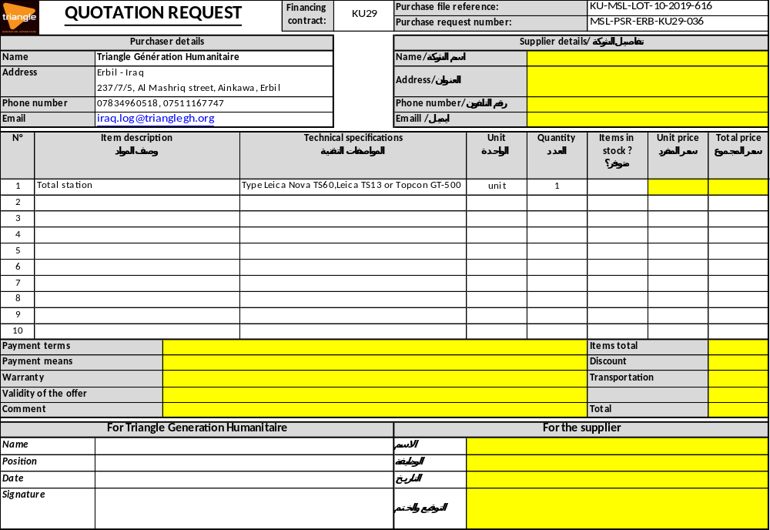

Administrative evaluation grid (for information – Do not fill)

Envelope N° | Name of the bidder | Registration to the Chamber of Trade and Commerce | Copy of Taxation clearance certificate | ID Card  of the Bidder | Copy of valid commercial ID card | Tender commitment form signed and stamped | General Conditions signed and stamped | Ethic clauses and Grounds of exclusion signed and stamped | Statement of Integrity, Eligibility and Social and Environmental Responsibility | Selection  (Yes/No)
1
2
3
4
5

President of the committee | Done in Erbil, | Voting member names | Signature
Signature: | Date : ___________________

Technical and financial evaluation grid (for information – Do not fill)

