INVITATION TO TENDER AND Specification of bidding (SOB)

TENDER DOSSIER: PRF_EBL_2020_0007

Title: Rehabilitation of Karamless Park in Ninewa Plains

Work completion and materials delivery under Incoterms of DDP, to Karamless Park

Completion Time: A maximum of Sixty (60) calendar days after contract awarded

Malteser International project number: 2541-EBL
Tendering procedure number: PRF_EBL_2020_0007

Dear Sir/Madam,
Malteser International herewith invites your company in the framework of Malteser International´s project 2541-EBL to submit an offer for the above-mentioned item as per the quantity and technical specifications described herein. The full tender dossier consists of:
- This Letter of invitation to Tender and the Specification of Bidding
- Administrative and Technical Compliance Criteria Grid;
- Annex 1 – Tender Letter
- Annex 2 – Bill of Quantity and Scope of Work (SoW)
- Annex 3 – Mandatory Principles of Humanitarian Aid Procurement
- Annex 4 – Qualification Information
- Annex 5 – Completion Plan Chart (Optional).

Complete tender must reach the following address no later than:

27 January at 16:00 hours, Erbil City Time.

For submitting in sealed envelop

- Address: Malteser International Office at KRI Erbil Base Office, Park View Compound, Building A2, Floor 11, Apartment 44.

- Your Tender offer should be submitted in a sealed Envelope bearing only the words:
• Do not open before 27 January 2020 at 16:00 hours, Erbil City Time.
• Tender Process: PRF_EBL_2019_0007

Or email the offer to
mb.procurement-erbil@malteser-international.org
Email subject: PRF_EBL_2019_0007

Requests for clarifications are to be sent to: sarah.noori@malteser-international.org before
23 January 2020 at 16:00

Annexes and documentation required for the offer are:
- Annex 1 – Completed and Signed Tender Letter.
- Annex 2 – Signed Bill of Quantity and Scope of Work (SoW), including price for the item tendered, dated and signed as appropriate, your offer must contain the following items:
  - The offer shall be typed or written and signed by the legal representative of the supplier
  - The price of the tender must be expressed in US Dollar.
  - The price will be considered fixed.
  - No additional change of whatsoever nature and type will be accepted by Malteser International
- Annex 3 – Signed Mandatory Principles of Humanitarian Aid Procurement
- Annex 4 – Signed Qualification Information, supported by the following documentation:
  - A copy of the business registration certificate in KRI/Iraq
  - A copy of Commercial/Industrial Chamber Membership Certificate
  - Financial statement for last 6 months.
- Annex 5 – Completion Plan Chart, Dated and Signed. Not compulsory if you wish to provide your own one. Your Completion Plan should be capable to cover all work stages, per implementation days, and per the commitments with Malteser International.

Completion Period is a maximum of Sixty 60 calendar days starting the same date that the contract is signed by Malteser International and the selected tenderer.
The completion and delivery terms are to be delivered INCOTERM DDP, to Karamless Park, Ninewa Plains.
The contract will be a unit price contract, where price is fixed and not open for review.
Price is taxes and customs duties excluded. Supplies, services and conduction items must be delivered with relevant stamps and/or certification by the state authorities.
The language of the contract will be English and the currency of the contract is United States Dollar, USD.
Tenderers are bound by their tenders for a period of thirty (30) days following the deadline for submission.
By submitting an offer, the bidder accepts the terms set out in this tender.

- Description of the organization and its activities
Malteser International is the worldwide humanitarian relief service of the Sovereign Order of Malta and legally a division of Malteser Hilfsdienst e. V. based in Cologne, Germany. Malteser International is a charitable organization recognize as a relief organization according to the Geneva Convention. In Kurdistan/Iraq, Malteser International is currently working on the support for IDPs in Duhok and Erbil Governorates.

- Information about the project
The project financed by the Federal Ministry of Economic Cooperation and Development BMZ, and aims to improve general conditions for the permanent return of displaced people to Ninawa plains.

- Objective of the invitation to bid
In accordance with the overall targets of the above mentioned operations, Malteser International plans to continue rehabilitate a Karamless Park, Ninewa, to cover beneficiaries’ needs in those area during the implantation period of the project.

- TENDER OPENING PROCESS
The opening will take a place after the deadline for submission mentioned above. The opening session is not opened to the public. The presence of the main required documents will be stated during the opening session.

- EVALUATION
After the opening session, tenders will first be reviewed by an Evaluation Committee to verify the administrative compliance of the tenders and that they do contain all required documents. Incomplete or non-compliant tenders may be rejected by the Evaluation Committee. Thereafter, the Evaluation Committee will verify the technical compliance of the tenders. This Committee will possess the technical expertise required to give an informed opinion of the tenders. Tenders which are evaluated as technically not substantially compliant against the technical evaluation criteria will not be considered for the award of the contract.

To promote the “Green Procurement”, Malteser encourage the construction work that using environmentally friendly construction materials and products.

The Evaluation Committee reserves the right to request any additional information seems necessary to the tenderers. The tenderers’ responses must be received before the deadline set by the Committee.

If less than 2 administratively and technically compliant tenders from 2 different suppliers have been received, the Committee reserves the right to seek additional tenders through re-advertisement which the suppliers who already submit the bid shall be informed.

- Tender AWARD
The tender will be awarded to the substantially conform economically and technically most substantially compliant offer, thus, the Contracting Authority reserves the right not to award the contract to the lowest bid.

This contract does not include any complementary or additional acquisition of items other than this listed in the BoQs.

- tenderER awardeD obligations:

The contractor who awards this tender has to draw attention and take in consideration carefully the below aspects before submitting a bid:
- The contractor (supplier) shall provide all labour, transport loading and offloading, tools, equipment, materials and appurtenances, and shall perform all works necessary to satisfactorily construct the kindergartens work in the above locations.
- The contractor is responsible for follow up the BoQs and MI site construction supervisor.
- The contractor shall be responsible for all construction means, methods, techniques,
sequences and or procedures, and for safety precautions and programme in connection
with the works.
- The contractor commits to perform the construction work as detailed in the BoQs of this
Contract and not to change any specifications of the work without the written consent of MI.
- The contractor shall be responsible for all acts and omissions of any sub-contractors they deal with, any agents or employees or of any other persons performing any of the requested works.
- For the execution of work and supervision of the project, the contractor shall employ or hire
professional employees, skilled and experienced and guarantee the presence of one or two
experienced workers in the work site as in charge of the safety of the operations.
MI reserves the right to ask the contractor to remove from the work process any persons
employed by the contractor who in the opinion of the client (MI) misconducts himself or is
incompetent or negligent in the performance of his duties and misconducts. Such persons
shall not be employed upon the work without the permission of MI.
- The contractor shall keep accurate and systematic records in respect of the works, in
accordance with the Specifications and Bill of Quantities
- The contractor shall facilitate inspection and audit of the works done under the tender contract and performed by the client (MI) or any auditors the client authorize.
- The contractor commits to hire unskilled daily workers among the local community each
time it is possible in order to train the community labour force and enhance their capacity.

- GENERAL CONDITIONS
- Currency of the contract and payments:
  - All payments will be done in US Dollars upon presentation of the corresponding invoice and hand-over of the work including all relevant documents, certificates, permits etc.
  - Payments will be based on actual implemented volume of works using the unit rates quoted in the finally agreed Technical Specifications and Bill of Quantities.
  - The contractor is responsible for keeping work tracks in good faith of actual numbers that will be used for invoicing purposes and later payments. MI reserves the right to check these numbers at time.
  - Payment will be made only for complete works meeting the specifications and terms and conditions as detailed in Annex 2 (Technical Specifications and Bill of Quantities).

- Terms of payment: Bank transfer, or bank cheque, at our account with Erbil Bank in Erbil, Iraq, payable within 10 (ten) working days after signed satisfactory completion of all works accepted by Malteser technical team for quality and quantity as per technical specification, BOQ, site inspection /engineering data report.

- Payments Schedule:
  - 50% of the total tender amount after the completion of 50% of works in BoQs.
  - 40% of the total tender amount after the completion of 90% of works in BoQs.
  - 10% of the total tender amount will be reserved as a guarantee on work quality and will be paid after three (3) months from completion the entire work in BoQs.

- Terms of delivery:
  - Failure to comply with the delivery plan applies a sanction of 1% of tender amount per delay day. The deduction will take a place each time one of the payments goes to take a place.

- Quality of the materials:
  - All materials and items used in the construction project, must be comply with minimum requirements and regulation, following international standards and specifications required in KRI and Iraq State.

- Completion plan:
- Work implementation shall be registered and clarified in the completion plan attached with this SoB, under Annex (5). The template will be sent in a separate Excel file in parallel with tender package files. The plan template is not mandatory, and the contractors are welcome to provide their own templates. The provided plan should be capable to cover all work stages, per implementation days, and per the commitments with Malteser International.

- CANCELLATION OF THE TENDER
Under no circumstances, MI, Malteser International will be excluded for any damages whatsoever their nature, in particular damages for loss of profit; or in relationship to the cancellation of this tender, even if Malteser International has been advised of the possibility of damages.
The publication of the procurement notice does not commit Malteser International to implement the project announced nor to procure any items needed. Nothing will be due to the contractor in case this procurement needs to be cancelled due to whatsoever reason.

On behalf of Malteser International,
Sarah Noori
MI Logistics Officer
sarah.noori@malteser-international.org
January 20th, 2020
Malteser International, Ninawa Return Program

CRITERIA FOR ADMINISTRATIVE COMPLIANCE OF TENDERS

No. | REQUIRED DOCUMENTS | COMPLIANT
No. | REQUIRED DOCUMENTS | YES | NO
1. | Annex 1 – Tender Letter
2. | Annex 2 – Bill of Quantity and Scope of Work, dated and signed including initials on each page
3. | Annex 3 – Signed Mandatory Principles of Humanitarian Aid Procurement
4. | Annex 4 – Qualification Information
4.1 | A copy of the business registration certificate in Iraq
4.2 | A copy of Commercial/Industrial Chamber Membership Certificate.
4.3 | Financial statement for last 6 months
5. | Annex 5 – Completion Plan Chart, dated and signed. (Optional if other templates are provided).

The absence or the non-compliance of any above item may result in the rejection of the tender, should any other items or information be missing or not compliant, the Evaluation Committee may decide to request the tenderer to provide the missing document or information within a set deadline. If this deadline should expire without satisfactory reply for the tenderer, the tender shall be considered non-compliant.

In all cases, provision and compliance of all the above items is a condition to the award of the contract.

CRITERIA FOR TECHNICAL COMPLIANCE OF TENDERS

No. | REQUIRED DOCUMENTS | COMPLIANT
No. | REQUIRED DOCUMENTS | YES | NO
1. | Offer substantially conforms to the technical specifications and cover all points set in the Bill of Quantity of the tender dossier.
2. | Completion terms and time conform our requirements in this invitation to tender

The Evaluation Committee reserves the right to request any additional information it seems necessary to the bidders to be provided within a set deadline.

ANNEX 1 – TENDER LETTER

To: Malteser International
Iraq Program
Erbil, Iraq

Gentlemen and/or Ladies:

Having examined the tender documents, the receipt of which is hereby duly acknowledged, we, the undersigned, offer to conduct and complete the works in conformity with the said tender documents for the sum of USD_____________________________________________ [total tender amount in words and figures].

We undertake, if our tender is accepted, to complete the works listed in the tender BoQs and their related items in accordance with the delivery schedule specified in the tender process.

We agree to abide by this tender for a period of one month from the Deadline for tender submission, and it shall remain binding upon us and may be accepted at any time before the expiration of that period.

Until a formal Contract is prepared and executed, this tender, together with your written acceptance thereof and your notification of award, shall constitute a binding Contract between us.

We understand that you are not bound to accept the lowest or any tender you may receive.

We certify/confirm that we comply with the eligibility requirements as per requirements of the
tender documents.

Date: ______/_______/201_

_____________________ _______________________
[Signature] [In the capacity of]

Duly authorized to sign tender for and on behalf of:
Company name

ANNEX 2 – BILL OF QUANTITY AND SCOPE OF WORK (SOW)
ANNEX 2.1 – BILL OF QUANTITY
Bill of Quantity for Karamless Park
General Specifications:
1- All Works Must be executed in accordance with Iraqi General Technical Specifications (I.G.T.S.) published by Ministry of Housing and reconstruction / Republic of Iraq, the drawings, contract document and instructions of Engineer.
2- The contractor must provide samples, mockup, catalogues for testing / inspection to be approved by Malteser's Engineer.
3- Contractor must pay the cost for samples including any laboratory tests, both inside and outside the country as required.
4- The contractor shall check all items and measurements given in the BoQ. All changes, additional quantities etc. require the written approval by Malteser Engineer. A site assessment by the contractor is mandatory.
5- The Price of works includes all job requirements as per Iraqi's Standard Specifications.
6- The contractor must provide PPE for all laborer's, personnel, Engineers and possible visitors to the site.
Item No# | Specifications Required | Unit | Quantity | Unit Price ($) | Total Price ($)
1 - CIVIL WORKS
1.1 | Plastic Painting External:  Supply tools & materials and painting of the building (external walls), using Plastic paint (Turkish type Petek or equivalent), with minimum three layers, according to the specifications and instructions of the site engineer. | m2 | 550
1.2 | Emulsion Painting Internal:  Supply tools & materials and painting of the building (internal walls), using emulsion paint (Turkish type Petek or equivalent), with minimum three layers, according to the specifications and instructions of the site engineer. | m2 | 400
1.3 | Ceramic Tiles:  Supply of materials, tools and manpower to install ceramic tiles (Turkish type class A, Indian class A) for bathrooms & kitchen walls. The price of works includes joints grouting using white cement paste, cement: sand mortar, slope, horizontal and vertical leveling, .includes Supply and installation of plastic or aluminum rulers for walls angles, the price include removing the damaged and old ceramic tiles with needed works to complete the job will be included within the price, according to the instructions of supervisor engineer. | m2 | 220
1.4 | Mosaic Tiles:  Supply of materials, tools and manpower to place mosaic tiles of dimensions 30x30cm and 3cm thickness (#4), by using cement mortar (1:3). The price includes cutting, fittings, trims, curve edges, pointing with stick, polished and glazed mechanically. The price include removing the damaged and old mosaic tiles with needed works to complete the job will be included within the price. | m2 | 300
1.5 | Porcelain Tiles:  Supply materials and tools fix porcelain tiles (Turkish class A, Chinese best type, Indian class A or equivalent) 60X60cm for the building using cement-sand mortar (1:3) and filling the joints with white cement mortar. the price includes removing the old and damaged flooring with all needed works to complete the job will be included within the price. All according to the specifications and instructions of the site engineer. | m2 | 670
1.6 | Plain Concrete:  Supply materials and tools to cast plain concrete (C21MPA) for the building under floor tiles (10cm thickness). according to the specifications and instructions of the site engineer. | m2 | 970
1.7 | Skirting:  Supply materials and tools and skirting by ceramic tiles 10 cm height and cement-sand mortar 1:3 and filling the joints by white cement of the building, according to the specifications and instructions of the site engineer. | m.l | 60
1.8 | Excavation:  Supply equipment, machinery and labors to start remove the top soil to a depth of 30 cm below the level of the foundation and 30 cm under the foundation, according to the drawings. Work includes: The transfer of debris to a suitable place must be approved by the local authority. According to the specifications and instructions of the site engineer. | M3 | 22
1.9 | Reinforced Concrete for Footings :  Supply materials and tools and casting reinforced concrete for footing(50wx30h)cm, using concrete (C25MPA) using sulphate resistance cement. the casting should perform with a concrete pump to ensure the right distribution of the concrete under the foundation. Also the work includes all the requirements of steel reinforcement, as mention in the drawing, according to specifications and the instructions of site engineer. | M3 | 5
1.10 | Filling works:  Supply materials and tools for filling above the footing (in layers not exceeding 25cm, including compaction up to 95%of MDD) with sub-base (type A), with all necessary works. according to specifications and the instructions of site engineer. | M3 | 12
1.11 | Walls building:  Supply of materials and tools to demolish part of the walls above the level of D.P.C for the building and rebuild it with a thickness of 20 cm with mortar of cement (1: 3). The wall should be flat vertically and horizontally, according to the specifications and instructions of the site engineer. | M2 | 20
1.12 | Plastering works:  Supply of materials, manpower and tools to start repairing plastering works using cement mortar (1: 3), the work involves repairing wall cracks by removing the damaged plaster 25 cm both side of the slit, then filling the cracks with cement mortars 1: 3 and adding SBR and use mesh networks Where necessary, all work must be done in accordance with the specifications and instructions of the supervising engineer. | M2 | 200
1.13 | Walkways works:  Walkways: supply materials and tools and build wall (40)cm height (20 cm thickness) align the building by using concrete block (15x20x40) cm and filling by sub-base type A (20cm) with compacting and cast concrete for the walkways (thickness 15cm and width 100cm), and joints for the walkways every 4m and mold wooden frame, according to the specifications and instructions of site engineer. | M.L | 38
1.14 | Roof Insulation:  Supply material, manpower and tools to start cleaning the roof from dirt and dust and then applying water-proofing flint coats painting (2 layers),and then installing one layer of bitumen membrane 4mm thickness ( Turkish class A or equivalent brand). considering at least 10 cm overlap between the membrane sheets and raising 20 cm high at the edges. all according to the standard specifications and to the supervisor engineer instructions. | m2 | 290
1.15 | Main Doors:  Supply materials, tools and manpower to install main doors as the following: Installation main gate (3.5*2.3)m frame. The gate frame and partition are made from square pipe 2 X 2 inches, 2 mm thickness. The price includes suppling and fixing iron Turkish engrave with painting of all the parts with 1 layer of anti-corrosion paint and 2 layers of oil paint, according to the instructions of the supervisor. | NO. | 1
1.16 | Steel Door for entrance:  Supply materials and tools and fix steel door for entrance without frame size (2*2.1)m, with steel plate gauge 18 (1.41mm) on double face, using steel tube (20*20*2mm), including a layer of Styrofoam to be placed between the two faces, hinges, doors handles, locks and painting one layer of anticorrosion and two layers of oil paint, according to the specifications and instructions of the site engineer. | NO. | 1
1.17 | Steel Door:  Supply materials and tools and fix steel door with frame size (1*2)m, with steel plate gauge 18 (1.41mm) on double face, using steel tube (20*20*2mm), including a layer of Styrofoam to be placed between the two faces, hinges, doors handles, locks and painting one layer of anticorrosion and two layers of oil paint, according to the specifications and instructions of the site engineer. | NO. | 2
1.18 | Iron Doors Reparation:  Repair damaged doors includes smithery, welding , three layers painting (one of anti-oxidation paint and 2 layer of oil paint) ,installing new door lock and latch (safeer al khair or equivalent). All necessary works and details according to drawings and instruction of supervisor Engineer. | NO. | 8
1.19 | PVC Door:  Supply materials and tools and fix PVC door with frame size (2*1)m (frame of minimum 60 mm width), handles, locks, best quality available. according to the specifications and instructions of the site engineer. | NO. | 6
1.20 | Suspended Ceiling:  Supply materials, installation secondary ceilings using (60 × 60 cm) of Gypsum board or plastic with a black American’s rail of aluminum (Chinese type best quality or equivalent) for roofs, with good installation using bolts and all the work required of materials and work according to the guidance of the supervisor. | m2 | 350
1.21 | Windows Glasses Reparation:  Supply manpower and tools to start works in repairing broken Glass windows using perfectly installing fixing paste of the windows glasses with thickness 4mm, all works should done according to the instruction of the supervisor engineer. | m2 | 35
1.22 | Steel Window:  Supply Material, equipment and start installation of steel window, the works include painting one layer of anticorrosion and two layers of oil paint, anti-insects wire mesh for openable parts and handle of good quality (heavy type) and glass 4mm. all works should done according to the instruction of the supervisor engineer. | m2 | 2
1.23 | Windows Reparation:  Repair damaged windows includes smithery, welding , three layers painting (one of anti-oxidation paint and 2 layer of oil paint) , new windows lock and latch heavy quality, all works should done according to the instruction of the supervisor engineer. | m2 | 35
 | Total of Civil Works
2 - Electrical Works
2.1 | Cables (4*25mm²):  Supplying, laying and connecting (4*25mm²) PVC insulated and sheathed un-armored copper cable (Turkish Berly, Jordanian class A or Saudi class A) (from the main network to the main distribution board), with all accessories to complete works as required. | m.l | 60
2.2 | Cables (4*16mm²):  Supplying, laying and connecting (4*16mm²) PVC insulated and sheathed un-armored copper cable (Turkish Berly, Jordanian class A or Saudi class A) (from the main network to the main distribution board), with all accessories to complete works as required. | m.l | 40
2.3 | Cables (2*2.54mm²):  Supplying, laying and connecting (2*2.5mm²) PVC insulated and sheathed un-armored copper cable , with all accessories to complete works as required. | m.l | 600
2.4 | Main Circuit Breaker :  supply, install, connect and test 3-pole molded case circuit breaker (ABB) capacity (250 A) best Turkish brand or equivalent brands, with three Air circuit breaker (ABB) capacity (100 A) placed inside a suitable iron box with good quality , and suitable bus bar. all needed works to complete the job. All necessary works and details according to instruction of supervisor Engineer. | L.S | 1
2.5 | Distribution board installation:  Supply and installation of a distribution panel consisting of 3ph MCCB 100A and 12 sub-distribution lines of 20 AMP (best quality), inside a suitable steel box, with all accessories. All needed works to complete the job, will be included within the price. | NO. | 2
2.6 | Ceiling Fans:  Supply material and fix mounted ceiling fans ( Fajer or equivalent) (60*60)cm, with wiring works, complete, according to the specifications and instructions of the site engineer. | NO. | 10
2.7 | Switches & Switch Plugs (13&15):  Supply and fix Switches & switch plugs (13&15) amp (UAE Adeson class A or equivalent) with wires, complete, according to the specifications and instructions of the site engineer. | NO. | 53
2.8 | Exhaust fan 12":  Supply and fix exhaust fan, size 12 inch (Shami or equivalent), with wires and switches, complete, according to the specifications and instructions of the site engineer. | NO. | 9
2.9 | Led lights for suspended ceiling:  Supply and Connection Ceiling Light Type of (LED 25W) (Halistar Chinese first class) or equivalent ,The price includes the installation its wiring inside the secondary ceiling and with the switches and installed with the cable clamp and pass through the plastic pipes in the walls and as directed by the supervisor engineer. | NO. | 38
2.10 | 9 M Lighting Pole Installation:  Supply and installation of galvanized lighting poles with (Height 9m). Install and fix on top of the pole (4 LED projector 400 watt), with excavations and concrete base depth (1m), dimension (50x50) cm and connect with cables for each pole. All needed works to complete the job, will be included within the price. | L.S | 1
2.11 | Projectors lighting:  Supply and installation and testing a projector of (400 watts) (Crown brand or equivalent), and fixed in the specific areas by the supervisor The price includes the installation of a cable (2 × 4 mm) and with all work and materials according to specifications and the instructions of site engineer. | NO. | 10
2.12 | Outdoor Lights:  Supply and fix outdoor lights, waterproof type, 22 watt (Chinese Home or equivalent), with switches and wires, complete, according to the specifications and instructions of the site engineer. | NO. | 48
 | Total of Electrical Works
3- Sanitary Works
3.1 | Galvanized Pipes:  Supply and installation a galvanized iron pipe (1") (Heavy Turkish type) for external connections and connected to the water tanks in the building's roof , with painting the pipes with anti-oxidation paint. according to specifications and the instructions of site engineer. | M.L | 20
3.2 | PPR Pipe (½") (¾"):  Supply and fix new PPR pipe lines, size (½") and (¾") (Egyptian Sharif or equivalent). The price includes all fittings and accessories, excavation, backfilling, according to the specifications and instructions of the site engineer. | M.L | 80
3.3 | PVC Pipes (2.5"):  Supply and fix PVC pipes (2.5") diameter (Egyptian Sharif or equivalent), 6 bar for drainage and laying to the septic tank, slope (20cm per 100m). The price includes all fittings and accessories, excavation, backfilling, according to the specifications and instructions of the site engineer. | M.L | 18
3.4 | PVC Pipes (4"):  Supply and fix PVC pipes (4") diameter (Egyptian Sharif or equivalent), 6 bar for drainage and laying to the septic tank, slope (20cm per 100m). The price includes all fittings and accessories, excavation, backfilling, according to the specifications and instructions of the site engineer. | M.L | 60
3.5 | Manholes (15*15)cm:  Supply materials, labor and equipment to install plastic manholes (15*15)cm (Turkish Heavy type or equivalent) . All needed works will be included in the price, according to the specifications and instructions of the site engineer. | NO. | 10
3.6 | Manholes (40*40):  Supply materials, labor and equipment to install plastic manholes dimension (40x40)cm (Turkish heavy or equivalent). The price includes excavation, removing the old and damaged manholes, complete, according to the specifications and instructions of the site engineer. | NO. | 3
3.7 | Wash Basin:  Supply and fix white ceramic wash basin (40*50)cm (Turkish Turkuaz or equivalent), with stand to be fixed on the wall, mixer taps (Itimat or equivalent) (double handle), valves, and all fittings, with complete water connection, according to the specifications and instructions of the site engineer. | NO. | 5
3.8 | Western Toilet:  Supply and fix ceramic eastern toilet (TOOTA or equivalent). , flexible hose and water connection complete, according to the specifications and instructions of the site engineer. | NO. | 7
3.9 | Taps 1/2" or 3/4":  Supply and fix chrome taps 1/2" or 3/4" (Itimat or equivalent), with all fittings complete, according to the specifications and instructions of the site engineer. | NO. | 6
3.10 | Water Tanks:  Supply and installation Cylindrical water tank (1.4 m3), G16 .The price includes all fittings and connections with other tanks. And make iron bases for each tank, according to specifications and the instructions of site engineer. | NO. | 6
3.11 | Water Heater:  Supply and installation of electric water boiler capacity of (220 liters) of (TOOTA or equivalent) with two Heaters and all accessories , wiring and switches, ventilation pipe, and according to the instructions supervisor engineer | NO. | 2
3.12 | Sink :  Supply of materials, tools, machine and manpower for Sink (120*60), with water mixer (Itemad or equivalent) with all needed accessories. complete according to specifications and the instructions of engineer | NO. | 1
3.13 | Water pump:  Supplying materials shimge local brand or equivalent brands, tools and manpower to install and connect water pump with motor (1.1kW,220V,50Hz), Q=3M3/Hr. @H=30M. The price include providing all necessary fitting, check valve and strainer for connecting the pump suction pipe to the main water source pipe, also the pump should have pressures switch in the pump and electrical float switch ball type in the tank the price include extending cable (2X1.5mm²) from motor control switch to float switch for shutdown the pump when the tank is filled .all accessories and requirements to complete work will be included. | NO. | 1
 | Total of Sanitary Works
4-CHILDREN'S PLAYGROUND:
4.1 | Kids outdoor playset 1:  Supply and install Kids outdoor playground, plastic equipment (Turkish type best quality with providing certification and warranty),the work include the concrete base for the installation (C25), with all needed reinforcements or bolts to complete the job as the required standard specifications. See attached annex (Kids outdoor playset 1) | NO | 2
4.2 | spinning game:  Supply and install Kids spinning game, outdoor playground, plastic equipment (Turkish type best quality with providing certification and warranty),the work include the concrete base for the installation (C25), with all needed reinforcements or bolts to complete the job as the required standard specifications. See attached annex (Kids spinning game) | NO | 2
4.3 | Seesaw:  Supply and install Seesaw with double seat (Turkish type best quality with providing certification and warranty),the work include the concrete base for the installation (C25), with all needed reinforcements or bolts to complete the job as the required standard specifications. See attached annex (Seesaw) | NO | 2
4.4 | Spring rider toys:  Supply and install spring rider toy, outdoor playground, anti-rust, plastic equipment(Turkish best quality with providing certification and warranty),the work include the concrete base for the installation (C25), with all needed reinforcements or bolts to complete the job as the required standard specifications. See attached annex (Spring rider toys). | NO | 3
4.5 | Picnic Table:  Supply and install Picnic table (Turkish type best quality),the work include the concrete base for the installation (C25), with all needed reinforcements or bolts to complete the job as the required standard specifications. See attached annex (Picnic Table) | NO | 10
4.6 | Garbage Bins:  Supply and install garbage bins on the sidewalks above the concrete base 1: 2: 4 (10 cm thickness) (Turkish type best quality), according to the attached drawing. See attached Annex (Garbage Bin) | NO | 10
 | Total of Children playground Works
Total of all works

Annex Attached to the BoQ

Karamless Park Annex
NO. | item | Picture
1 | Kids outdoor playset 1 | 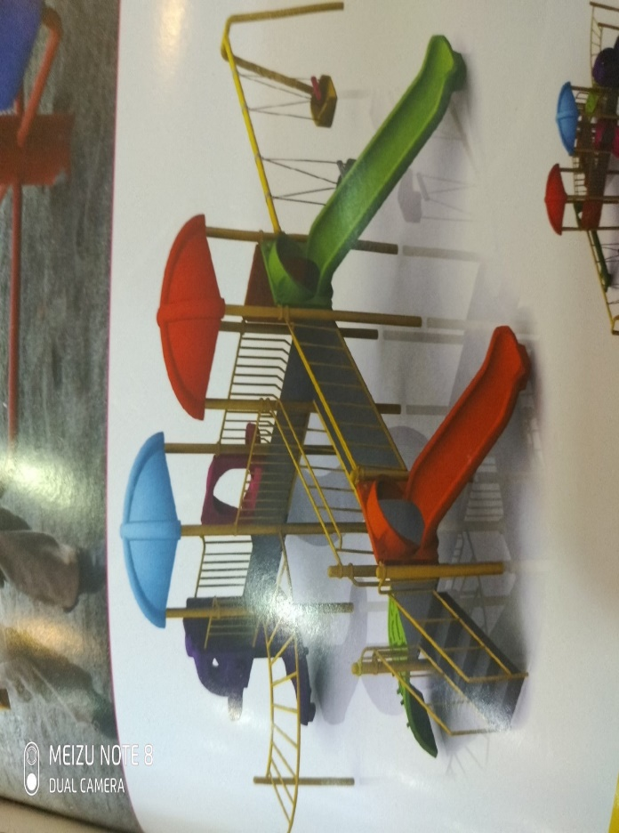
2 | Kids spinning game | 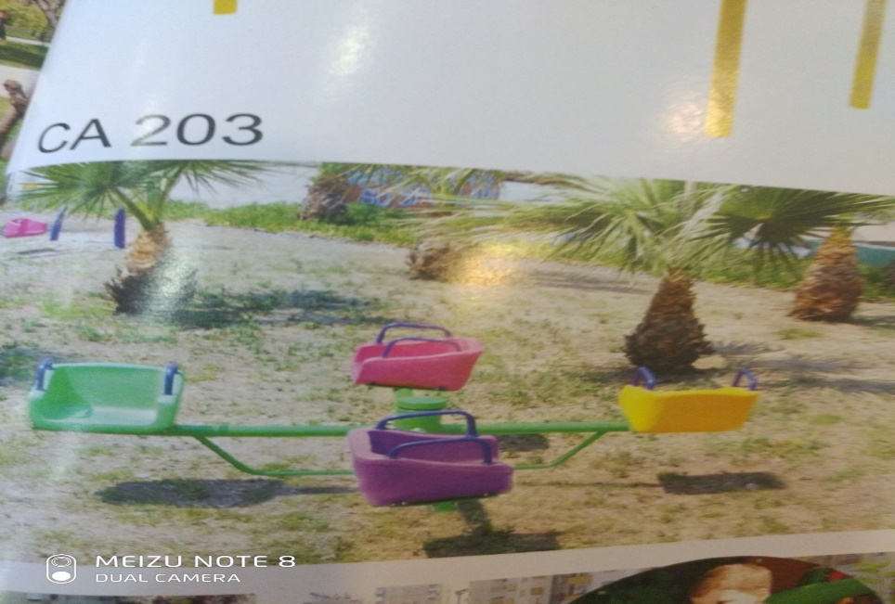
3 | Seesaw | 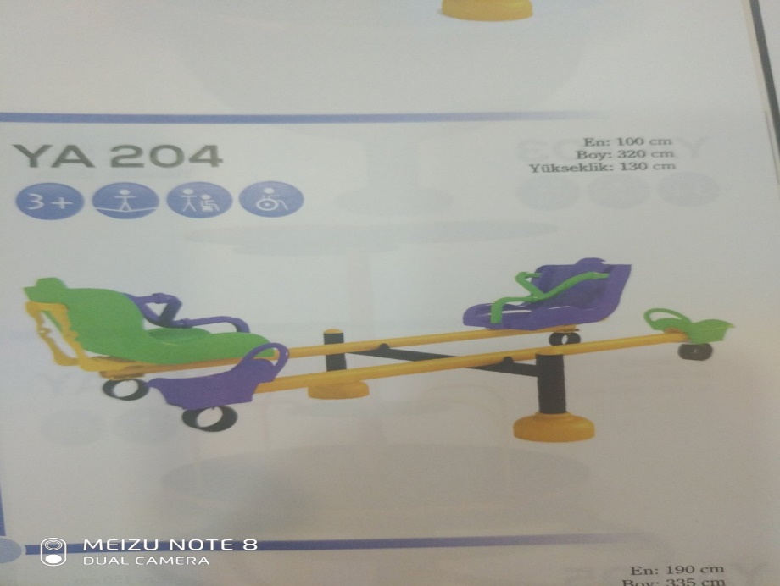
4 | Spring rider toys | 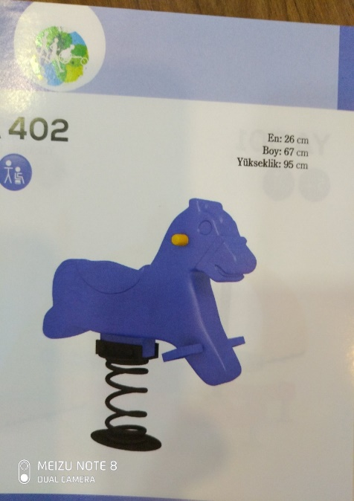  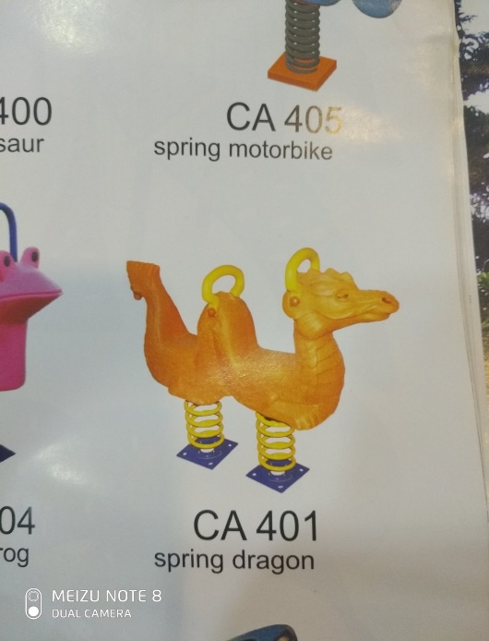
5 | Picnic Table | 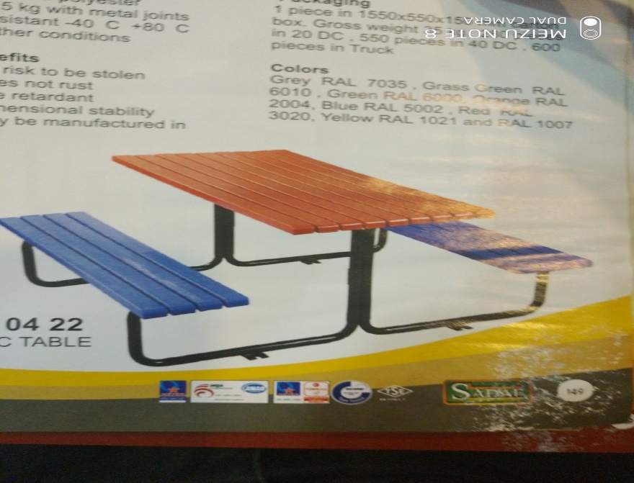
6 | Garbage Bin | 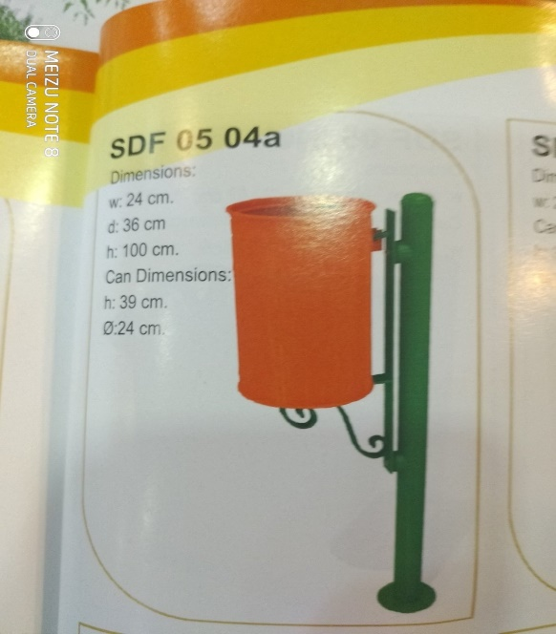

ANNEX 2.2 – SCOPE OF WORK (SoW)

Scope of works for Rehabilitation of Karamless Park in Ninewa Plains

- STANDARD OF PERFORMANCE:

The Contractor shall perform the required services and carry out his obligations under this Contract with all due diligence, efficiency and economy, in accordance with generally accepted techniques and practices used in performing such type of activities and with professional engineering and contracting standards recognized. He shall observe sound management, and technical engineering practices, and employ appropriate advanced technologies and safe and effective equipment, machinery, materials and methods. The Contractor shall operate and maintain the equipment and machinery involved in the implementation activities in accordance with the relevant laws, standards, regulations and legislation, as well as the requirements under the Contract, and the manuals and guidelines as provided by the manufacturers and suppliers of the equipment and machinery.

Site Safety:

The Contractor shall be responsible for implementing strict safety measures on site in view of the type of works being implemented; the Contractor shall provide and erect protection items required by site Conditions or as requested by the Engineer to protect persons, onsite and offsite property, as required and as supplementary to such items that have been left in place; ascertain legal and other requirements. The Contractor shall maintain protection in place until work is complete and danger of damage has ceased; at such time as approved by the Engineer, remove protections.

Site Access:

The contractor shall visit the site before starting execution of the project and he shall satisfy himself of the suitability & availability of the access routes that he chooses for using during the Contract duration. The Employer will not accept any claim whatsoever if the contractor raise a claim related to not being aware of the site conditions and its surroundings as well as The Employer will not guarantee either the suitability or availability of any chosen road and will not held responsible or subject to any claim in respect of non-suitability or non-availability of any such route.

Contractor obligation with the municipality and official authorities:

The contractor should always coordinate & inform the municipalities and any concerned authorities for any temporary blockage of roads or any road found necessary to execute the works. The contractor is responsible to set meeting & follow up any issue related to this project with the local & national authorities. Any amount resulted from the above is to be borne by the contractor.

Contractor’s Resources:

The Contractor shall utilize all necessary resources, manpower, machinery and equipment etc. in order to perform the required works in a proper, safe and timely manner. The Contractor should employ, to the maximum extent possible, the necessary laborer (skilled and/or unskilled) from within the project area

2- Technical Specifications:

a- Concrete:
- Plain Concrete for Walkways: the concrete mixture should in 1:2:4 ratios. All according to ACI-18 code, the compressive strength should not be less than 20 MPa after 28 days.
- Reinforced Concrete: the concrete mixture should in 1:2:4 ratios. All according to ACI-18 code, the compressive strength should not be less than 25 MPa after 28 days.

b- Reinforcing Work (Steel bars): Steel Bars minimum yield stress should not be less than 420 MPA and the steel grade should be G60.
- Minimum steel cover for the bars should be
2.5-3 CM for slabs and columns
6-7.5 CM for foundation or any concrete section that is in touch with the soil.
C- Suspended Ceiling: The suspended ceiling should be implemented in symmetric shapes for all the halls or rooms.

D- The Term Class A: this term in the BoQ is referring to the best quality of the specified brand or origin of manufacturing, taking in count that the mentioned brand or origin might have a copy, so this material will be applied to testing according to the supervisor Engineer Instructions.

E- Kids Outdoor Playsets: All the playsets materials and installation should be according to the ASTM F1487 Code for 2-12 years old, 5-12 years old and 2-14 years old, as below;
- Slides: The Slides should be made of FRP (Fiberglass Reinforced Plastic), and the Roller should be made up of HDPE with UV stabilized pigment. The slides are smooth hand curve is given to provide smooth ride to the riders.
- Arch Swing: the frame should be made of 80DN G. I. pipe for the sides and top pipe is made up 50NB G. I. pipe. The two swings are made up of 10mm thick anti skied chequered reinforced rubber top, the belt seat is suspended on 6mm rubber coated G. I. chain.
- Spinning game: the seats are made of non-skid type FRP, and pipes minimum thickness should be 2 mm. The whole structure is mounted on heavy-duty bearing shaft permanently lubricated with water sealant.
- All games components should be installed according to the standards ASTM codes for Kids Safety.

F- All Construction Items (Excavation & Filling, Tiles, Painting, PVC doors & Windows, Roof Insulation…...etc.) Should be implemented according to the Iraqi General Technical Specifications (I.G.T.S.).

Completion Time: _____________ Calendrer days

I, the representative of the company submitting the offer, by signing here, confirm that my company will be able to implement and complete the works listed in the tender BoQs and Scope of Work within the timeframe presented in Annex 2.

Date: ___________________ Name, Company and Signature: ________________________________

Annex 3 – Mandatory Principles of Humanitarian Aid Procurement

Malteser International is obligated to observe and apply the following Procurement Principles. Malteser International also expects its partners and contractors to note these principles and act in accordance with them during the execution of the contracts signed with Malteser International.

The partner or contractor agrees to the adherence of following principles by signing the contract and annexes.

- Principle of Ethical Procurement
- Avoidance of child labour,
- Respect of basic social rights and working conditions based on international labour standards,
- Avoidance of any connection with a party to a conflict, involvement in the supply or transport of illicit arms and land mines and unethical exploitation of natural resources.

- Principles of Equal Treatment, Non-Discrimination and Untied Aid
- No discrimination or unjustified differentiation between legal or natural persons, regardless of the origin or the nationality.

- Right of Access
- Right of Access: the donor has full access to premises and documents referring to procurement procedures, documents, evaluations, award recommendations and contracts (regardless of whether these belong to the Malteser International or to the partner or contractor)
- Malteser International is obliged to immediately inform the donor if it becomes aware of any corrupt, fraudulent or coercive practice, the breach of the principles or a situation that is likely to constitute a conflict of interest.

- Principle of Avoiding Conflicts of Interest
- Measures have to be taken to prevent any conflict of interest (impartial and objective implementation is compromised for reasons involving on economic interest, political or national affinity, or familiar or emotional ties).

- Principle of Supporting the Local Economy
- Whenever it is possible local human or material resources have to be used. Before it has to be ensured that this will not distort the local market, increase prices or unduly burden the local natural resources or the environment.

- Principle of Due Diligence
- Timely delivery and satisfactory quality of the received supplies, works or services have to be followed up and in case this is not fulfilled appropriate measures have to be taken to mitigate negative consequences for the beneficiaries.

I, as the representative of the company submitting this offer, confirm that I have read and understood, and I agree to respect all the principles set out in this Annex 3.

Date: Name, company and Signature:

___________________ ________________________________

ANNEX 4 – QUALIFICATION INFORMATION

- For Individual tenderers.

  - Constitution or legal status of tenderer [attach a copy of the items listed below]

    - Business registration certificate number : ………………………
    - Commercial/industrial chamber membership number: ……………..……..
    - Financial Statement for last 6 months.

I, the representative of the company submitting the offer, understand that presenting any false information can result in immediate dismissal from this tendering process and/or future tendering processes, hereby I confirm that all information presented is true and offer copies of the documents listed in this Annex 4.

Date: _______________ Name, signature, title: ________________________________

ANNEX 5 – COMPLETION PLAN (Optional)
