 | Item | Quantity | Notes
1 | Bee suit | 45 | Pullover jacket with veil. See photo. 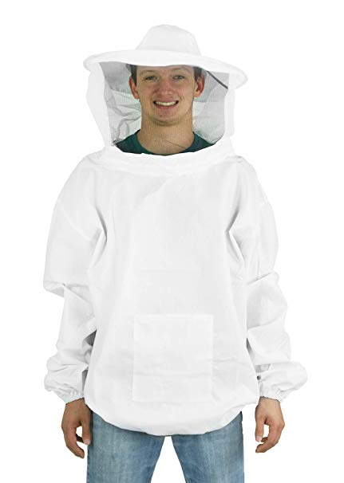
2 | Bee gloves | 45 | 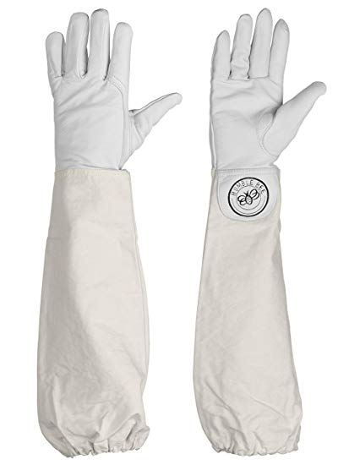
3 | Smoker | 35 | Stainless steel with shield. 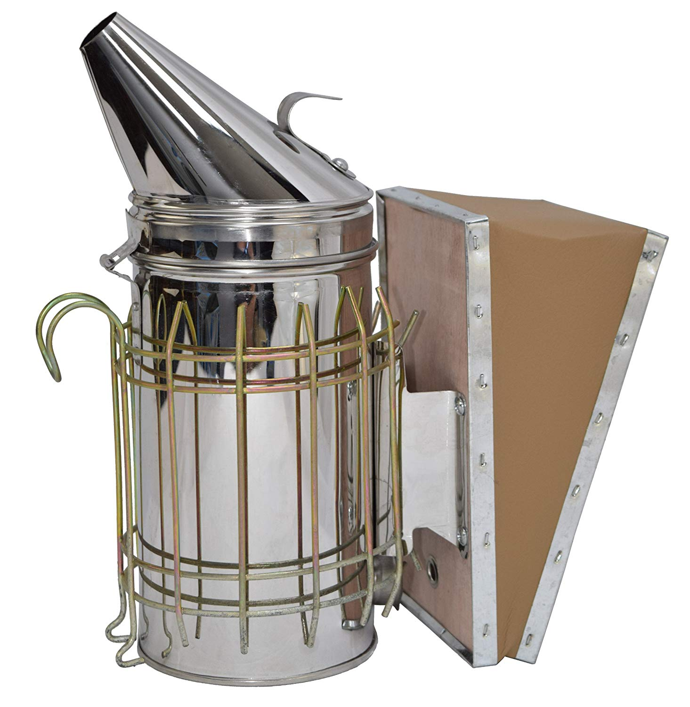
4 | Hive tool (lever) | 30 | Small metal tool for tending hives. 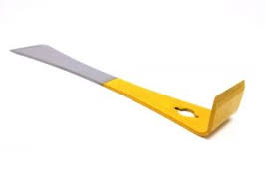
5 | Apiary brush | 30 | Brush with plastic bristles. 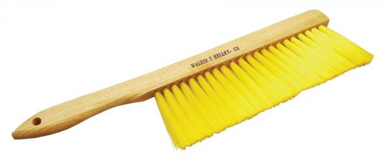
6 | Bee fork | 30 | Bee keeping uncapping fork. 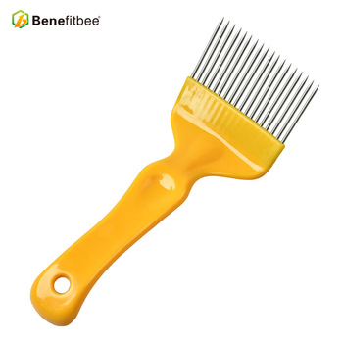
7 | Honey extractor | 5 | Four frame machine for harvesting honey. See photo. 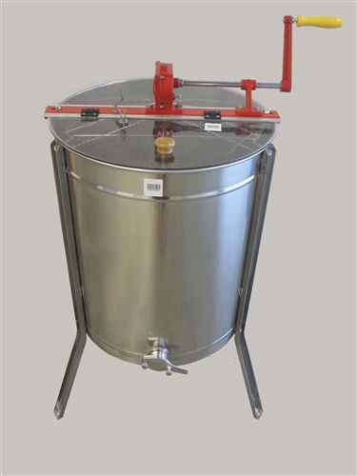
8 | Wasp traps | 75 | Portable. Large mesh box style.  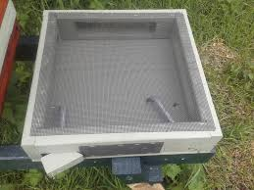
9 | 1 kilo plastic jars | 4,050 | 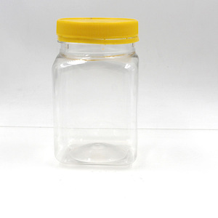
10 | ½ kilo plastic jars | 900 | Same as above but ½ kilo size.
11 | Clear plastic square containers with lids (1 kg) | 225 | 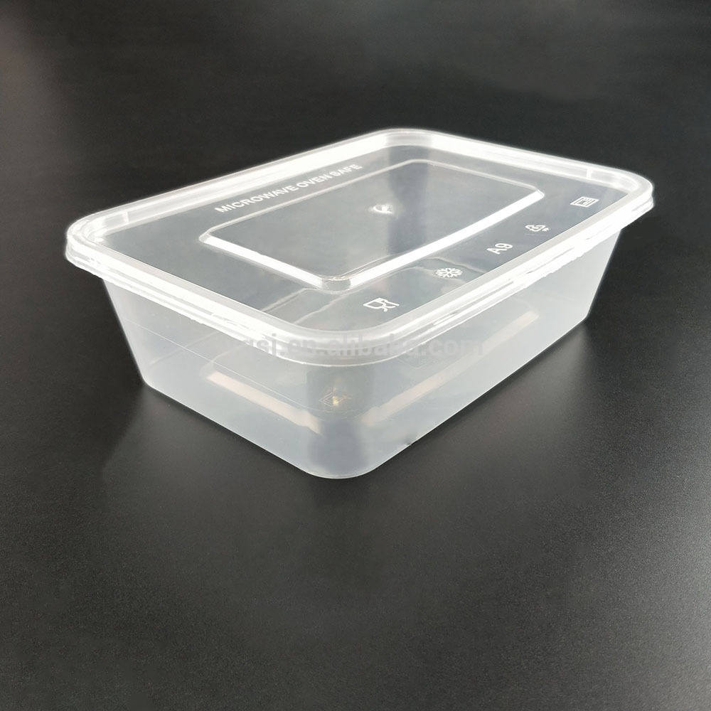
12 | Inside hive feeder | 525 | Plastic, hanging feeder to go inside the beehive.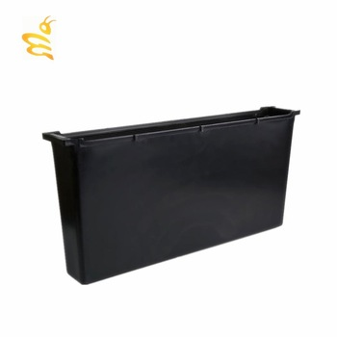
13 | Wax/honeycomb | 150 boxes | Beeswax foundation sheets. Standard size. Comes in 2kg boxes. Need 150 boxes. German or Egyptian brand preferred.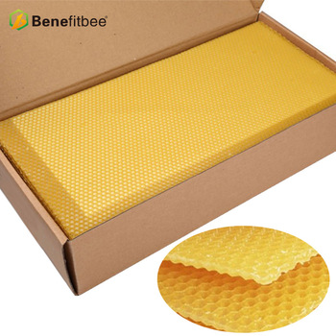
14 | Wooden frames | 5,250 | 39.2x37.2 wood bee hive frame Langstroth style.  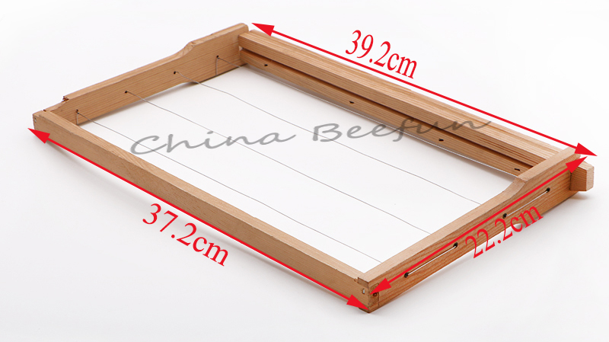
15 | Bee food | 1050 | Not natural pollen. 1 kg bags. Photos not requested brand.  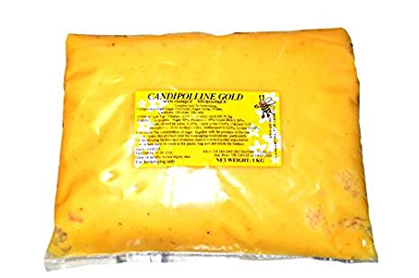
16 | Natural pollen | 435 | 1 kg bags. German brand. Photo not requested brand.  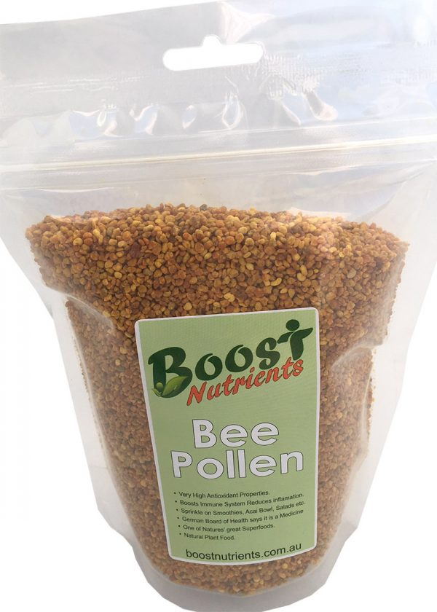
17 | Oxy-tetracyclene | 105 | Jordanian, 100g. Do not get the Iranian brand.  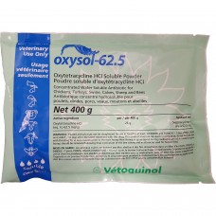
18 | Anti-Varroa treatment | 750 strips (75 packs of 10) | Apistan brand, in packs of 10 strips.  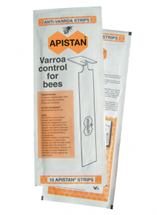
19 | Liquid bee vitamins | 75 | Turkish, 1 liter.
20 | Wooden beehives | 210 | Standard size. Langstroth style. Wood. No frames if ordering live frames of brood separate.  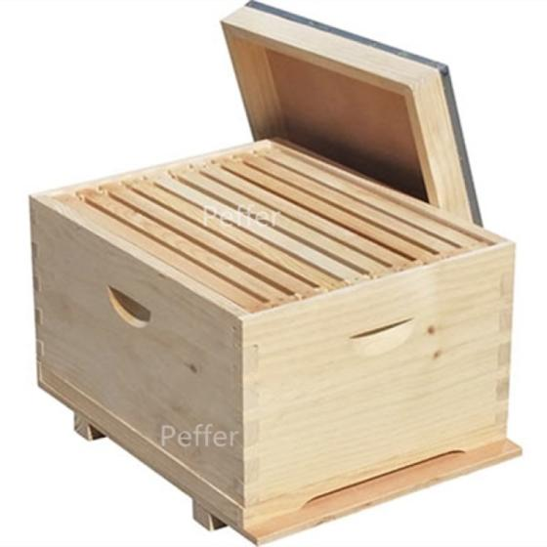
21 | Live bee colony | 210 | Live bees with queen and ten frames of brood. (Iranian)
22 | Super hives with 5 frames | 390 | Smaller top box in the photo below. Needs to fit on top of a Langstroth box.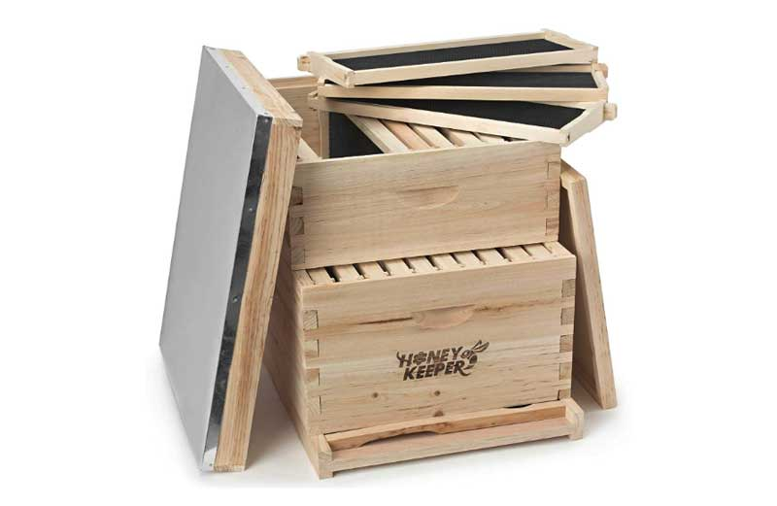
23 | Growing hives | 315 | Miniature bee box. Includes frames.
24 | Nuc boxes | 210 | 5 frames should be included. 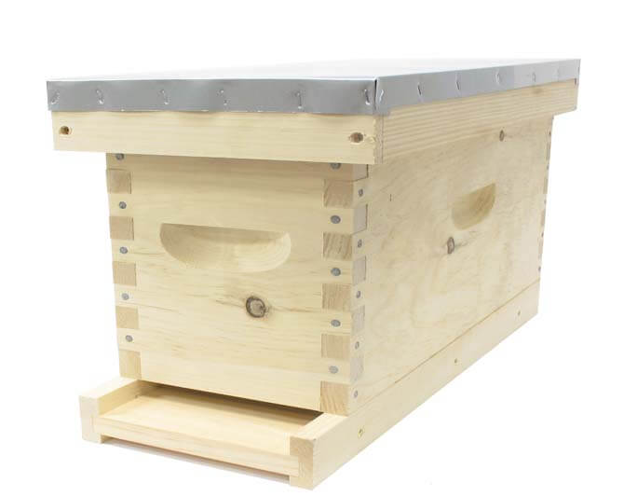
25 | Straw mats | 255 | 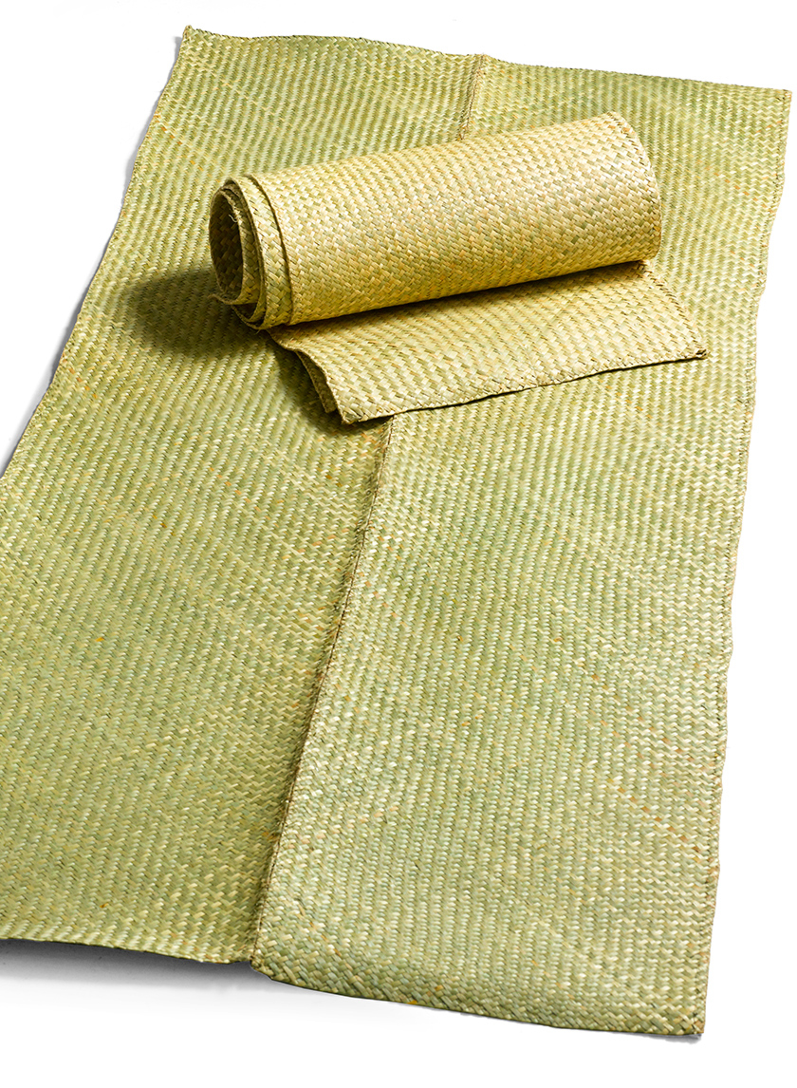
26 | Hive stand | 180 | Metal stand to elevate bee hives.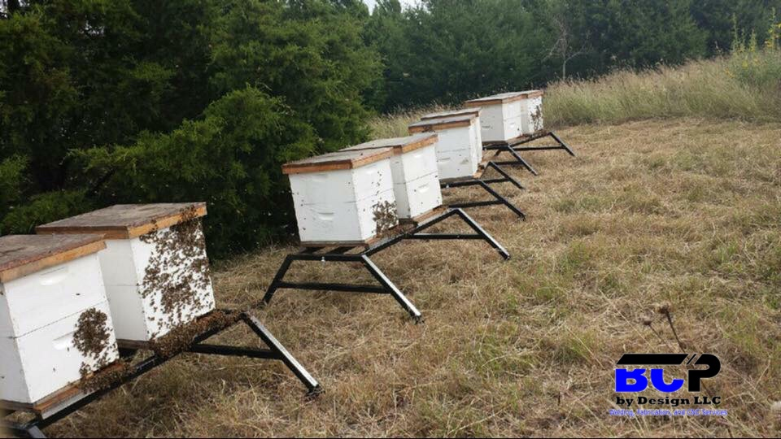
27 | Transformer | 30 | Please call if you have questions on this.  جهاز تسليك الاطارات  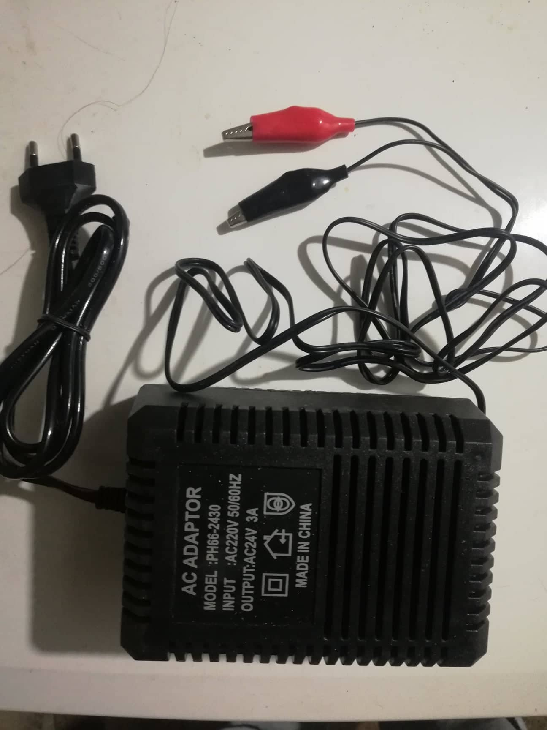
28 | Moisture meter | 5 | Also called a honey refractometer. 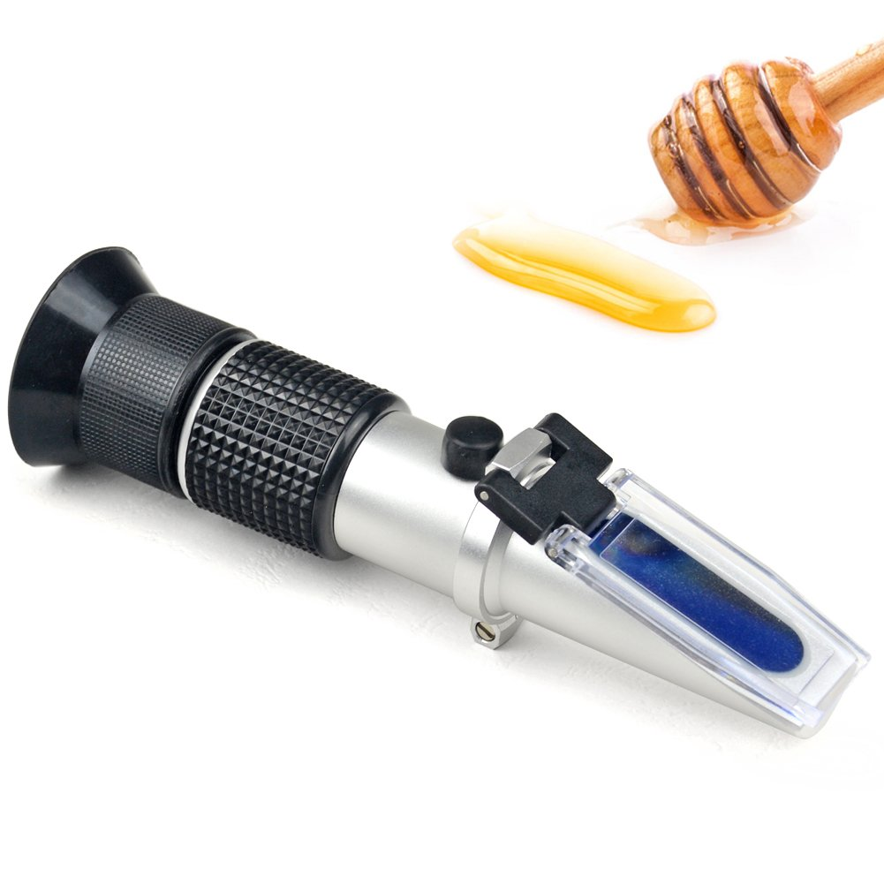
29 | Hive transporter | 2 | 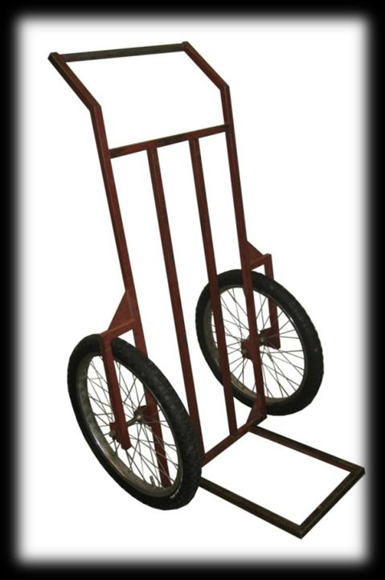
30 | Schley Harbo Syringe | 2 | A queen bee insemination instrument.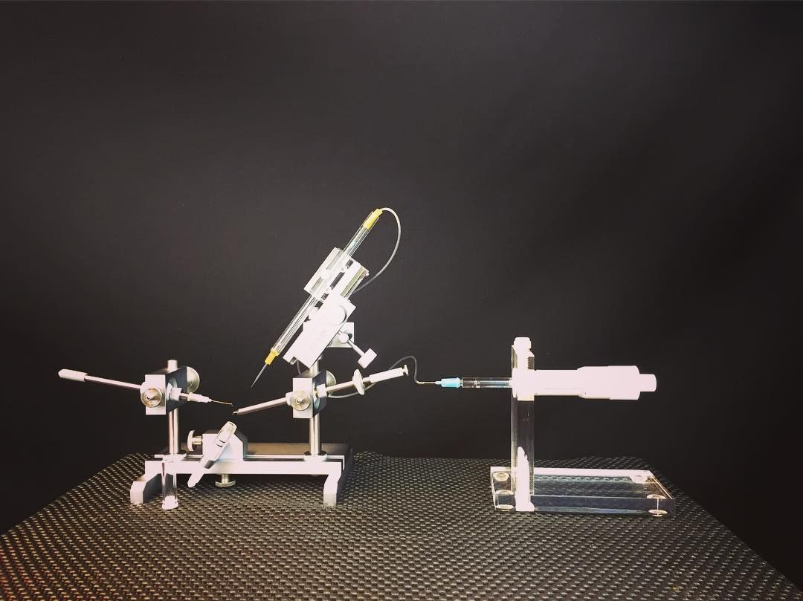
31 | Queen rearing frames with Jenter cells | 46 | 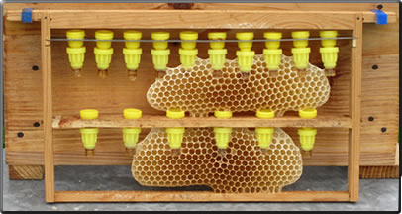
32 | Royal Jellyالغذاء الملكية | 46 | Queen bee food. Smallest size container (16 grams?)
33 | Queen pheromones | 46 | Plastic strips that are impregnated with queen bee pheromones. Require careful handling.  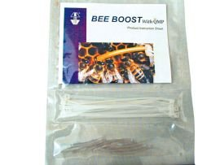
34 | Grafting tool | 46 | 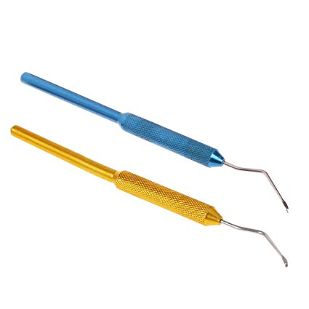
35 | Plastic pollen trap | 46 | This goes inside the hive. There are variations. Whatever the local brand is will work!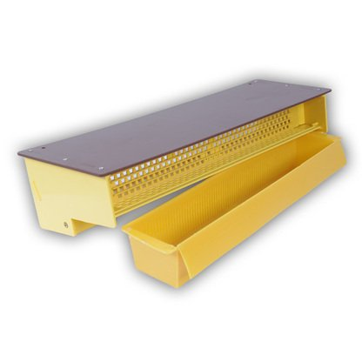
36 | Jenter kit | 2 | 