Call for
Expression of Interest
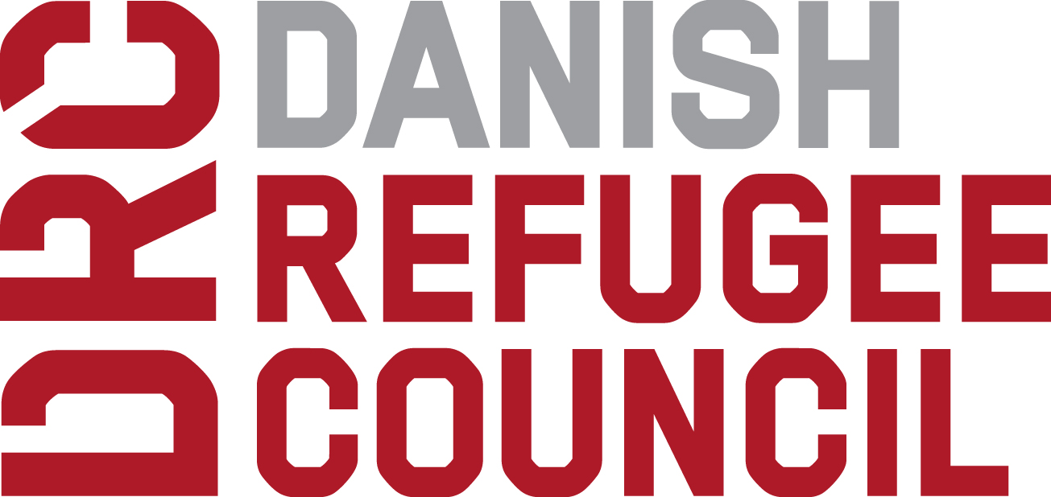

Danish Refugee Council
Office Address: Ninawa-Zummar Closest to Al Salam Mosque
Phone number: NA

15 Jan 2020

To: ________________________________

Expression of Interest No.: EOI001MOS2020 – For Financial Service Provider

Dear Sir/Madam:

DRC is providing support to displacement-affected communities in Tel Afar, Ninewa in order to have enhanced resilience through improved basic services, community-based protection and socio-economic self-reliance support.

This Expression of Interest (EOI) process is the first stage of a multi-stage process. DRC intends to distribute staff salaries and vehicle car hire rental fees up to a total monthly value of 145,000,000 IQD through one or more FINANCIAL SERVICE PROVIDERS (FSPs). The FSPs passing the evaluation of the EOI will be invited to participate in a Request For Proposal (RFP).

The goal is to disburse staff salaries within close proximity to their location of work within Ninewa at the end of every month, in areas which do not have banks. It also intends to provide flexibility for staff to withdraw cash at their leisure, at a time that suits them. The transfer should take in to consideration staff safety so that monthly withdrawal need not be 100% at one time, and staff should not be able to know when each member cashes their salary. This will cover all DRC’s program sector and support staff: Shelter and Infrastructure, Livelihoods, Protection, Community Engagement, Supply Chain, Finance, and HR.

DRC seeks the EOI from different FSPs to provide their services in the implementation of DRC’s Cash Transfer Programme (CTP). Selected institution(s) will be required to provide the most effective and efficient cash delivery mechanisms CTP modalities.

Options to deliver cash can be, but not limited to:

- Direct cash distribution through money transfer agents / microfinance agents
- Cheques / cash distribution through branches available in the intervention areas
- Prepaid / Debit / Smart cards
- Mobile money

DRC invites qualified FSPs to submit their EOI before the deadline as stipulated in the section below.

EOI DETAILS

The EOI details are as follows:

Line | Item | Time, date, address as appropriate
1 | Call for Expression of Interest published | 16 January 2020
2 | Briefing on EOI | 21 January 2020 – 11 :00 AM @ Erbil DRC head Office
3 | Closing date for clarifications | 27 January 2020 – 12PM
4 | Closing date and time for receipt of EOI | 30 January-2020 11AM
5 | EOI Opening Location | MRF Towers, Tower A floor 10, Meeting room
6 | EOI Opening Date and time | Feb 2,2020 – 10:00AM

WHO SHOULD APPLY?

Any company interested in becoming a Financial Service Provider (FSP), with demonstrated experience in cash transfer programme in Iraq or technical, managerial and financial capacity to execute the cash transfer programme, are encouraged to apply.

QUERIES ABOUT THIS EOI

For queries on this EOI, please contact the Procurement Manger, daniel.ambaw@drc.ngo

All questions regarding this EOI shall be submitted in writing to the above. On the subject line, please indicate the EOI number. EOI responses shall not be sent to the above email.

All questions during the EOI period, as well as the associated answers, will be shared with all invited FSPs, or for open Calls for Expression of Interest published at: NCCI We site

BRIEFING SESSIONS

An EOI briefing session will be held on Monday 21 January 2020 at DRC Office, Erbil, MRF Tower A, Floor 10 at 10am, for all interested parties to attend.

The objective is twofold:
- For DRC technical staff to give an overview of the requirements and expectations of the FSPs, including types of contracts etc. to be entered into.
- To allow potential service providers the opportunity to further understand the DRC requirements and ask questions to clarify the program and or the application process.

All questions and answers covered at the EOI briefing session will be sent to all parties who attend the meeting.

A copy of the questions and answers can be requested from:

All costs associated with attending the EOI briefing session are on the individuals account.

SELECTION CRITERIA

The following criteria will be used to evaluate this EOI:

Criteria # | Criteria description | Weighting in evaluation  [Total 100%]
1 | Network and outreach to the areas for DRC programs | 35%
2 | Experience and technical capacity in similar projects | 35%
3 | Financial capacity | 10%
4 | Legal status and other necessary approvals required by the Government | 20%

Please note that EOI submissions shall respond to all criteria, or they may be disqualified.

EOI SUBMISSION

Your EOI submission must contain the following documents:

# | Annex # | Document | Instructions
1 | A | EOI Application Form | Complete ALL sections in full, sign, stamp and submit
2 | C | DRC Supplier Code of Conduct | Sign, stamp and submit
3 | B | Supplier Profile and Registration Form | Complete ALL sections in full, sign, stamp and submit
4 |  | Any other document required to validate the information submitted in the DRC Supplier Profile and Registration Form (i.e. Company Registration, audit reports, etc.)

FSPs invited for the Request for Proposal will be asked to submit their financial proposal. Financial proposals should not be submitted with the EOI.

Email submission

EOI submissions can submitted by email to the following dedicated, controlled, & secure email address:
tender.irq.osm@drc.ngo

This address should not be used for any other correspondence and questions to this address will not be answered.

When submissions are emailed the following conditions shall be complied with:

- The EOI number shall be inserted in the Subject Heading of the email
- Required documents shall be included as an attachment to the email in PDF, JPEG, TIF format, or the same type of files provided as a ZIP file. Documents in MS Word or excel formats, will result in the submission being disqualified.
- Email attachments shall not exceed 4MB; otherwise the FSP shall send his EOI response in multiple emails.

Failure to comply with the above may disqualify the EOI submission.

DRC is not responsible for the failure of the Internet, network, server, or any other hardware, or software, used by either the Bidder or DRC in the processing of emails.

DRC is not responsible for the non-receipt of EOI submissions by email as part of the e-Tendering process.

Hard Copy
Hard copy EOI submissions shall be placed in a sealed envelope, marked as follows:
EOI No.: EOI001ZUM2020
Company Name: ________________________

To: Mosul / Al-Noor Neighbourhood,
Close to Thi- Alnoreen Masjed,
36.366956, 43.183317.

Bids can be submitted in one of two ways; hardcopy or electronically. If the Bidder submits a Bid in both Hardcopy and electronically, DRC will choose the version that is the most advantageous to DRC.

REVIEW OF EOI SUBMISSIONS

The review of all EOI submissions will be done by Feb 16,2020 (Tentative). Those accepted as DRC FSPs will then be sent a ‘Request For Proposal’ (RFP) to complete and submit to DRC as a formal Tender.

The outcome of the review process will be advised to all those who submit EOI submissions by Feb 14,2020 (Tentative).

DRC will not be liable for any costs incurred by applicants through participation in the EOI process.

Under DRC’s Anticorruption Policy all parties shall observe the highest standard of ethics during the procurement and execution of such contracts. DRC will reject a Bid if it determines that the Bidder recommended for award, has engaged in corrupt, fraudulent, collusive, or coercive practices in competing for, or in executing, the Contract.

DISCLAIMER
DRC is not committed contractually in any way to those applicants whose applications are accepted.

While the information contained in this request for EOI has been formulated with all due care, DRC does not warrant or represent that the information is free from errors or omissions. The information is made available on the understanding that the DRC and its respective employees and agents, shall have no liability (including liability by reason of negligence) for any loss, damage, cost or expense incurred or arising by reason of any person using or relying on the information and whether caused by reason of any error, omission or misrepresentation in the information or otherwise.

We look forward to your participation.

Yours sincerely

ANNEX A

EOI Application Form

INTRODUCTION

Brief Introduction of Financial Service Provider
Please write short description about your organization/company (1 page).

Networking / Outreach:

Total number of branches/service centers/franchises in Iraq or Ninawa: ____________ (Please attach the list)

Total number of branches / service centers / franchises in DRC’s Targeted areas are: ____________ (Please attach the list)

Total Number of ATMs in COUNTRY_______________________________ (Please attach the list)

Total Number of ATMs in DRC’s Targeted AREAS: _____________________ (Please attach the list)

Total Number of Agents and / or Cooperatives in COUNTRY _______________________________ (Please attach the list)

Total Number of Agents and/or cooperatives in Ninewa: _____________________ (Please attach the list)

Any other additional information about your network/ outreach:

If you do not have any delivery points, outreach, networking in the selected districts how would you rapidly respond and distribute cash?

Do you already have access to required technology for cash distribution / ecard or would you need to develop new solutions / implement or adapt or rent through third party? How long it will take for you to setup? If required technology is available then please include a complete details of process used for cash distribution.

Experience in Cash Transfer Programme
Please write short description about your experience in Cash transfer programme / cash distribution in Iraq or any other country. Please attend to the following questions too.

Do you have experience in Cash Transfer Programme? If yes, please list down the clients you are working with on cash transfer programme / Cash distributions including payment methods / minimum & maximum transactions / speed (how long does it take to reach to 100 / 500 / 2000 people).

Please tell us with whom (services / partners) you have worked with in cash transfer process e.g. any remittance company, mobile company, any government department, etc.

Do you have any working experience with DRC? If yes, please describe this experience below (completed projects and / or ongoing projects):

If you have no experience in Cash Transfer Programme, would you be interested in possible future involvement? Please describe your interest.

What are the minimum and maximum amounts of funds you can disburse in a day?

How many transactions can you disburse in a day at a single site?

Will you be able to open Client account (in case of banks/ money transfer agents); please state what documents are required and how long it will take to open Client account? What flexibility can you offer in the case if the beneficiaries have lost their documents?

What are the minimum document required from the clients?

Services provided by your organization
Please list down the type of services your organization is currently providing in COUNTRY i.e. banking, branchless banking, E banking, E cards Mobile money transfers, etc.

Role
How would you see your role and how would you deliver cash to affected communities in a given context (in addition to your core business, would you see a role for example in fraud controls, security, training, IT, management reports, communications, reconciliations and financial inclusion, etc.)?

Additional information
Please add any additional information you want to add in this EOI.

