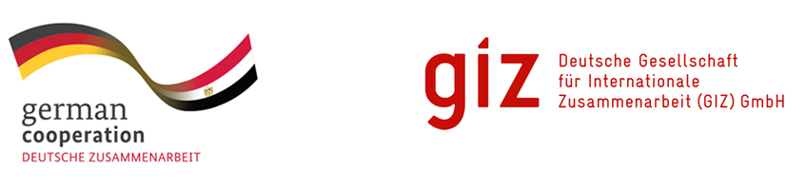
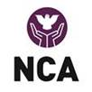

Terms of References (TOR’s) for Project Final Evaluation

Project title: | Water and Cash for Work - Telkaif (C1, C3)
Project duration: | Till April 30th, 2020
Overall Project budget in EUR | 2.800.000 EUR
Geographical Area Covered: | Telkaif, Alqosh, and Wana
GPS coordinates for intervention (CFW Project) | Jarahiyah, Kavrok, Ain Baqar, Al-Qawseyat, Alqosh, Badriyah, Babire, Baaweza, Beyban, Bozan, Jagan, Msherfa, Chrkhan, Dakan, Dashqotan(Dost qatil), Dersteen, Doghat, Galata Farhan, Karanjok, Khatare, Khoshaba, Masqalat, Nuferiyah, Nusariyah, Sada, Shalalat, Shekhka, Sandanic Olya, Sandanic Sofla, Sreshka, Tlsin, Telkaif, Telsquf, Wana.

Contents
1. NCA’s INTRODUCTION: 3
2. BACKGROUND & CONTEXT OF THE PROJECT: 3
3. OVERALL OBJECTIVES, OUTCOMES & ACTIVITIES OF THE PROJECT: 4
4. PURPOSE OF THE EVALUATION STUDY: 5
4.1 SCOPE OF THE EVALUATION STUDY: 5
4.2 COVERED AREA-MAP OF THE PROJECT: 5
5. DUTIES/TASKS & EXPECTED OUTPUT OF THE ASSIGNMENT: 5
5.2 DELIVERABLES/OUTPUTS: 6
6. QUALIFICATIONS OF THE FIRM/INDIVIDUAL CONSULTANT: 6
6.1 PROFESSIONAL EXPERIENCE: 6
7. SUPERVISORY ARRANGEMENTS: 7
9. PAYMENT SCHEDULE AND METHOD: 7
10. SUBMISSION OF THE DETAIL PROPOSAL: 7
10.1 TECHNICAL PROPOSAL: 7
10.2 Financial Proposal detailing the following: 8
11. HOW TO APPLY: 8

1. NCA’s INTRODUCTION:
NCA-Norwegian Church Aid is a Norwegian humanitarian organization with headquarters in Oslo. Norwegian Church Aid works together with people and organizations across the world to eradicate poverty and injustice. NCA is a member of ACT Alliance-one of the largest humanitarian alliance. NCA provides emergency assistance in disasters and works for long-term development in local communities. To address the root causes of poverty, NCA advocates for just decisions by public authorities, business and religious leaders.

2. BACKGROUND & CONTEXT OF THE PROJECT:
NCA has been working in Iraq since 2014 and has implemented WASH emergency activities to improve the condition of life of IDPs living in camps and to support the hosting communities. NCA is also implementing projects on Gender-Based Violence (GBV) and Peace and social cohesion in Iraq.
After the initial emergency phase, NCA broadened its focus to include interventions to the ‘Rehabilitation and Stabilization Phase’. In this regard, NCA pursued the donors to support focusing on the improvement and rehabilitation of water supply infrastructures (rehabilitation of boreholes, pipelines, etc.).
In 2019, NCA and GIZ, German Agency for international cooperation, decided to focus on recovering the economic condition of the local populations and returnees with a project including two components: rehabilitation of water supply infrastructures and support to existing or new commercial enterprises (Livelihood Activation Grants).
The project has two major components namely; CFW-Cash for work and LAG-Livelihood Activation Grants. CFW-Cash for wok focuses on the restoration of drinking water infrastructure. Through the Cash for Work component, 1300 HHs for CFW have been targeted in 32 villages in TelKaif, Wana and Alqosh Sub Districts, Northern Ninewa Governorate. Each beneficiary has worked for 40 days for the remuneration of $800 for this period. The beneficiary selection was done through vulnerability assessments and priority was given to the extremely vulnerable (Women HH, Single parents, Divorced, Disables and elderly HHS). The selected beneficiary had to sign a contract with NCA and agreed with terms and conditions for the CFW in his/her respective village.
For water infrastructure projects, NCA also hired/recruited skilled workers for the restoration of drinking water infrastructure as per need. The skilled workers were identified and hired based on their abilities and technical skills to complete the task/work.
The LAG component LAG was designed to support the restoration of livelihoods and to support the local economy in a post-conflict context. Under this activity, 232 HHs were selected, one beneficiary from each HH from the three targeted districts (Telkaif, Alqosh, and Wana) through a preliminary vulnerability and viability assessment.
The priority was given to existing Small and Medium Size Enterprises (SMEs). 232 selected beneficiaries attended two days of training on basic enterprise development and business management skills. Selected beneficiaries received start-Up capital between $1000 and $2500 per person depending on their needs and capacity that were expressed in an individual business plan.

3. OVERALL OBJECTIVES, OUTCOMES & ACTIVITIES OF THE PROJECT:
3.1 OVERALL OBJECTIVES:
The overall objective of the project is to ensure access to an adequate quantity of safe drinking water supplied through newly constructed or rehabilitated permanent water distribution infrastructures and to restore the living conditions supporting the local economy.
3.2 OUTCOMES AND ACTIVITIES:
Outcome 1: 200,000 inhabitants in the selected villages have access to the appropriate quantity of safe drinking water through the improved/rehabilitated water distribution networks.
Activity 1.1: The water supply schemes in 32 villages to be rehabilitated through Cash for Work
Activity 1.1.1: Rehabilitation and/or improvement of the drinking water supply networks in a minimum of 32 villages.
(Under this component NCA employed 1300 Vulnerable HHS as CfW: = 1,300 daily workers work for cumulative 52,000 working days with $800 per day per worker)
Outcome 2: Minimum of. 232 beneficiaries in the selected villages will profit from an upgraded economic environment
Activity 2.1: 232 beneficiaries to have Livelihoods activation grants (LAG)
Activity 2.1.1: Microeconomic assessment in the target area to stipulate the wider range of LAGs
Activity 2.1.2: tailor-made selection criteria for the LAGs are being established
Activity 2.1.3: 232 Livelihood Activation Grants are to be awarded
(Under 2nd component NCA has awarded Livelihood Activation Grant to 232 HHs as LAG: = per Entrepreneur $1000 - $2500 as per their need and capacity. The grant was aligned to their business plans and budgets submitted)

4. PURPOSE OF THE EVALUATION STUDY:
The CFW project has been implemented in three targeted Sub-districts Alqush, Telkaif, and Wana in Northern Iraq. The overall objective of this evaluation study is to assess the worth of GIZ Funded NCA’s CFW intervention in the post-conflict context in targeted districts in Iraq. The study aims to draw lessons learned and document best practices adopted during implementation, success factors, encountered challenges and concrete recommendations to design other livelihood projects in the next future. Within the framework of the project, the “selected individual Expert/company”, in coordination with NCA Iraq, shall provide specialized expertise in conducting the evaluation study of the project “Water and Cash for Work - Telkaif (C1, C3)”

4.1 SCOPE AND FOCUS OF THE EVALUATION STUDY:
The valuation study will cover all the key areas and the major components of the NCA’s CFW Project in Iraq. Through the final study following areas will be carefully assessed:
Project Relevance:
- Assess CFW project's design, the methodology adopted, target groups, focus, and Context to get more insights on the relevance of the project implemented
Impact of the Project:
Assess the change in the lives and livelihoods of the direct and indirect beneficiaries. This includes
- The number (and %) of grant recipients that report a stabilization on the household level.
- The number (and %) of grant recipients that can generate their income at the basis of the support provided.
- The number (and %) of Vulnerable (Women HH and Disables) of all activities that indicate that their access to income has improved.
- # Of People Access to safe drinking water in the targeted villages.
- The number of functional and viable enterprises established through grants
- Assess the local market to see any changes due to Livelihood Activation grants and cash for work- CFW component.
Effectiveness and efficiency:
- Assess Project Management and Implementation Process and approaches used
- Assess the Project management tools and budgeting/costing methods/planning tools etc.
- Assess internal control mechanisms etc. Financial, Procurement, Logistics, fleet management, and warehouses mechanisms.
- Assess the available Monitoring and Evaluation mechanism and capacity of the organization for cash for work and livelihood programs.
Sustainability of the Project:
- Assess Continuation of efforts includes (Phase-out Plans, Maintenance mechanisms for cash for work schemes, exit strategy, etc.)
Stakeholders Management Mechanisms:
- Assess stakeholders’ level of engagement and Implications in the project. The relevant local stakeholders level of communication, sharing information mechanisms and coordination mechanisms, etc.
Cross-Cutting Themes:
- The capacity and used approaches to address the cross-cutting themes, like gender and disability, will be assessed in the final evaluation study.
The study should cover both outcomes with each relevant indicators and activities to assess the overall success and achievements. The consultant will design the study framework, tool for data collection, methodology, and scope for the final study and submit to NCA staff before the inception of the actual work on the ground.

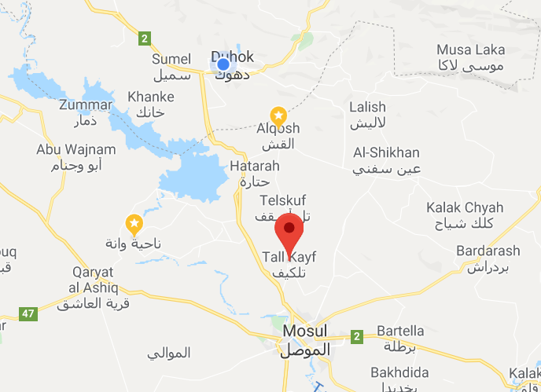
4.2 COVERED AREA-MAP OF THE PROJECT:

5. DUTIES/TASKS & EXPECTED OUTPUT OF THE ASSIGNMENT:
5.1 DURATION OF THE STUDY:
The duration of this study is one month starting indicatively/tentatively from (25th March 2020) and ends on (27th April 2020)

5.2 DELIVERABLES/OUTPUTS:
a) Inception Report will be drafted and shared with NCA Office for review and approval
Deadline for submission: (18th March 2020)
b) Design the study questionnaire and submit it to the NCA office for review and approval
Deadline for submission: (1st April 2020)
c) Detail methodology of the study needs to write and submitted to NCA for approval
Deadline for submission: (1st April 2020)
d) Details of human resource, logistics and work plan required to be submitted NCA office
Deadline for submission: (1st April 2020)
e) Conduct Study and Final Evaluation Study Report including (Executive Body, Methodology, Tools, FGDs details, lessons learned, Best Practices, recommendations, and all relevant annexure, etc.)
Deadline for submission: (26th April 2020)
f) Presentation of the main results, key lessons learned best practices, success factors, and recommendations.
Deadline for submission: (27th April 2020)
g) Final Evaluation Study Report including (Executive Body, Methodology, Tools used, FGDs details, key results analysis, Lessons Learnt, Best Practices and recommendations)
Deadline for submission: (27th April 2020).

6. QUALIFICATIONS OF THE FIRM/INDIVIDUAL CONSULTANT:
The “selected individual Expert or company” shall have the following minimum qualifications to be considered for this consultancy:

6.1 PROFESSIONAL EXPERIENCE:
- In the case of a firm, it should be legally registered and prove to have at least five years of work experience in conducting livelihood related evaluations in a relevant context.
- Significant experience in Iraq or similar volatile context, familiar with the agriculture, local markers and drinking water management systems.
- At least 5 years of increasingly responsible management of complex projects, specifically on cash for work, enterprise development, and other livelihood activities in a similar context.
- Proven experience, expertise and capacity in terms of conducting project end-line evaluations against the set indicators and outcomes.
- Proven record of similar assignments and demonstration of experience in similar projects through concrete examples; (Need to submit final study samples)

7. SUPERVISORY ARRANGEMENTS:
NCA Office in Erbil/Dohuk Iraq will:
- Supervise the overall process and all the activities carried out within the framework of the Contract for the evaluation study.
- Provide suggestions on the approaches for the works and the arrangements.
- Regularly monitor the effective and timely implementation of the contract tasks.
- Review and approve the list of human resources, material, planning, and methodology.
- Review all final deliverables for each task making suggestions and requesting revisions where necessary
8. FACILITIES TO BE PROVIDED BY NCA (if any)
- NCA will provide all the necessary support including access to the project area and meetings with the local authorities

9. PAYMENT SCHEDULE AND METHOD:
- NCA Iraq will make all payments through bank transfer only. The payments will be made in line with the deliverables and deadlines as follows:
Milestones | Required deliverables | Installment Amount (%)
Milestones-1 Completion of Initial Deliverables | Submission of work plan, and resource mobilization, Inception Report, Tool, Submit methodology, work plan, study basic framework, etc. | 50%
Milestones-2 Conducting Study and submission of Final Report with all annexures | Final Study report with all annexures and presentation on key results, lessons learned, success factors, and recommendations | 50%

10. SUBMISSION OF THE DETAIL PROPOSAL:

10.1 TECHNICAL PROPOSAL:
- Maximum of 4- 5 pages outlining the Consultant(s)' understanding of the TOR and the proposed methodology to conduct the assignment, including techniques, approaches, and tools to be used)
- A proposed activities schedule/work plan with time frame and responsibility.
- Human Resources- CV of consultant and data collection and supporting team specifying the roles and responsibilities of each team member.
- Two samples of similar previous assignments (Final Study Reports)

10.2 Financial Proposal detailing the following:
- Itemized fees and costs - consultant should indicate professional rates and time input for each team member
- A complete budget for the said assignment including stationary, logistics, transportation, etc.
- Candidates/firms should consider that the budget would cover approximately 30 days (One Month) from March-April 2020

11. HOW TO APPLY:
- Interested candidates/companies should submit a detail technical and financial proposal along with two samples of similar previous assignments, work plan and CVs of the experts and data collection team no later than (18-03-2020)to email: nca-nikr-office@nca.no Norwegian Church Aid Duhok – Kurdistan Region of Iraq, Subject : External Consultant

NOTE: Applications received after the deadline will not be considered for any review.

