ANNEX A.1
VEHICLE DETAILS AND DESCRIPTIONS
LOT # 1
Name: Sedan Car Lot #1
Brand: Chevrolet | Make Year: 2013 | Model: Chevrolet Malibu LS
Chassis Number: KL1GJ5DU4DB006360 | Colour: White | Registration number: Erbil-317795
Engine Number: N/A | Driven KM: 133541 | Present Vehicle Location: Baghdad, Iraq

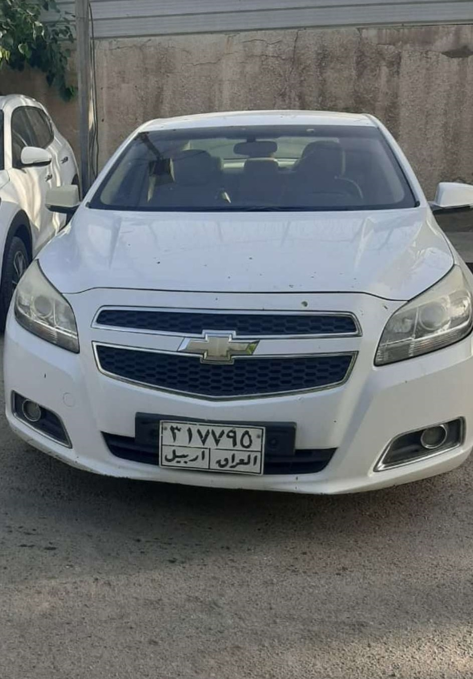

LOT # 2
Name: Sedan Car Lot #2
Brand: Toyota | Make Year: 2009 | Model: Toyota Camry
Chassis Number: 4T1BE46K19U299297 | Colour: Gray | Registration number: Erbil-220184
Engine Number: N/A | Driven KM: 142194 | Present Vehicle Location: Erbil, Iraq

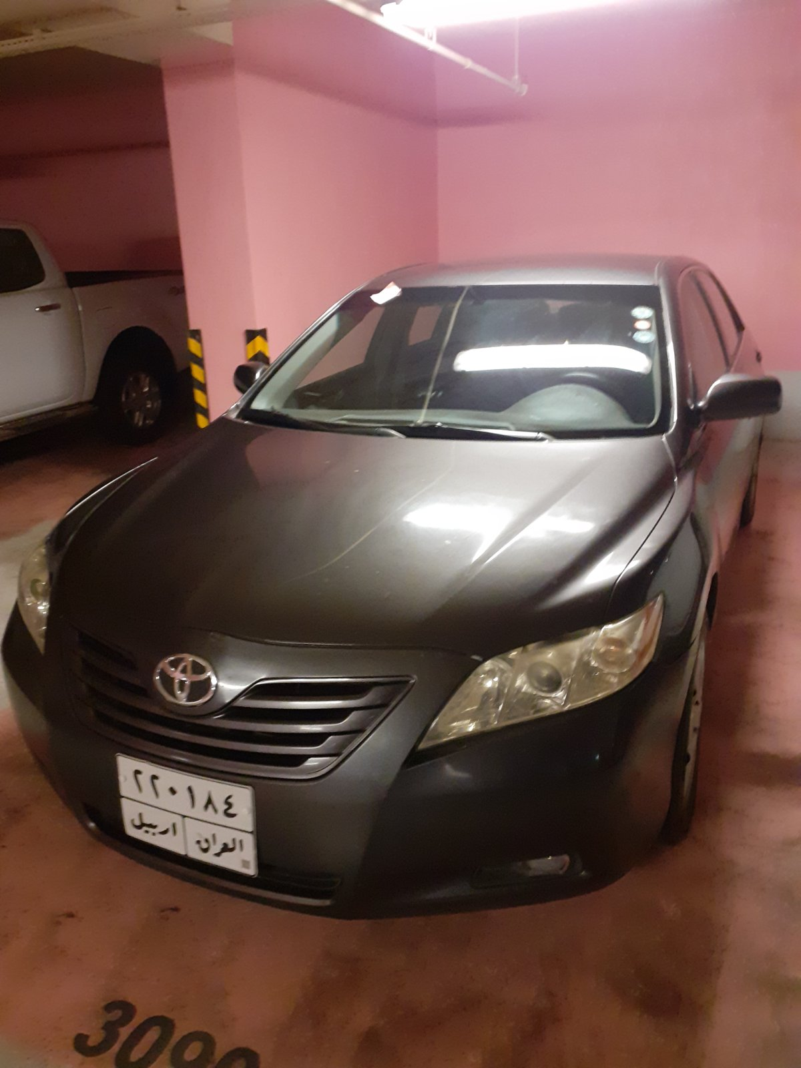

LOT # 3
Name: Sedan Car Lot #3
Brand: Toyota | Make Year: 2009 | Model: Toyota Corolla
Chassis Number: JTDBZ42E69J012935 | Colour: White | Registration number: Erbil-153732
Engine Number: N/A | Driven KM: 151000 | Present Vehicle Location: Erbil, Iraq
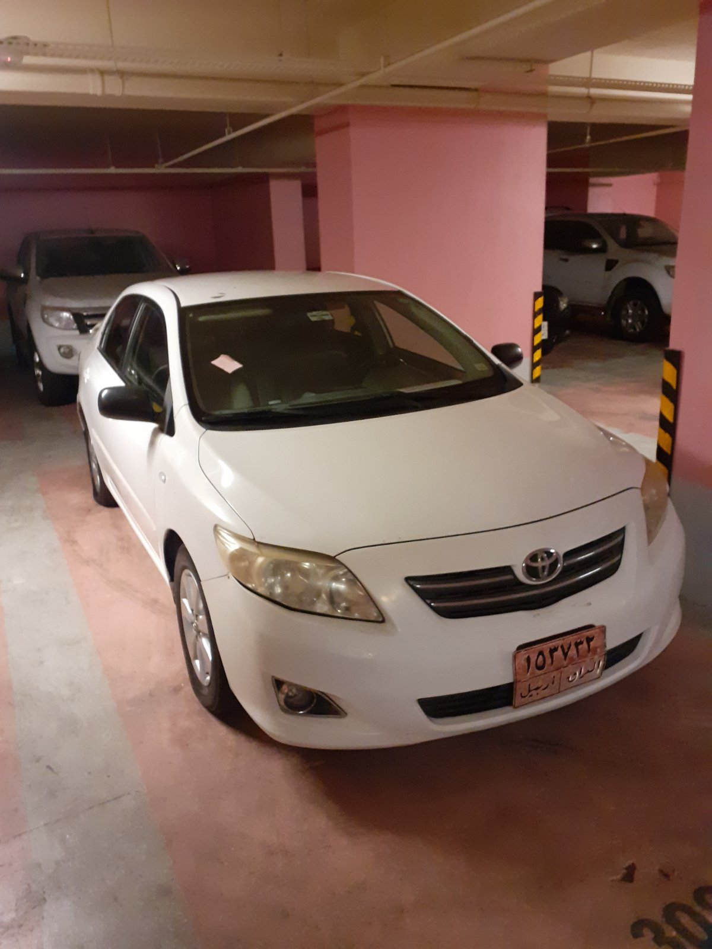

LOT # 4
Name: Sedan Car Lot #4
Brand: Chevrolet | Make Year: 2013 | Model: Chevrolet Malibu LS
Chassis Number: KL1GJ5DU6DB006523 | Colour: Silver | Registration number: Erbil-317636
Engine Number: N/A | Driven KM: 84691 | Present Vehicle Location: Erbil, Iraq
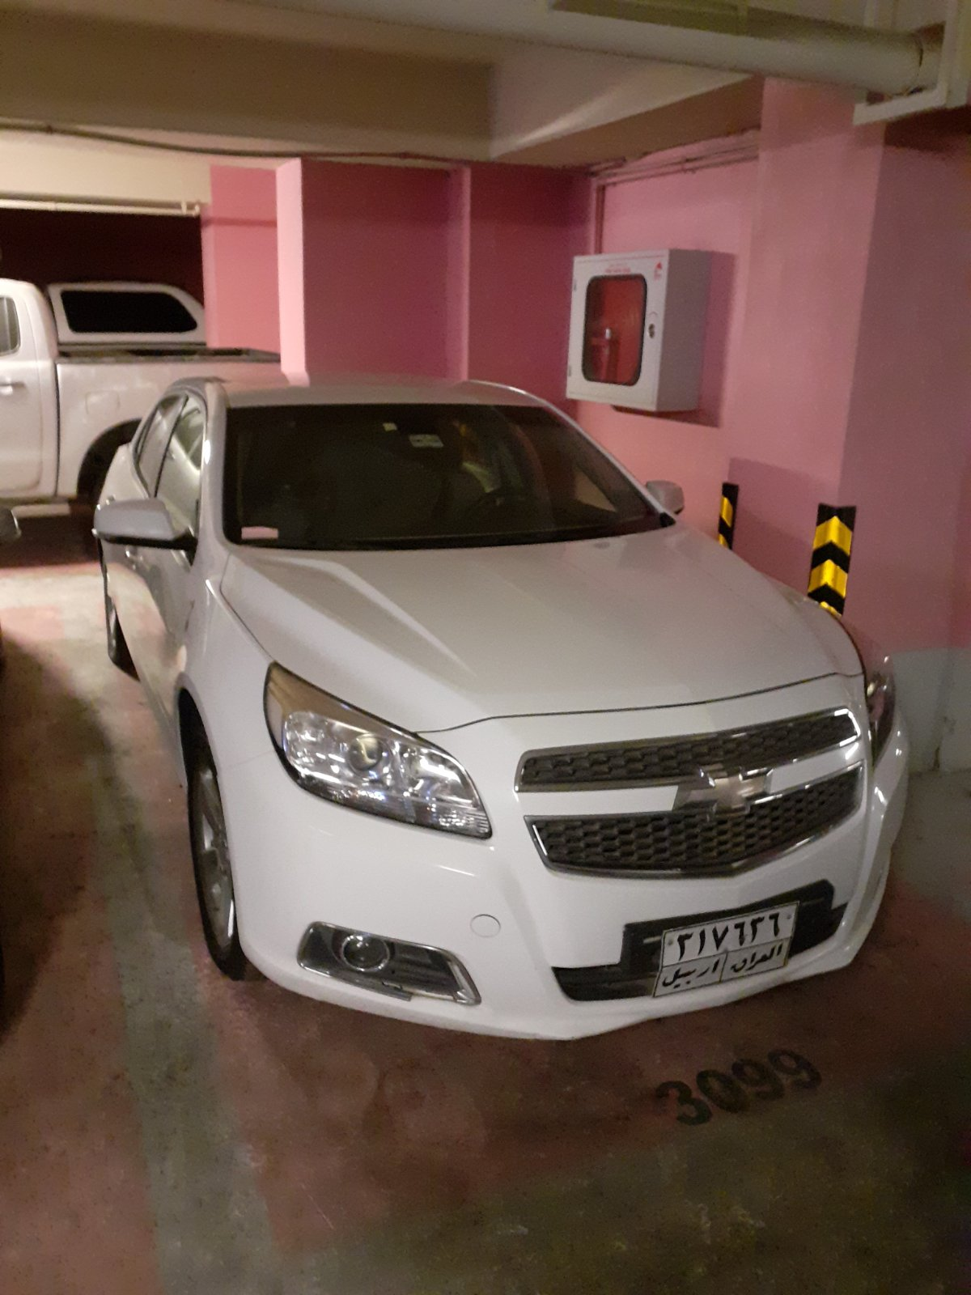

LOT # 5
Name: Sedan Car Lot #5
Brand: Chevrolet | Make Year: 2013 | Model: Chevrolet Malibu LS
Chassis Number: KL1GJ5DUXDB000451 | Colour: Silver | Registration number: Erbil-317652
Engine Number: N/A | Driven KM: 118764 | Present Vehicle Location: Erbil, Iraq
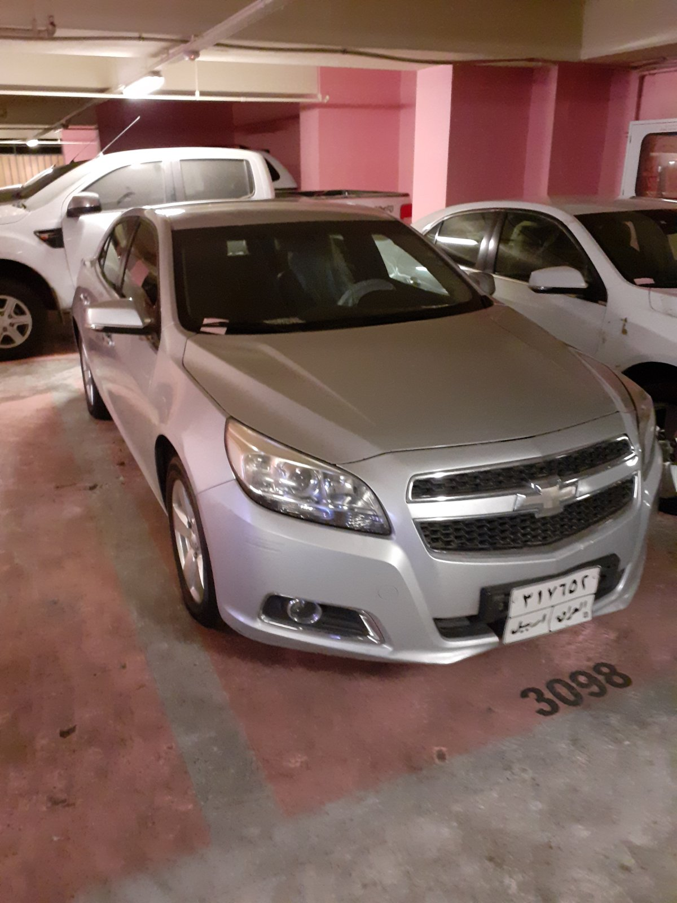

LOT # 6
Name: Minivan Car Lot #6
Brand: Toyota | Make Year: 2017 | Model: Toyota Haice
Chassis Number: JTGSX23P4H6178711 | Colour: White | Registration number: Erbil-42946
Engine Number: N/A | Driven KM: 13415 | Present Vehicle Location: Erbil, Iraq

