SPECIFICATIONS SHEET
Office, Center, and Housing Furnishings Supply and Installation Tender
Duhok (Ba’adre)
NO | Item Description | QTY | UOM | Picture
1 | Rectangle table desk for two persons  Dimensions: 155cm x 60cm x 75cm (LxWxH)  Legs: 2 T-legs with 4 locking wheels  Color: Neutral (gray, black, white, wood) | 26 | pc
  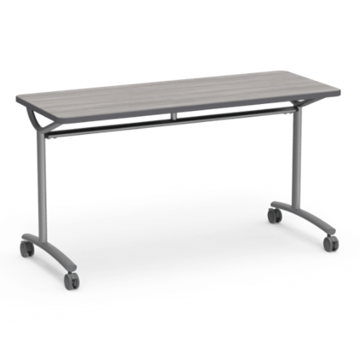
2 | Student chairs  Material: Polypropylene plastic seat, comfort fit  Seat height: 45cm  Legs: 4 tubular steel legs, stackable, felt or metal glides to protect floors  Color: Black, gray, dark green (no blue) | 80 | Pc | 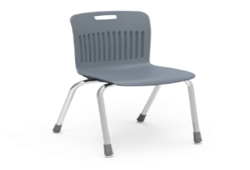
3 | Teacher desk with drawer unit  Dimensions: 140cm x 60 cm x 75cm (LxWxH)  Color: Neutral (gray, black, white, wood)  Built-in storage with 3-5 drawers+C5:C7 | 5 | pc | 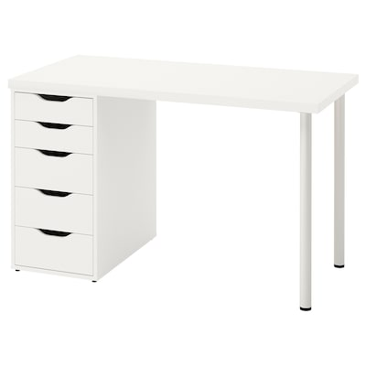
4 | Mobile teacher podium  Dimensions: 55cm x 40cm x 115 cm (LxWxH)  Color: Neutral (gray, black, white, wood)  Includes underneath shelf and lockable wheels | 3 | pc | 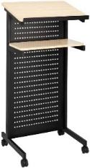
5 | Bookcase with 4 shelves  Dimensions: 80cm x 30cm x 155cm (LxWxH)  Color: Black brown | 2 | pc | 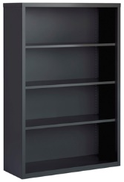
6 | One-person desk table, no wheels  Dimensions: 100cm x 60cm x 75cm (LxWxH)  Legs: 2 or 4 legs, no wheels  Color: Neutral (gray white, black, wood) | 12 | pc | 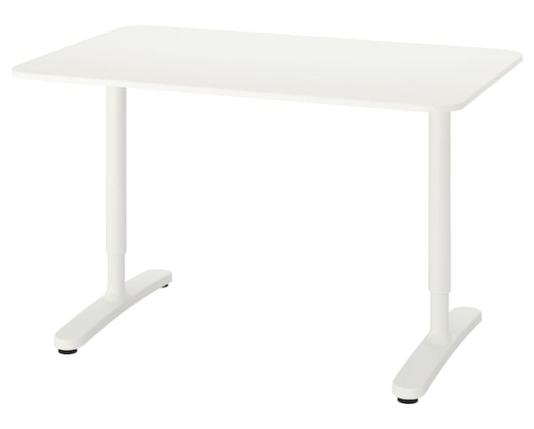
7 | Large work table for fabric cutting  Dimensions: 185cm x 92cm x 95cm (LxWxH) | 2 | pc | 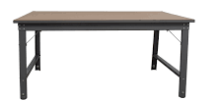
8 | Craft storage cart  Material: Metal frame with plastic bins  8-12 clear white plastic drawers | 1 | pc | 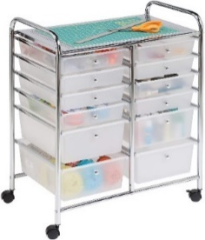
9 | Projector screen with tripod stand  Dimensions: 220cm x 125 cm  16:9 aspect ratio  Front Projection  Premium white matte fabric | 2 | pc | 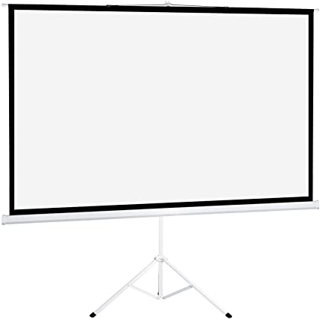
10 | Rectangle activity table for children 6-12 years  Dimensions: 155cm x 76cm (LxW)  Adjustable legs (55-75cm), no wheels, felt or metal glides to protect floors  Color: Light wood  Seats 6 children | 2 | pc | 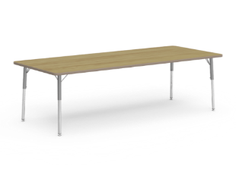
11 | Circle activity table for children 6-12 years  Dimensions: 120cm diameter  Adjustable legs (55-75cm), no wheels, felt or metal glides to protect floors  Color: Light wood  Seats 6 children | 2 | pc | 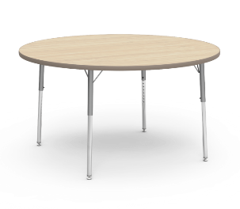
12 | Classroom chairs for students 6-12 years  Material: Polypropylene plastic seat, tubular steel legs, stackable, felt or metal glides to protect floors  Seat Height: Child (35-38cm)  Color: Black, gray, dark green (no blue) | 30 | pc | 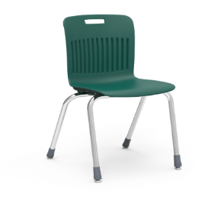
13 | Bookcase with 3 shelves  Dimensions: 80cm x 30cm x 110cm (LxWxH)  Color: Light brown wood | 1 | pc | 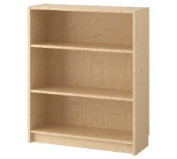
14 | Toy storage unit with 9 clear storage bins  Dimensions: 105cm x 45cm x 70cm (LxWxH)  Color: Light brown wood | 1 | pc | 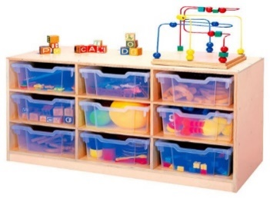
15 | Book display for children's books  Dimensions: 76cm x 26cm x74cm (LxWxH)  Color: Light brown wood  4-5 shelves for books | 1 | pc | 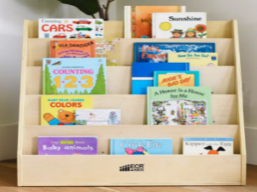
16 | Storage cabinet with lockable doors and 3 shelves  Dimensions: 80cm x 45cm x 100cm (LxWxH)  Color: Light wood | 1 | pc | 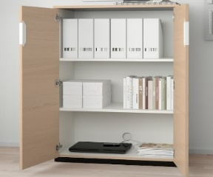
17 | Colorful carpet for children's classroom  Dimension: 240cm x 270cm  Prefer colored squares or similar  Space for 20 children to sit | 1 | pc | 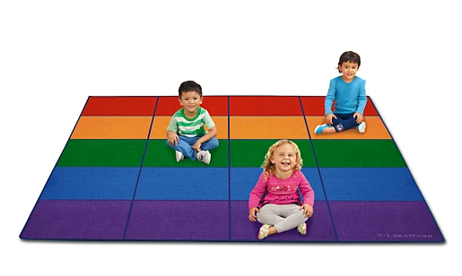
18 | Neutral carpet for children's reading area  Dimensions: 180cm x 120cm  Color: gray, green, plum | 1 | pc | 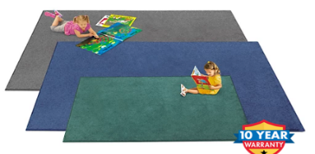
19 | Traditional kurdish cushion set  1 base cushion, 2 back cushions, 2 arm cushions | 1 | pc | 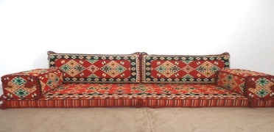
20 | Dry erase magnetic whiteboard easel with adjustable tripod legs  Board Dimensions: 60cm x 90cm | 1 | pc | 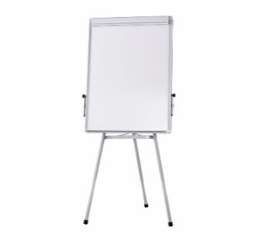
21 | Sofa couch seats 3 people  Dimensions: 190cm x 82 cm x 85 cm (LxWxH)  Color: Gray, beige, tan  Firm cushions | 3 | pc | 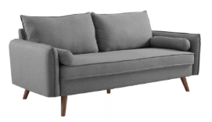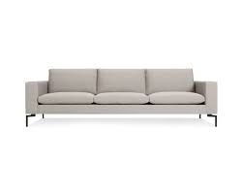
22 | Accent armchair with wood frame  Material: Fabric cushions, wood frame  Color: Gray, beige, tan | 6 | pc | 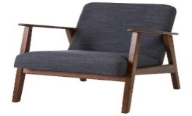
23 | Accent fabric armchair  Material: Fabric chair and cushion  Color: Gray, beige, tan | 4 | pc | 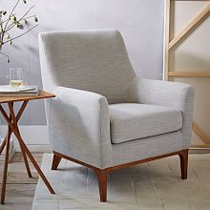
24 | High top dining table seats 4 persons  Dimensions: 140cm x 70cm x 105cm (LxWxH)  Material: Dark wood surface, black metal legs | 2 | pc | 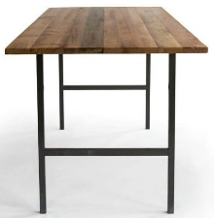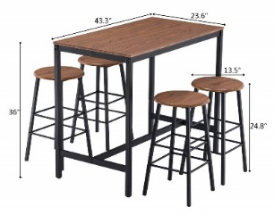
25 | Stool chairs for high top table  Seat shape: Round or square  Color: All black or black legs/wood seat  Height: Legs 75cm from floor to seat | 8 | pc | 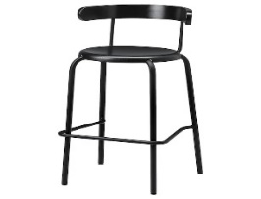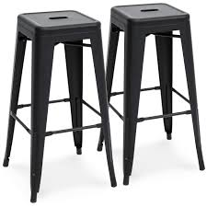
26 | Rectangle dining table seats 6 persons  Dimensions: 185cm x 95cm x 75cm (LxWxH)  Color: Black brown | 1 | pc | 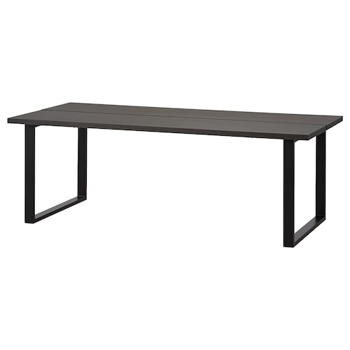
27 | Dining chairs with back and 4 legs  Dimensions: 46cm from floor to seat, 42cm wide  Material: Wood  Color: Black brown | 14 | pc | 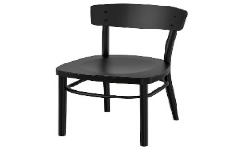
28 | Circle dining table seats 2-4 persons  Dimensions: 85cm diameter, 75cm height  Color: Black, black brown, or wood top/black legs | 2 | pc | 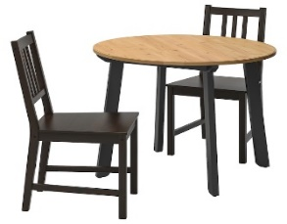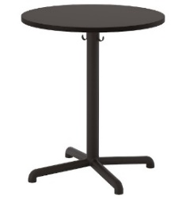
29 | Rectangle coffee table  Dimensions: 90cm x 46cm x46cm (LxWxH)  Color: Wood top, black metal legs | 2 | pc | 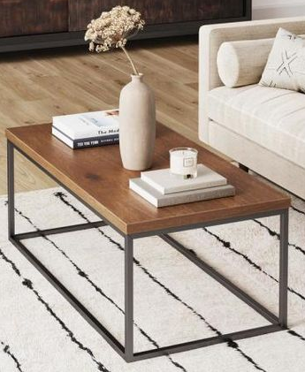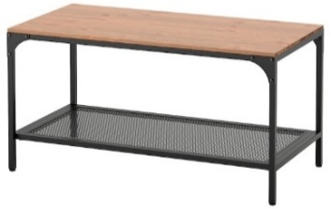
30 | Bookcase with 3 shelves  Dimensions: 80cm x 30xm x 110cm (LxWxH)  Color: Black brown | 2 | pc | 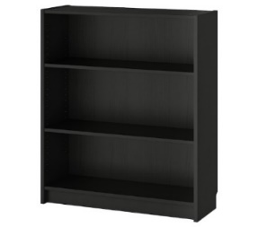
31 | Circle end tables  Dimensions: 49cm diameter, 51cm height  Color: Black brown or wood | 3 | pc | 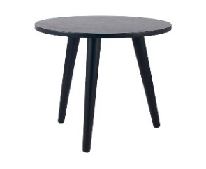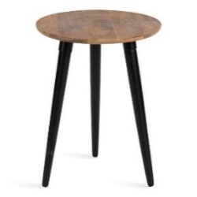
32 | Standing lamp with shade  Silver round or square base  White or beige lamp shade | 151 | pc | 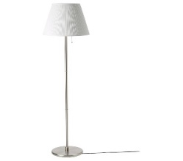
33 | Storage cabinet buffet with 4 doors and shelving  Dimensions: 180cm x 60cm x 90cm (LxWxH)  Color: Black brown, gray, wood | 1 | pc | 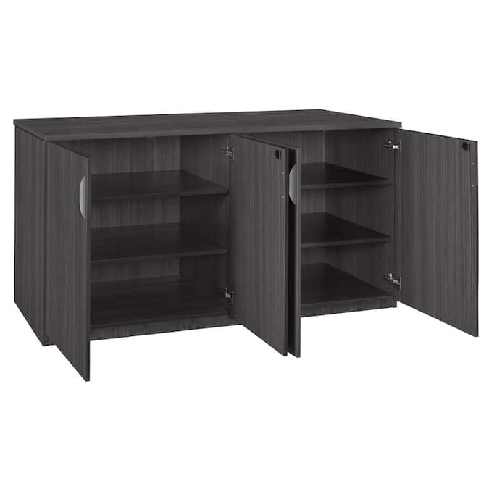
34 | Commercial electric water heater for tea, large capacity | 2 | pc | 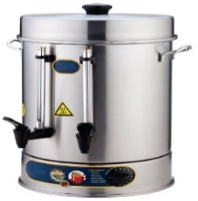
35 | Padded stack chair  Foam padding seat and back, 4 legs, stackable  Dimensions: 47-50cm wide, 45cm floor to seat  Color: Neutral (black, gray, tan) | 200 | pc | 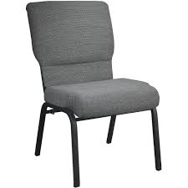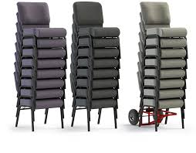
36 | Office desk with drawers, 140cm x 70cm x 76cm (LxWxH), dark brown wood | 18 | pc | 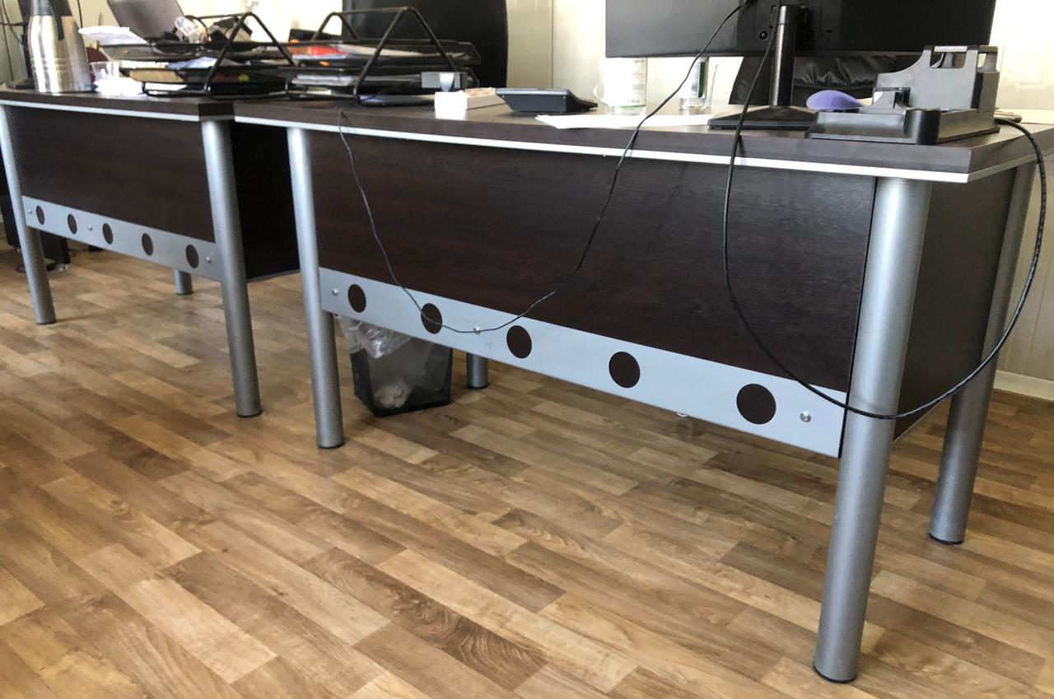
37 | L-shaped reception desk with drawers  Color: Neutral (wood, black, gray, white)  Includes upper workspace for visitors and lower workspace for receptionist | 1 | pc | 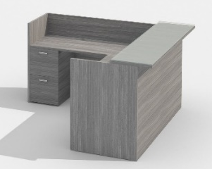
38 | Office rolling chair, black or dark brown | 19 | pc | 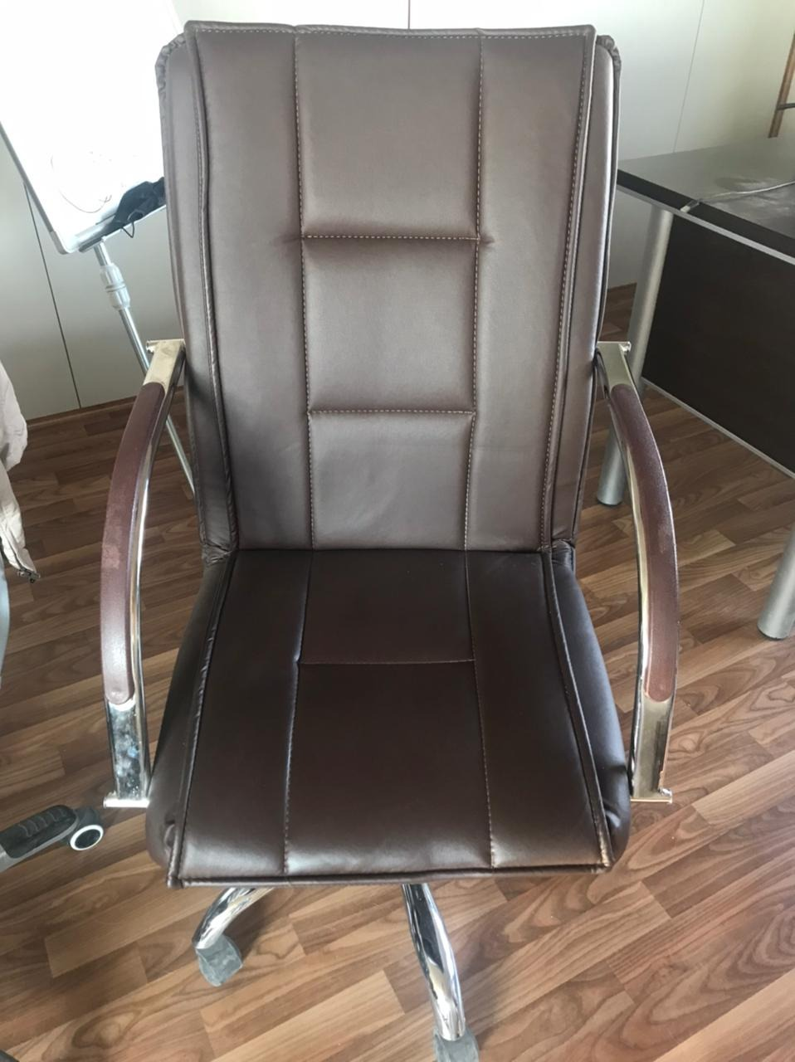
39 | Storage cabinet  Dimensions: 80cm x 40cm x 190cm (LxWxH)  Glass cabinet above (3 shelves) and wood cabinet below (2 shelves)  Same as YEP office | 10 | pc | 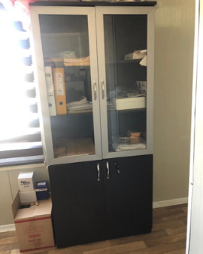
40 | Filing cabinet, 4 drawers, metal, silver | 9 | pc | 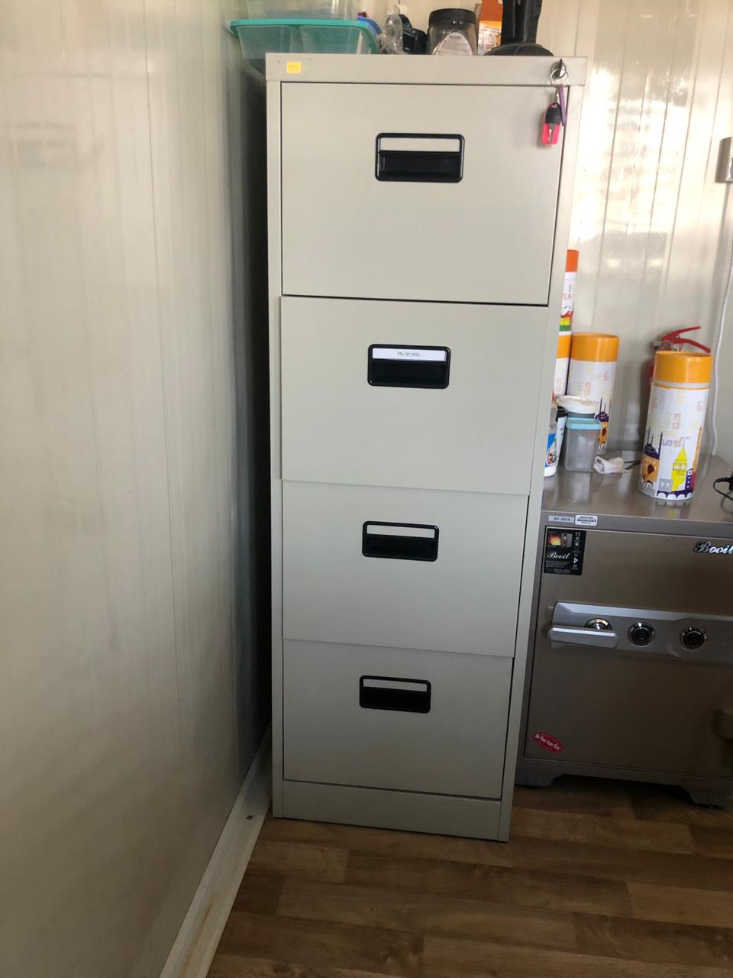
41 | Visitor chair, metal, cushion seat and back, black | 20 | pc | 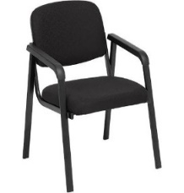
42 | Rolling chairs with plastic arms, adjustable height, 5 wheels, padded seat  Color: Black | 10 | pc | 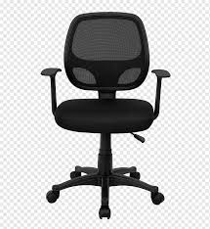
43 | Whiteboard, 120x80 cm | 15 | pc | 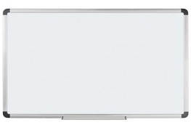
44 | Corkboard, 90x60 cm | 15 | pc | 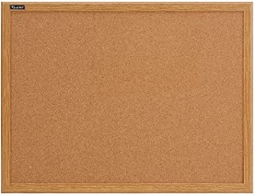
45 | Oven and stove unit, 90cm wide and 90cm tall, at least 5 burners, black or silver | 1 | pc | 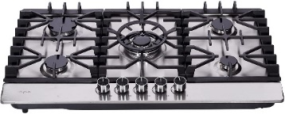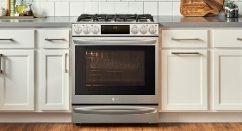
46 | Kitchen hood over stove, 90cm wide, 3 speed with light, black or silver color | 1 | pc | 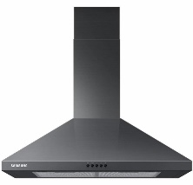
47 | Large capacity refrigerator with freezer unit, 78cm x 55cm x 175cm, silver or black, two doors and pull out freezer compartment. LG, Samsung, or equivalent | 1 | pc | 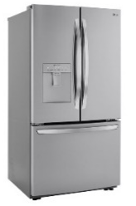
48 | Microwave, 50cm x 36cm x 30cm (LxWxH), black or silver, LG, Samsung, or equivalent | 1 | pc | 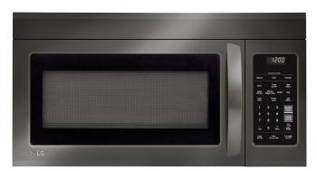
49 | Dishwasher, 59cm x 64cm x 84cm (LxWxH), LG, Samsung, or equivalent | 1 | pc | 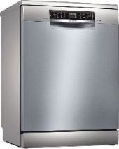
50 | Industrial metal kitchen storage  Dimensions: 100cm x 45cm x 180cm  Material: Metal  4-5 shelves | 4 | pc | 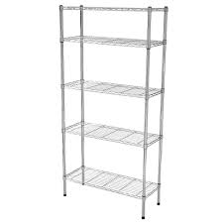
51 | Rectangle dining table seats 6-8 persons  Dimensions: 220cm x 100cm x 76cm (LxWxH)  Color: Black brown or wood top, black legs | 4 | pc | 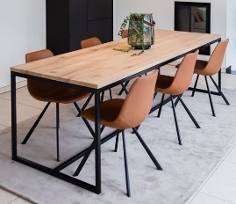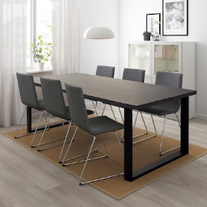
52 | Dining chairs for adults (45cm), lightweight, stackable, felt or metal glides to protect floors  Color: black or gray | 30 | pc | 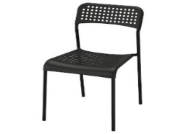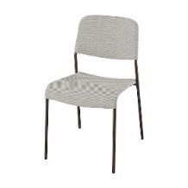
53 | Lockable metal storage cabinet  Dimensions: 90cm x 40cm x 195cm (LxWxH)  Color: Neutral (gray, tan, black)  Two doors with lock, 5 shelves | 6 | pc | 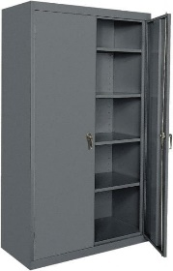
54 | Open shelf storage unit  Dimensions: 100cm x 45cm x 180cm (LxWxH)  Material: Metal/wood mix or all metal  4-5 shelves | 12 | pc | 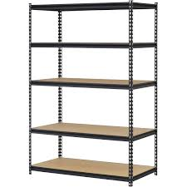
55 | Sports ball storage cart, 89cm x 69cm x 80cm (LxWxH), metal, lockable wheels | 1 | Pc | 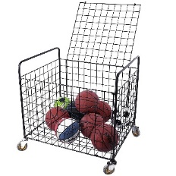
56 | Curtains for Beneficiary Homes (x5 each)  Zebra roller blinds, dark brown, high quality (small mesh)  Dimensions: 2.1m x 1.2m (WxH) | 300 | pc | 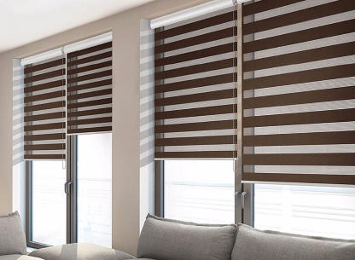
57 | Curtains for Beneficiary Homes (x5 each)  Zebra roller blinds, dark brown, high quality (small mesh)  Dimensions: 1.2m x 1.2m (WxH) | 75 | Pc
58 | Curtains for Community Center W1  Zebra roller blinds, light-medium brown, high quality (small mesh)  Dimensions: 2m x 2m (WxH) | 20 | Pc | 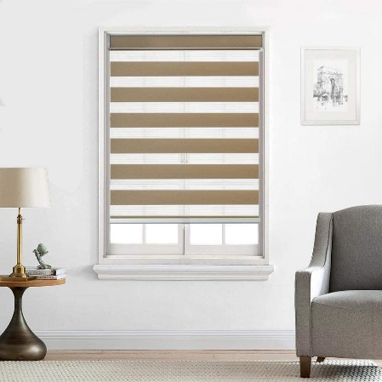
59 | Curtains for Community Center W2  Zebra roller blinds, light-medium brown, high quality (small mesh)  Dimensions: 1.5m x 2m (WxH) | 13 | pc
60 | Curtains for Community Center W3  Zebra roller blinds, light-medium brown, high quality (small mesh)  Dimensions: 1m x 2m (WxH) | 8 | pc
66 | Carpet (living space), fire, and flame resistant, preferably dark color | 75 | pc | 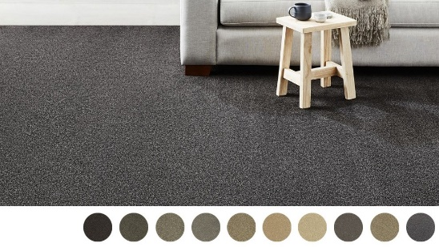
67 | Carpet (sleeping space), 4m x 4m, preferably dark color | 75 | pc | See item 66 for picture reference
68 | Doshag mattress 10 cm high, foam mattress 90cm x 180 cm, cotton/poly blend removable cover. Neutral colors preferred, no blue color. | 600 | Pc | 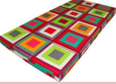
69 | Mat, polypropylene or recycled reed-woven matt, 3mx4m | 75 | Pc | 