Project Name: Restoration of Peace, Livelihoods and Economic Cycles in Anbar (RePLECA)
Agriculture Refrigerated Storage/ Anbar
Location: 33°31'9.95"N 43°20'6.17"E Ramadi

General Notes:
- Site will be delivered officially to the potential contractor and through official letter.
- All labor, professional engineers, Company representatives and Visitors must comply with PPEs.
- All works will be subjected to final measurements- Final installments Might be increased/decreased based on what implemented on the ground and based on written approval by GIZ representative.
- Any implemented additional/Extra quantities without prior written approval from GIZ representative will not be considered for the contracted company or even in the contract amendment.
- Sample must be provided in advance before items installations and service required- otherwise, implemented works without prior approval by GIZ representative, works will be exposed to rejection.
- Winner contractor will be under supervision by GIZ engineers and Directory of Agriculture engineers.
- Contractor must comply with Project schedule/planner offered at earlier stage. In case of any change, new plan should be approved by GIZ representatives.
- Contractor should install sign board at the beginning of the project explaining Building name, project duration, client, etc.…
- All works provided, technical specification must comply with IRAQI General Technical Specifications (IGTS)
- All works in the Bill of Quantities will be done according to supplied design details, specifications, instructions and directions of supervisor.
- All works required in the BoQs covering materials, Transportation, services and any additional fees required. The offer submitted and approved should cover all related cost.
- Potential Contractor is mainly responsible for his own/Labor and professional staff access from/to Anbar and Checkpoints pass in/between the governorates
- For Concrete works, its forbidden to cast the reinforced/unreinforced concrete without obtaining necessary approvals from GIZ Representatives on wooden forms status, steel bars distribution and availability of equipment.
- All steel bars that will be used in the reinforcement concrete must be approved by GIZ Representative prior provision.
- Construction supplies and Services (Steel bars, Reinforced concrete, River sand, Clean soil, Sub-base, Coarse aggregate, Cement, Sand, Gravel and Compacted Area must be tested by official and approved construction lab.
- All workers and staff in the site of works must comply to COVID-19 measures that explained in annex ( )

Technical Project Description and contents:

The Project of Refrigerated Storages will be implemented on a land of 96*76 M owned by Anbar Agriculture Directorate. The Refrigerated and non-Refrigerated Storages will be used for:
- Store the Seeds,
- Store the agriculture corps
- Store the Agriculture donations.
- Store Potato
- Store Potato Seeds
- Store Tomato
- Store Cucumber
- Store date
- Store Strawberry
- Provide help for the farmers to temporarily store their crops if they had no capacity to build their own storages
The compound Elements consist of the followings:
- (Refrigerated Storage 1) Approx. 1000 M2.
- Non-Refrigerated (normal Storage 2) Approx. 1000 M2.
- Guard building (one story building) 48 M2.
- Electrical room Control 12 M2
- Administration building (one story building) Approx. 250 M2
- Lighting System
- Generator-Transformer. [Generator 250 KVA- Transformer 400 KVA]
- Fence and two main sliding doors.
- Parking Shade
- Compound concrete spaces including (Temporary caravan for the supervisor engineer).
- Weighbridge and its caravan.

Project Element Details and Methodology
1- Refrigerated Storage:
- Storage area is 1027 M2 (20.30*50.6) M
- All civil works must be implemented following the structural design and BoQs
- All electrical works must be implemented following the BoQs.
- All the working cost and supplied materials including the assembly foam, rivets, nets, Silicon) is included in the works even if its not mentioned in the BoQ.
- storage has two gates for entrance and exit.
- storage has 1-5 Chambers with five slack doors.
- Collision protection will be required for Refrigerated chambers and corridors as mentioned into the BoQ.

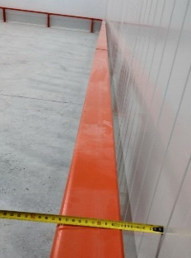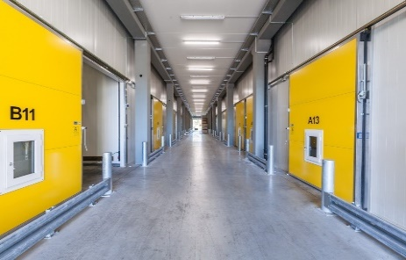

Picture 1 Collision protection Variant 1 &2
- Chambers 1-2 Dimension [14.42*9.67*4.60 M] (L*W*H)
- Chambers 3-5 Dimension [14.42*9.90*4.60 M] (L*W*H)
- Chamber capacity Approx. 130 Tons per one unit.
- Chamber’s atmosphere [Normal, Cooling, ventilation, and Humidification partially]
- Each Chamber will have its own door with specifications as mentioned in the BoQs.
- In each chamber, the air-outlet flat 1300/800 mm will be considered for ventilation purposes following the drawings VE001-a and BoQs.
- Sandwich panel Insulations as following Thickness [120 mm Ceiling, 100mm Internal walls and 80/100 mm for the Corridor] Following MP001 Drawings and BoQs.
- Edging for the cooling Chambers will be required to connect the refrigerated chambers [Walls and Ceilings] within outer halls walls and ceilings.
- Edging thickness that will be used in each position will include [K001, K180, K190, K006, K163, K140, K011] Following the drawings MP001.
- Humidification system will be required to 3 Chambers out of 5 as HUMI master 10K or equivalent.
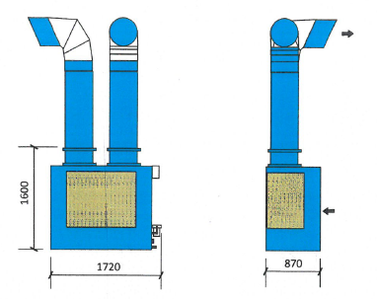
Picture 2 Humidification System
- The equipment will be required for cooling system is integrated mixing air Chamber IKS 330 or equivalent with 5 Pieces aggregate type IKS 330-Compact or equivalent.
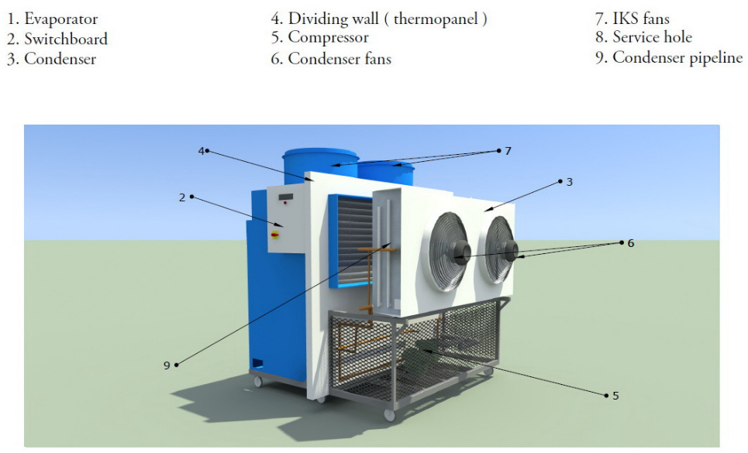
Picture 3 Cooling and Ventilation system
- The aggregate is completely equipped, all electric connections are connected, and the chill system is also ready to work.
- All the Cooling, Ventilation and Humidification works must be implemented according to the BoQs and drawings.
- Refrigerant R513A or R407C approx. 10 kg /unit will be required for each unit.
- The awarded Contractor will be responsible for system synchronization, connection, and functional test.

2- Non-Refrigerated Storage:
- Each Storages area is 1027 M2 (20.30*50.6) M
- Each storage has one main gate for entrance and exit.
- Each storage has two emergency doors which might be used for evacuation purposes.
- All civil works must be implemented following the structural design and BoQs
- All electrical works must be implemented following the BoQs
3-Administration building Approx.250 M2 & Guard Building 48 M2 and Electrical Room 12 M2.
- All Civil works must be implemented according to the written specifications on BoQs and Shop drawings.
- All Samples for the finishing works (tiles, plastering, Paintings, False ceiling, roof protection type, Doors and Windows) must be approved in Advance by GIZ Representative. Otherwise, the supplied materials and implemented services might be Rejected.
- Plumbing works must follow the Specifications that mentioned into the BoQ.
- All Samples for Plumbing works (Water pipes connection Galvanized and the plastic, eastern toilets, western toilets, handwash basins, Water mixers, Water taps, Water tanks, Sinks, Rainwater downpipes and electrical water heater) must be approved by GIZ representative prior installation.
- Septic tank will be used as a sewerage system for this building. All the toilet, handwash basins and kitchen disposal must be connected properly within septic tank.
- All electrical works must be implemented following the BoQs.
- All samples for electrical supplies (ceiling fans, ventilators, sockets, air cooler devices and cables) must be approved prior provision and installation.
- This building electrical board must be connected properly with compound main board.
4- Compound Fence 96*76 M:
- All Civil works must be implemented according to the written specifications on BoQs and Shop drawings.
- All Samples for the finishing works (Plastering, Paintings, Top concrete cap) or the materials interact inside the mix must be approved in advance by GIZ representative.
- BoQ of Fence works include the installation of two sliding doors as a main entrance and exit to the compound. The location as indicated in the drawings.

5-Transformer-Generator
- The required Transformer Capacity is 400 KVA. The provided sample must be approved by GIZ representative and according to Anbar Directory of electricity guideline.
- The awarded Contractor is responsible for authorization approvals from Anbar Directory of electricity for transformer installation within land boarders.
- The contractor responsible for Transformers poles installation in cooperation with Anbar Directory of Electricity and Directory of Agriculture.
- The contractor responsible for High pressure poles installation in cooperation with Anbar Directory of Electricity and Directory of Agriculture including the route of cables outside the boarder of the compound.
- The Contractor responsible for High pressure poles installation inside/outside land boarder within official approval or cooperation with Directory of Electricity/Agriculture.
- The Contractor responsible for electrical power synchronization between Generator and electricity that comes from power grid.
- The Contractor is responsible for all electrical connection between building components, Generator and Electrical room boards according to BoQ specifications and Quantity mentioned.
- The contractor responsible for Generator house installation and arrangement for Supplies connections including the Fuel tank connection with Generator.
- All sample provided (Generator 250 KVA, Fuel Tank, Manual Changeover, Electrical cables, main board and all Circuit breakers) must be approved by GIZ representative prior provision and installation.

6- Compound Concrete Spaces:
- The Awarded Contractor is responsible for raising the land level up +20 Cm by using clean soil.
- The Land should be lifted for another +20 cm using the Sub-Base where the compound Components not included. (Each component has specific level of Sub-Base layer thickness)
- The Land should be lifted for another +20 cm using the Concrete where the compound Components not included. (Each component has specific level of Concrete layer thickness)
- The Contractor will be responsible for planting the area in front of the Admin Building.
- The awarded Contractor responsible for Temporary caravan provision and installation for GIZ Engineer supervisor and DoA supervision committee with all necessary equipment’s (wooden desks, lockers, drawers, signboard, chairs, etc.…) Following the request mention in the BoQ.

7-Weighbridge:
- The awarded Contractor is responsible for Weighbridge & Weighbridge caravan provision and installation.
- The provided Sample for Weighbridge must be approved by GIZ representative and DoA Engineers prior installation.
- All the provided materials must be according to the specifications mentioned in the BoQ and Shop drawings.
- The contractor responsible for all the electrical connection and Synchronization for Weighbridge and Caravan.

8- Parking Shade:
- The Contractor will be responsible for land preparation and Concrete Casting the parking floor as per BoQs and Drawings following the instruction of Supervisor Engineer.
- The Contractor will be responsible for Parking shade Installation as per Technical specifications mentioned in the BoQ and dimensions mentioned in the BoQ

9- Lighting System:
- The Awarded Contractor will be responsible for Lighting poles installation as per mentioned specification in the BoQ and Location distribution mentioned in the Drawings.
- The Contractor will be responsible for Electrical connection for the Lighting system.
- All the Sample provided for Lighting should be approved by GIZ Representative prior the installation.
- The Contractor will be responsible for supply, install and operate the Control Box for the Lighting System. Control Box Contents sample must be Approved by GIZ Representative prior the installation.

GIZ – Anbar Construction team

