Request for Proposal (RFP)
Ref №: GTLSS-SAA-BASRA/MH2021/001
Subject: School Structure/ WASH Facility Improvement
- Invitation to submit bids in response to solicitation

You are invited to submit a bid for “School Structure/ WASH Facility Improvement” The technical and financial offers must be separate (not mixed) and each should be placed in its own sealed and stamped envelope. These envelopes should then be placed in another sealed envelope and delivered by hand to Mercy Hands Office by the deadline of 14:00 PM on 22nd October 2021, in accordance with terms & conditions contained herein.

Bids must be submitted to the following Mercy Hands offices:

Baghdad Office
Building No. 36, Street 4, Sector 929
Karrada District,Baghdad, Iraq
33.297789, 44.435413

Basra Office
Al- Jazzaer, Alwfoowd street,
GPS: 30.499381716033167, 47.83604401688925

Bids received after the deadline will not be accepted.
Queries must be submitted in writing to:
procurement@mercyhands.org
info@mercyhands.org

All envelopes should be sealed, stamped and labelled as follows:
Subject: School Structure/ WASH Facility Improvement
Available from: - 12/10/2021
Deadline: - 22/10/2021
Name and Address of Suppliers:

Bidder shall provide written proposal, fully compliant with the instructions given. Failure to comply with requirements may result in the rejection of the proposal. Every proposal will be evaluated in accordance with the prior approved terms & conditions by Supplier for the provision of tools, materials and equipment.

- Terms & conditions

- Terms

The proposal must take into account the following:

- All materials delivered must meet the quality and technical specifications mentioned in the attached BoQ (Annex 1).
- Mercy Hands staff have the right to inspect all goods delivered and are not obliged to accept any damaged, malfunctioning equipment or incorrect items.
- The companies applying to this tender need to have free access to Shat Al-Arab District, Basra City.
- The companies applying to this tender must have adequate storage (warehouse) facilities for the requested tools and equipment in Basra for the duration of 3 months, where Mercy Hands staff can have access when needed.
- The supplier is responsible for loss or damage to any of the materials as a result of poor storage.
- The companies applying to this tender must provide the following documents:
  - A copy of the company valid IDs.
  - The Certificate of Registration in Iraq.
  - Tax Clearance document 2021.
  - Tax ID valid
  - Chamber of Commerce ID.
  - A copy of the final annual financial report 2020.
  - Statement of Establishment
  - Establishment contracts
Note, any missed document from the above-mentioned documents the company will be excluded of competition to win the bid.
- The companies applying to this tender must provide their bank details (Annex 2: Financial Guarantee Letter).
- The companies applying must sign the attached MH Code of Conduct (Annex 3).
- The company should provide a list of past relevant experience, providing similar works.

- General Conditions
- Currency - Tenders must be presented in IQD.
- Period of Validity – Prices quoted in the tender must be valid for a period of at least 60 days from the deadline for the submission of tenders.
- The compliant tender that offers the best price-quality ratio will be chosen. MH does not bind itself to award to the lowest offer.

- Payment Terms
- The Supplier will submit invoices after the provision and acceptance of all the items as per the BoQ.
- Payment will be by bank transfer.
Bill of Quantities
BOQ for Education Project
UNICEF- GTLSS-SAA-BASRA/MH2021/005
Rehabilitation
# | Items | Unit | Amount | Price per unit  (USD) | Total cost  (USD) | Sample
1 | water tap (Steel) | Pcs | 109 |  | IQD - | 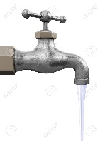
2 | bidet shower : to wash the lower parts of the body. (Plastic) | Pcs | 44 |  | IQD - | 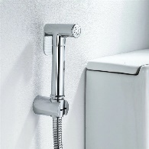
3 | Fan Discharge discharger air Machine (To get the air out of the bathroom ) | Pcs | 20 |  | IQD - | 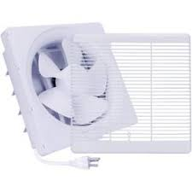
4 | Faucet (steel) | Pcs | 9 |  | IQD - | 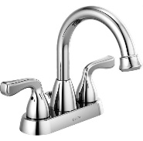
5 | Water tank ( Supply and install of cylindrical Plastic water tanks (have three layers) including all piping and fittings, Valves, float valves, cording to the instruction of Superivisor. | Pcs | 8 |  | IQD - | 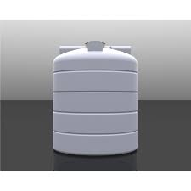
6 | water pump :Pumps are used to move water or other liquids from one place to another including all piping and fittings, Valves, float valves, cording to the instruction of site Superivisor. | Pcs | 9 |  | IQD - | 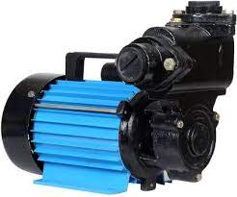
7 | Hand washer | Pcs | 4 |  | IQD - | 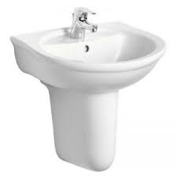
8 | Water hose for hand washer pool(plastric) | Pcs | 3 |  | IQD - | 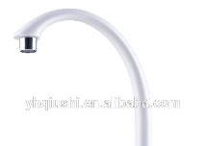
9 | Cleaning for the general Bathroom | Pcs | 2 |  | IQD - | 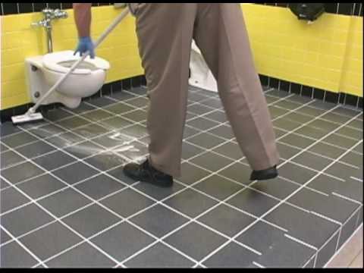  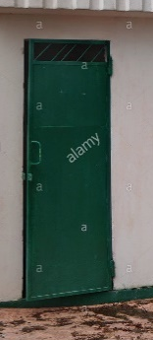  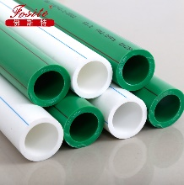  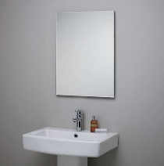  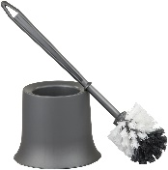
10 | toilet brush (plastic) | Pcs | 8 |  | IQD -
12 | iron door repair | Pcs | 4 |  | IQD -
13 | water pipeline + T FITs + 90 FITs | Meter | 120 |  | IQD -
14 | bathroom mirror | Pcs | 8 |  | IQD -
15 | lamp | Pcs | 17 |  | IQD - | 
16 | lamp base holder | Pcs | 17 |  | IQD - | 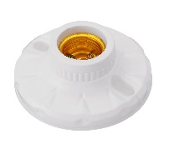
17 | led light | Pcs | 10 |  | IQD - | 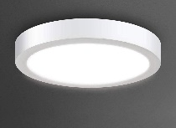
18 | Water hose (To get the water out ) | Pcs | 2 |  | IQD -
19 | soap | Pcs | 500 |  | IQD - | 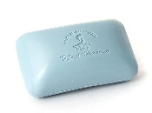
20 | water booster/flusher (To pull heavy water out ) | Pcs | 7 |  | IQD - | 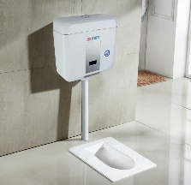
21 | cement bag(Repair some cracks in the wall ) | Pcs | 2 |  | IQD - | 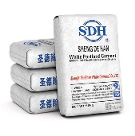
22 | Floor Mob | Pcs | 4 |  | IQD - | 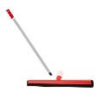  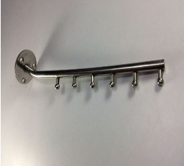
24 | Wall drope Hanger hook rail for Cloth | Pcs | 2 |  | IQD -
25 | Toilet seat and full setup | Pcs | 4 |  | IQD - | 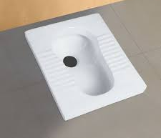
26 | sewer Cleaning | Work per school | 16 |  | IQD - | N/A
Total |  |  |  |  | IQD -

Read & approved by:
Supplier Name:
Supplier Address:
Supplier Signature and stamp:

