Annex 2 - Cabin specifications:

BASE Bottom: chassis with steel profiles for floor tie beam by hollow sections (3mm) all welded (150 kg/m2), a width and height of 10cm and for long and short directions divided into tubes by 5x10cm 3mm and 4x4cm 3mm in thickness per 60cm and using 10x10 for caravan columns and stands. All steel will weld together according to the Iraqi welding standards. and steel frames shall paint with double layer of anti-rust painting and three layers of oil paint.

Ceiling Frame: steel profile for ceiling frame by hollow section 10*10 – 3mm all welded (150 kg/m2), all steel will weld together according to the Iraqi welding standards, and steel frames shall paint with double layer of anti-rust painting and three layers of oil paint.

FLOOR: covered by cement/Marine board (18 mm), covering with vinyl (2 mm) also supply and install corrosion resistant metal (chequer plate) floor sheet (Bath- WC). All materials checked from water leakage proof especially in joints.

ROOF: polyurethane sandwich panel (50 mm)(40 kg/m3)0.5 mm + 0.4 mm polyester dyed galvanized trapezoidal sheet metal. Roof edges finished with metallic flashings.

Walls: "Walls covered by 50 mm thickness of 40 kg/m3 polyurethane sandwich panel. for external and internal sheet should be 0,45mm thick, 5 micron back coat and 20 micron RAL 9002 polyester and painted white in color.

Door: PVC doors with door dimensions (1*2) m and key locks with all accessories.

Window: Supply and install Window (dimensions as per BOQ) with mosquito, insects exclude and filled with glass 4mm and window including super section white color. Double glazing casement window.

Steel Steps: Installing one steel step on each external exit/ entry door.

Skirting: Cover all the floor, walls and ceiling corners with PVC skirting, lay under the vinyl flooring and overlap on wet areas to prevent any leakage.

Electrical items: Cable for lighting Supply and install 2x1.5mm², Cable for Sockets "Supply and install 2x2.5mm², Cables for electrical switch plugs including PVC cable tray and all needed accessories.

Socket switch 4 gang 1 way (5 AMP): Supply and install Socket switch (3 line) 5 Amp. for lighting,4 gang 1 way 10AX and 250V,82mm*82mm plastic face and switches with 16mm in depth, white color.

Socket Switch 13 (AMP):Supply and install three Trilogy socket switch/13 AMP, Switch with Neon white in colour,250V,82mm*82mm in dimensions and 16mm in depth.

Switch plug 32 AMP: Supply and install one switch plug 32 AMP for AC units.

Wall mounted lamp Supply and install fluorescent lamp, double fluorescent lighting fixture (2*36w) white in color, metal frame, tube and starter lamps with all accessories.

Exterior water proof lamp Supply and install exterior water proof lamp, Lamps (wall mounted), lamp, base and lamp with plastic cover. To IP65 specification minimum

Specifications Examples:

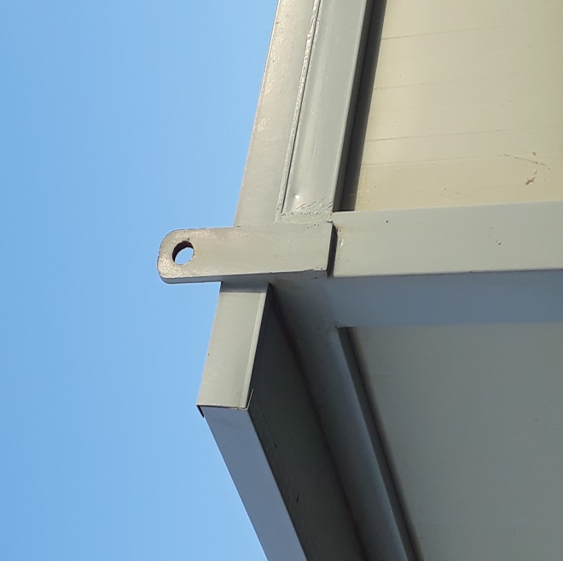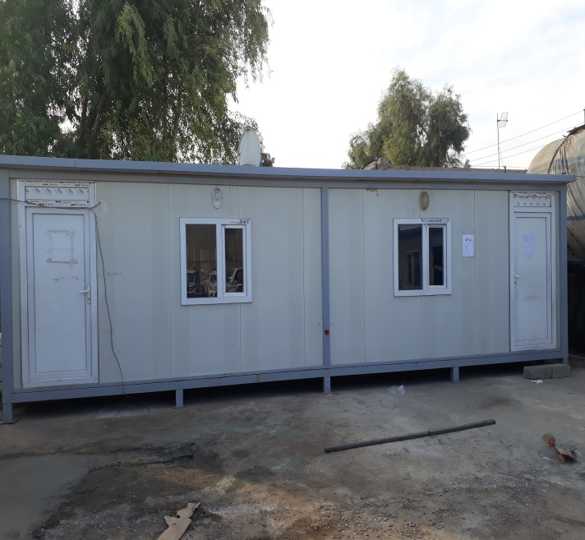

Lifting point All 4 Corners Example Double Unit

Container specifications:

- 20 Feet container standard
- 40 Feet container standard with the following modification
- To be partition into 4 and each partition 3 meter
- Each partition should have separate door and the size should be 1x2 meter, made out of 2mm plate for heavy duty reason.
- Each partition should have 2 rolls of shelves.

Specifications Examples:

