
Quick Impact Projects in Mosul, Tel Afar and Sinjar

Technical Questionnaire for Interested Bidders
RFI/10EOV/M57QIPS/MOSUL/PRO/13-12-2021

ACTED (Agency for Technical Cooperation and Development), an NGO implementing several projects in Iraq, is inviting suppliers to submit technical information in advance of a Restricted Procurement Process for Quick Impact Projects (QIPs) in Mosul, Tel Afar and Sinjar
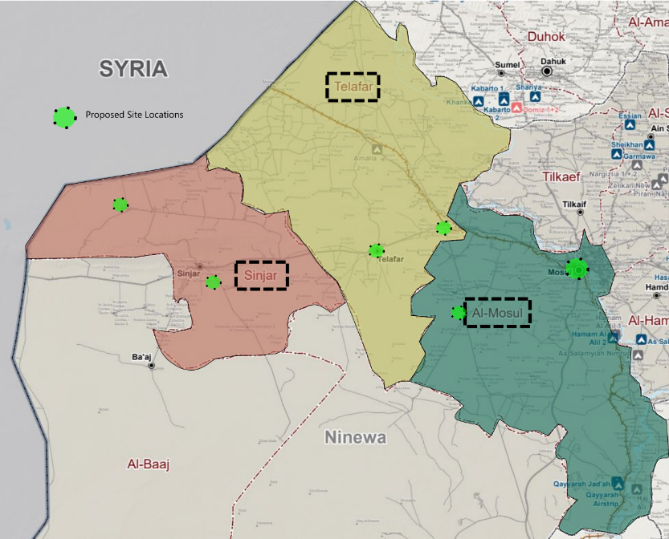
ACTED will be carrying our rehabilitation on an estimated 8 to 12 sites in Nineweh Governorate in Mosul, Telafar an Sinjar districts.

Each site will be procured individually through a request for quotation to suppliers who are technically approved on the basis of personnel and experience, according to the process below:

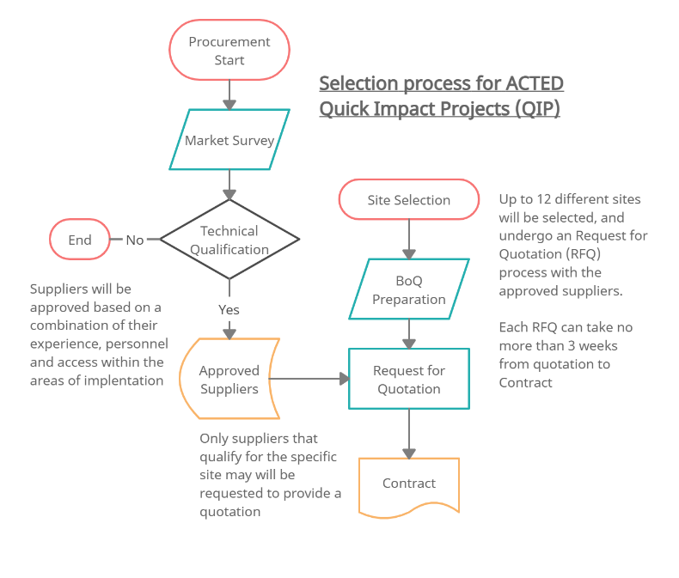
Interested companies are invited to complete the attached Market Survey online (in English or Arabic) in order to be technically pre-qualified to participate in the RFQ stage.

Link to Market Survey below:

https://ee.humanitarianresponse.info/x/GlHzmm5s
The results of the initial technical assessment will be shared by email to the address submitted on the Survey form, along with any required clarifications.

The RFQ stage will be conducted using ACTED standard bidding documents, open to all qualified suppliers and service providers.

There is no deadline for submission, but RFQ are anticipated to begin before the end of December 2021 and will only be shared to qualifying suppliers.

ACTED will not be responsible for any costs or expenses incurred by the Bidders in connection with the preparation and submission of their bids to ACTED.

For all inquiries regarding this tender, please contact the ACTED Country Logistics Manager William.alston@acted.org cc Logistics Manager Sura Salih sura.salih@acted.org

NOTE: ACTED adopts a zero tolerance approach towards corruption and is committed to respecting the highest standards in terms of efficiency, responsibility and transparency in its activities. In particular, ACTED has adopted a participatory approach to promote and ensure transparency within the organization and has set up a Transparency focal point (Transparency Team supervised by the Director of Audit and Transparency) via a specific e-mail address. As such, if you witness or suspect any unlawful, improper or unethical act or business practices (such as soliciting, accepting or attempting to provide or accept any kickback) during the tendering process, please send an e-mail to transparency@acted.org.

