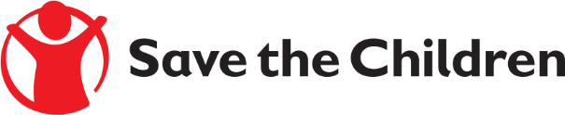
Formal Quote Notice

Save the Children believes every child deserves a future. In Iraq and around the world, we give children a healthy start in life, the opportunity to learn and protection from harm. We do whatever it takes for children – every day and in times of crisis – transforming their lives and the future we share.

Save the Children International in Iraq is inviting submissions of tenders for a contract to provide the following products/Services:

Supply of Diesel Generator for ECCD Center Kindergarten Qayyarah

Detailed technical specifications are included within the tender documents.
Completed tender documents are due to be submitted to Save the Children Office in the following location in sealed envelopes:

- Nineveh Al Mohandssen neighborhood Near by Qasr Al Sultan Hotel, beside the Nineveh Big Mosque

NOTE: Please mention the PR Reference number (PR68464 ) on the envelope.

In total, we request that you supply us with the following information:

- Signed, stamped and Priced copy of the RFQ/Quotation and BOQ with delivery/lead times
- Copy of business owner ID
- Copy of primary key contact ID
- Copy of Secondary key contact ID
- Copy of valid business registration
- Copy of your latest Tax Clearance documents from Ministry of Finance
- Signed and stamped copy of the SCI Policies in the attached of this tender package

The final date of submission will be 4-March-2022 no later than 4:30 P.m all offers sent after that date will be neglected.

