Call for Auction
Auction No.: 1. MAG-IQ-AUC-22-001

Mines Advisory Group (MAG) has been working in Iraq since the past 30 years. MAG Iraq intends to auction the following assets on as is where is basis.

#Lot | Description | Date of Purchase /Acquisition | Picture
1 | Semi-Trailer flatbed 3 Axle single super tire | 2005 | 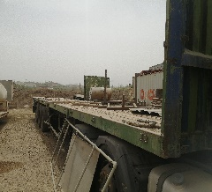
2 | LECITRAILER Low Loader 3 Axle small tire | 2012 | 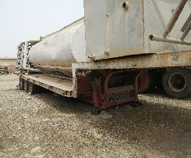
3 | Low loader 2Axle Big Tire | 2005 | 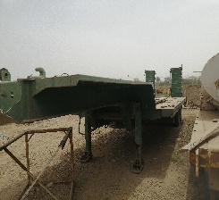

Terms and Conditions:
- The goods may be inspected at the MAG base in Chamchamal with address coordinates below during office hours (Sunday – Thursday / 8:30 – 16:00 hrs) from 27 June 2022 up to 7 July 2022;

35.499681466548125, 44.7809445802556

- Interested parties may submit their sealed bids at the following locations during office hours (Sunday – Thursday / 8:30 – 16:00 hrs) from 27 June 2022 up to 7 July 2022:
Chamchamal: 35.499681466548125, 44.7809445802556
Point of Contact: 0771 020 27 37
Erbil: 36.23423182134221, 43.98834463997686
Point of Contact: 0751 745 30 58

- The goods will be offered to the highest bidder for the respective lot
- The bidders can apply for a single or Multiple Lot(s)
- The goods are offered on as is where is basis therefore it will be the responsibility of the successful bidder/s to remove the goods from the MAG base
- Once upon the announcement of the successful bidder(s) the said bidder will be required to submit Cash/ Cheque/ Bank Transfer to MAG Iraq of the quoted amount within 3 working days. If the said amount is not deposited within 3 working days MAG reserves the right to not consider the said bid and offer the goods to the next highest bidder.
- The successful bidder will be required to remove the goods from MAG base within 7 working days of payment to MAG Iraq.
- Price quoted and accepted will only be in US Dollars.
- The quoted bid must be valid for 180 days.
- Interested parties/bidders are required to submit their bid using MAG bidding form
- This Auction is open for both Companies and Individuals to apply.

