Bid Form
Auction No.: 1. MAG-IQ-AUC-22-001
#Lot | Description | Offered Price (USD) | Picture
1 | Semi-Trailer flatbed 3 Axle single super tire |  | 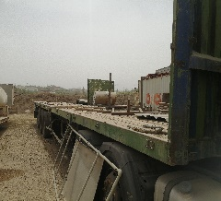
2 | LECITRAILER Low Loader 3 Axle small tire |  | 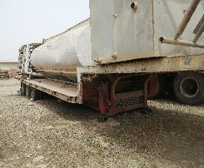
3 | Low loader 2Axle Big Tire |  | 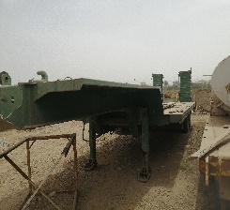

Bidder can apply for a single or multiple lot(s)

Bidders Comments (If any):

Name:
Address:
Phone Number:
ID Number:
Signature:
Stamp (If any):
Date:

