ITEM NO. | GOODS /DESCRIPTION |  | QUANTITY | UNIT PRICE (IQD) | TOTAL  (IQD)
1 | School uniform set for boys (shirt, trousers, shoes)  (As per the Annex1 Technical Specifications) |  | 2.356 set
2 | School uniform set for girls (shirt, trousers, shoes)  (As per the Annex1 Technical Specifications) |  | 2.075 set
 |  |  |  | TOTAL (IQD)
DELIVERY TIME:
(Please indicate your shortest delivery time)

DELIVERY LOCATION: Mosul Province | 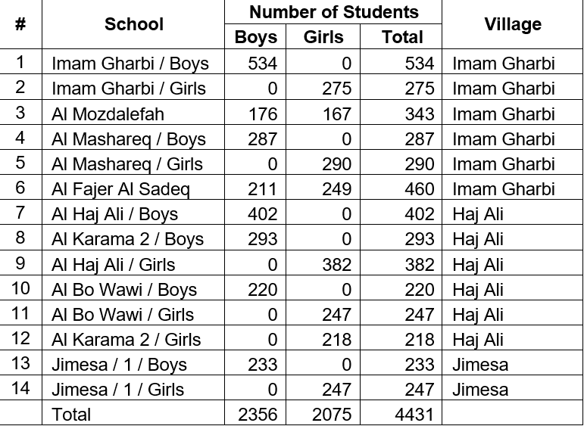

Remarks:
- Transportation (packing, loading, delivering, unloading, etc.) costs must be included in the total price.
- The company must provide the datasheets/catalogues with all technical details and specifications.
- The bid form should be completed fully, signed, and stamped.
- However, the bidder is free to attach a detailed Proforma-Invoice.

