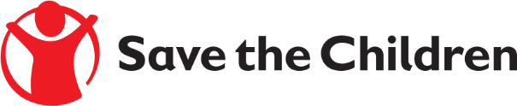
Formal Tender Notice

Save the Children believes every child deserves a future. In Iraq and around the world, we give children a healthy start in life, the opportunity to learn and protection from harm. We do whatever it takes for children – every day and in times of crisis – transforming their lives and the future we share.

Save the Children International in Iraq is inviting submissions of tenders for a contract to provide the following services:

Solid Waste Collection from Sinjar mountain camp

Please follow the below two submission options

- Electronic Submission via Ariba Network (ProSave)
- Submit your response in accordance with the guidance provided in the below document: if you are registered in Ariba Network
If you are not registered in Ariba Network (ProSave) please follow the standard account self-registration guidance
Or
- Paper Submission
- One paper copy submitted on headed paper to : Iraq, Ninewa FO - Al Muhandseen East Mosul Near to Big Mosque
- Bids should be submitted in a single sealed envelope addressed to Save the Children office, Ninewa FO - Al Muhandseen East Mosul Near to Big Mosque.
- The envelope should clearly the Invitation to tender reference number PR-107107, but contain no other details relating to the bid or the bidder name.
All supporting documentation should be labelled and grouped together (individual envelopes, stapled etc.), and then included in a single sealed envelope as per the above.

NOTE: Please indicate the following Reference number on your envelope (PR-IRQ-NIN-2022-107107)

In total, we request that you supply us with the following information:
- Copy of business owner ID
- Copy of primary key contact ID
- Copy of valid business registration
- Copy of your latest Tax Clearance documents from Ministry of Finance for 2021/2022 (it’s mandatory)
- Signed and stamped copy of the SCI Policies in the attached of this tender package

The final date of submission will be 26-June-2022 no later than 04:30 pm all offers sent after that date will be neglected.

