Call for Auction
Auction No.: 1. MAG-IQ-AUC-22-002

Mines Advisory Group (MAG) has been working in Iraq since the past 30 years. MAG Iraq intends to auction the following assets on as is where is basis.

#Lot | Description | Picture
1 | MITSHUBISHI Fuso/ Ambulance/2016 / Last Km Reading/4743  Chassis No: JN6BE6DS3G9800092 | 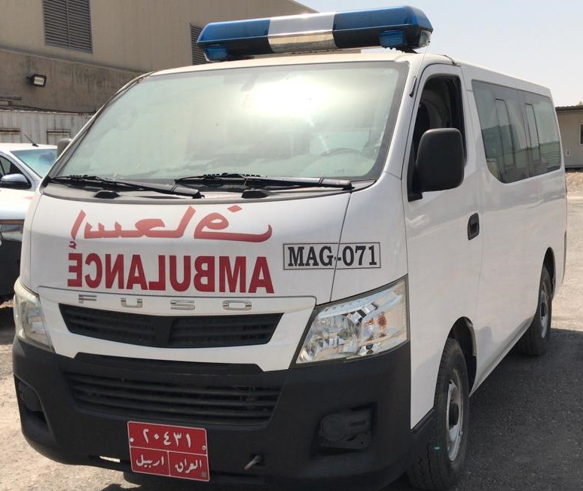
2 | NISSAN Urvan / Ambulance/2016 / Last Km reading/17180  Chassis No: JN6BE6DS3G9016771 | 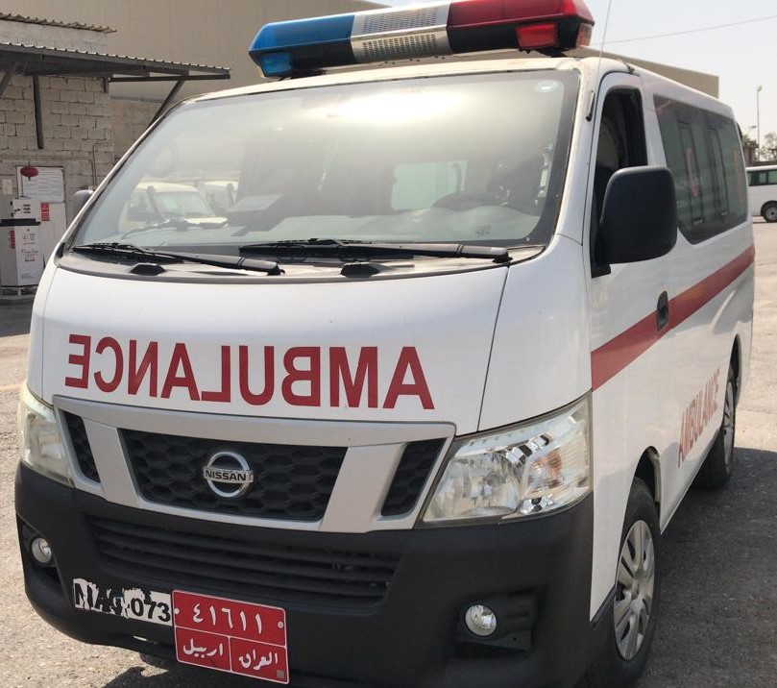
3 | NISSAN Urvan / Ambulance/2016/  Last Km reading/4697  Chassis No: JN6BE6DS5G9016707 | 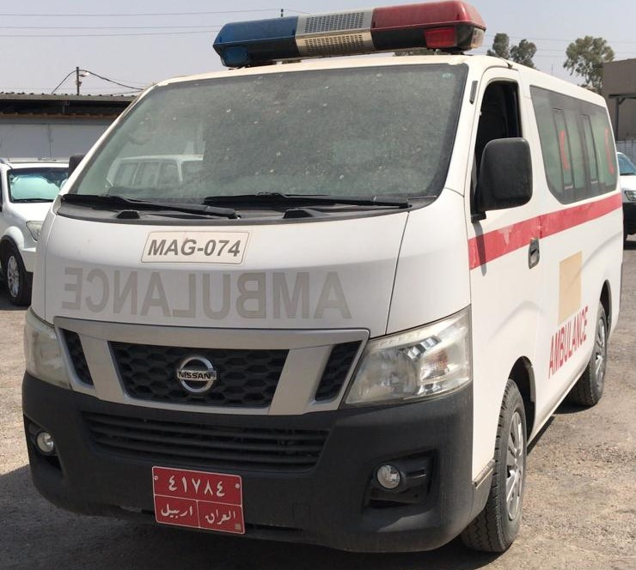
4 | NISSAN Urvan / Ambulance/2016  Last Km reading/2164  Chassis No: JN6BE6AS6G9003999 | 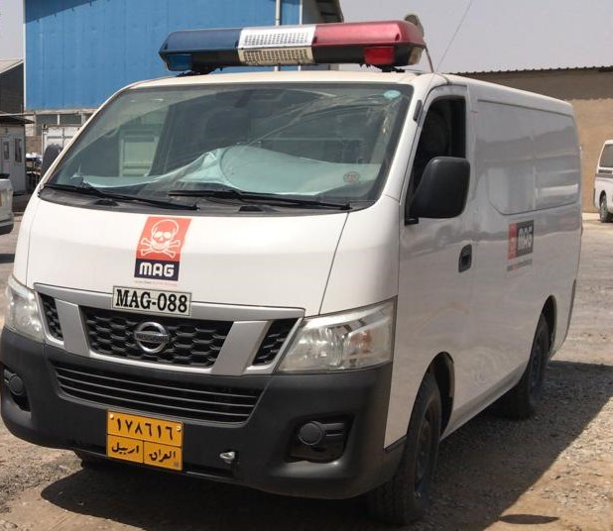
5 | NISSAN Urvan / Ambulance/2016  Last Km reading/53077  Chassis No: JN6BE6DS2G9016793 | 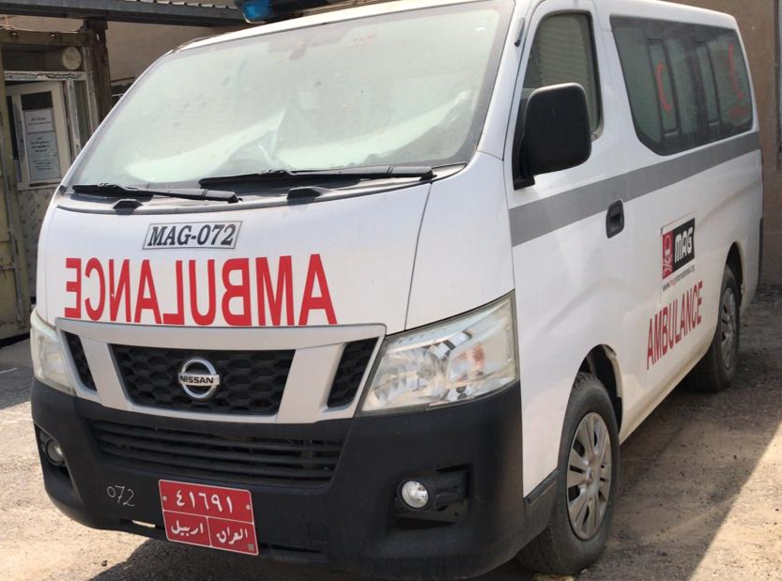

Terms and Conditions:
- The vehicles may be inspected at the MAG Erbil base in Adala District with address coordinates below during office hours (Sunday – Thursday / 8:30 – 16:00 hrs) from 18 September 2022 up to 29 September 2022;

36.14801242307794, 44.001657355608806
Before visiting please contact Mr. Sangar at 0771 020 27 37

- Interested parties may submit their sealed bids at the following location during office hours (Sunday – Thursday / 8:30 – 16:00 hrs) from 18 September 2022 up to 16:00 Hrs. on 2 October 2022;
Erbil: 36.23423182134221, 43.98834463997686
Point of Contact: 07504674296

- As MAG is a Tax exempted entity, therefore no registration Taxes have been paid for these vehicles and the purchaser will be responsible for payment of all Taxes and registration of vehicles.
- The vehicles will be offered to the highest bidder for the respective lot
- The bidders can apply for a single or Multiple Lots
- The goods are offered on as is where is basis therefore it will be the responsibility of the successful bidder/s to remove the goods from the MAG base
- Once upon the announcement of the successful bidder(s) the said bidder will be required to submit Cash/ Cheque/ Bank Transfer to MAG Iraq of the quoted amount within 3 working days. If the said amount is not deposited within 3 working days MAG reserves the right to not consider the said bid and offer the goods to the next highest bidder.
- After receipt of payment from the successful bidder(s) MAG will accompany them to the Traffic Police office for the transfer of ownership.
- The successful bidder will only be allewed to remove the vehicle from MAG base after the transfer of ownership process is completed.
- Price quoted and accepted will only be in US Dollars.
- The quoted bid must be valid for 180 days.
- Interested parties/bidders are required to submit their bid using MAG bidding form
- This Auction is open for both Companies and Individuals to apply.

