Bid Form
Auction No.: 1. MAG-IQ-AUC-22-002
#Lot | Description | Offered Price in USD | Picture
1 | MITSHUBISHI Fuso/ Ambulance/2016 / Last Km Reading/4743  Chassis No: JN6BE6DS3G9800092 |  | 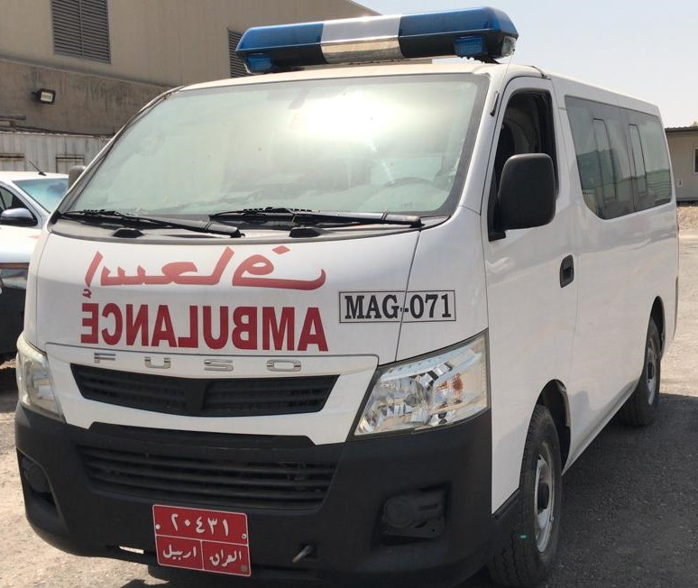
2 | NISSAN Urvan / Ambulance/2016 / Last Km reading/17180  Chassis No: JN6BE6DS3G9016771 |  | 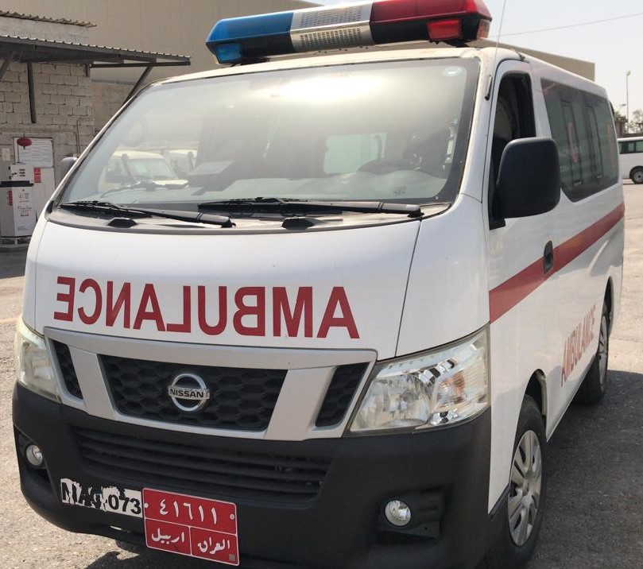
3 | NISSAN Urvan / Ambulance/2016/  Last Km reading/4697  Chassis No: JN6BE6DS5G9016707 |  | 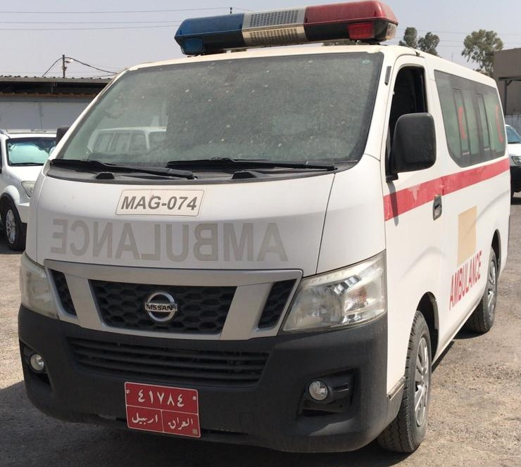
4 | NISSAN Urvan / Ambulance/2016  Last Km reading/2164  Chassis No: JN6BE6AS6G9003999 |  | 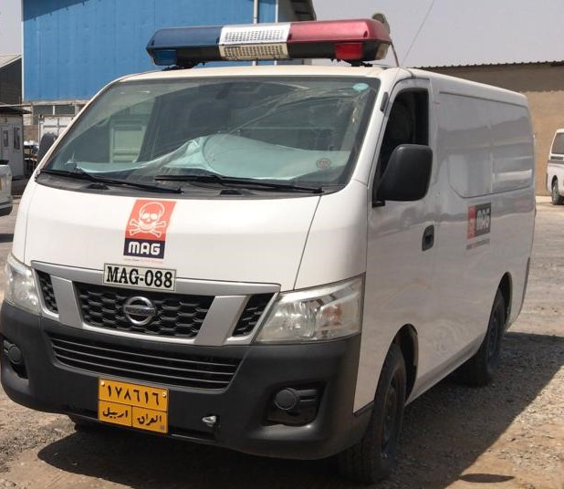
5 | NISSAN Urvan / Ambulance/2016  Last Km reading/53077  Chassis No: JN6BE6DS2G9016793 |  | 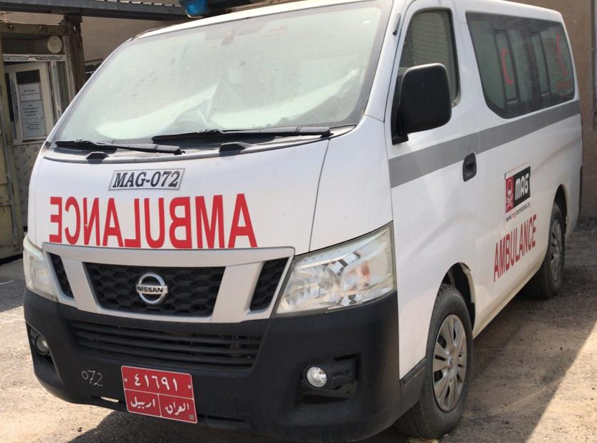

Bidder can apply for a single or multiple lot(s)

Bidders Comments (If any):

Name:
Address:
Phone Number:
ID Number:
Signature:
Stamp (If any):
Date:

