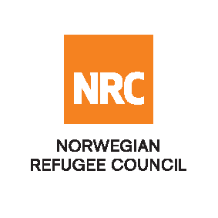

Tender Notice

Invitation to Request of Quotation to hiring Driverin Basra -Iraq

IRAQ-RFQ-196-2022

The Norwegian Refugee Council (NRC) is a non-governmental, humanitarian organization with 60 years of experience in helping to create a safer and more dignified life for refugees and internally displaced people.
NRC advocates for the rights of displaced populations and offers assistance within the Shelter, Education, Emergency food security, Legal assistance, and Water, sanitation, and hygiene sectors.

NRC has been present in Iraq since 2010, with offices located in Baghdad province, Anbar, Erbil, Dohuk, Hamam Al Alil, Mosul, and Kirkuk. We have scaled up our response across Iraq to meet the large-scale crisis facing the country, reaching Iraqis with emergency assistance and supporting Syrian refugees as they live in exile. Our goal is to always be prepared to work in new settings, so we are establishing more local partnerships in Iraq.
The Norwegian Refugee Council (NRC) Office in Iraq invites eligible and interested suppliers to participate in the tender, Refer to the table below;

Code# | Description | RFQ Number
 | Invitation to Request of Quotation for Rental Vehicle with Driver (Pickup 4-seater) | IRAQ-RFQ-196-2022

- Deadline of submission: on 5^{h} October 2021

- Interested bidders can collect the Request for quotation documents from the NRC office in Basra located at Basra – Al Twesa Neighbourhood, Olympic Committee Street - Rabat Police Station Street - near Lebanon Restaurant GPS (30.51903 N – 47.81958 E)
- during the period from (28th September 2022 to 4th October 2022).
- Submission: bidders can submit their bid by:
- Hard copy Submission:
bidders can submit their bids in a sealed envelope to the NRC office in Basra– Al Twesa Neighbourhood, Olympic Committee Street - Rabat Police Station Street - near Lebanon Restaurant GPS (30.51903 N – 47.81958 E) clearly indicated on the envelope, IRAQ-RFQ-196-2022. By the 5th of October 2022.
- Email Submission:
Bidders can submit a signed bid by email to IQ.Baghdad.Procurement@nrc.no with the RFQ reference number “IRAQ-RFQ-196-2022” as the Email subject.

NRC reserves the right to select/reject any bids, in part or full, as it may deem necessary without providing feedback in this regard. No liability or claim in that respect would be admissible or entertained whatsoever.

