- TECHNICAL SPECIFICATIONS

Lot 1
No | Item | Description | Quantity | Reference Picture | Comparative Specification  Comparative specification / remarks should indicate any deviation from technical parameter or functional description of tender specification or confirmation with "Yes" and if applicable further particularities.
- Electronic Supplies
1.1 | Supply and extend wires | (2x2.5) mm² length (600 M.L). To connect electricity for interior switches with all requirements to cover all wires using PVC trunk wire size (25 mm). 2-4 wires in each PVC trunk | 600ml
1.2 | Plug Socket Switches | Supply and fix 13 Ampere , for one-stop-shop, type of switch contains Neon Light. Price includes all requirements for fitting all electricity works at One-stop-Shop counter. | 20pcs | 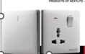
1. 3 | Supply and fix 10 Ampere Switch | 3 gangs two-way switch for fluorescent strip, work includes all requirements for fixing.  Switches | 6pcs | 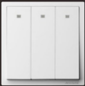
2. | Air Cooler | - Water tank capacity: 20 liters  - Blower function  - Rigid plastic body  - Cooling module 20000 m²/hr  - 1 channel  - 3-speed control  - Honeycomb cooling pad  - Air swingable for both sides, vertical and horizontal  - With an original remote control  - Movable and with 4 tires  - Proper pipe to be installed in order for the water reaches the cooling pads | 2pcs | 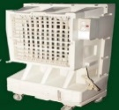
3 | Wall mount fan | - Motor: 14mm motor (motor size can be adjustable)  - Blade: 3 PP blade  - Voltage: 220V/50Hz  - Plug: Two round pin plug  - Color: Can be grey or black  - Body material type: PVC | 6pcs | 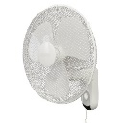
4 | STORAGE WATER COOLERS | - Capacity (40 LTR/HR)  - Storage capacity (80 LTR)  - Of faucets 2  - Dimensions (WXDXH) (665x 485 x 1210) mm (plus or minus 20 mm of the Dimensions are acceptable)  - Weight 45 Kg (plus or minus 2KG are acceptable)  - Refrigerant R22 /R 134A  - Current amps are 2  - Type of compressor ROTARY / RECIP  - Silver or White colour  - Work includes all requirement to install water pipes, electricity sockets, draining | 1pcs | 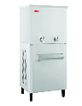

Lot 2
No | Item | Description | Quantity | Reference Picture
1 | Wooden desks | - Classic type. Material made of lamination wood type HDF (High density fibres)  - Paper & veneer  - High gloss finish  - Colours brown or grey or red.  - Dimensions (LXWXH) mm (1400 X700 X740) mm  - Three drawers’ size (5000 x4000 x5500) mm  - Drawers with Key to be fixed to the desk  - Hole/cord for computer cable and wires | 6pcs | 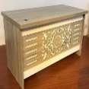
2 | Office chair |  | 6pcs | 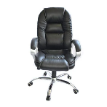
  - Moveable Leather office chair
  - Dimensions: 24.75"W x 27.25"
  D x 38-40.5"H
  - Sit on smooth rolling multi- Surface dual
  wheel
  Casters
  - Chrome base to provide easy
  Access to your surrounding work
  area
  - Heavy-duty chair supports
  Up to 300 lbs
  - Arm height adjustability allows
  Precise arm Positioning and added
  hand (arms rest)
  - Wrist and forearm comfort
  - Black color
3 | Fixed chair |  | 30 pcs | 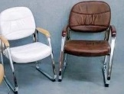
  - Wood arm rest arm style
  - Seat &back Material leather
  - Seat Color black /brown
  - Weight Capacity approx. 225 Ib
  - Chair frame steel
  - Seat Width 450 mm
  - Seat depth 480 mm
  - Height support 820 mm
  - Cushion Thickness 3"
4 | Fire extinguisher - Co2 fire extinguisher |  | 2 pcs | 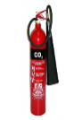
  - Capacity 6 ± 0.15
  - Fire rating 60 B
  - Working temperature:
  -20 C° ~ + 55 C°
  - Rate pressure test 22.5 Mpa
  - Expiry date in best condition:
  5 Years

- WARRANTY & DOCUMENTS:
- A minimum one-year warranty is required.

- GENERAL REMARKS AND SPECIAL CONDITION

- Technical data sheets or catalogues are required for all items
- Pictures are only for understanding the product specifications, not indicative of a specific model or brand.
- All standard accessories for the offered items should be provided.
- The supplier must provide the items with all standard technical features and specifications, in full working condition.
- Packing, loading, transportation, and unloading are the responsibility of the supplier.
- The price should include transportation and installation costs.
- Suppliers can make an offer for one lot or both lots, provided that all items under the lot they offer for are provided.
- All dimensions are approximate, with a tolerance of plus or minus 20 mm.
- All items are subject to thorough checking and approval by the GIZ team and the recipients.

- Delivery Location
- The delivery location is Al-Rumaitha Municipality, allocated to the ONE STOP SHOP space.

