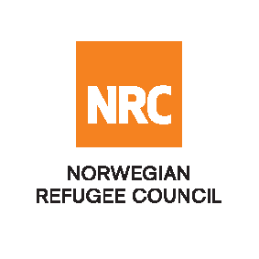

Tender Notice
Suppling Sewing Machines and Necessary Supplies in Anbar, Iraq

The Norwegian Refugee Council (NRC) is a non-governmental, humanitarian organization with 60 years of experience in helping to create a safer and more dignified life for refugees and internally displaced people.
NRC advocates for the rights of displaced populations and offers assistance within the Shelter, Education, Emergency food security, Legal assistance, and Water, sanitation, and hygiene sectors.

NRC has been present in Iraq since 2010, with offices located in Anbar province, Baghdad, Anbar, Erbil, Dohuk, Hamam Al Alil, Mosul, and Kirkuk. We have scaled up our response across Iraq to meet the large-scale crisis facing the country, reaching Iraqis with emergency assistance and supporting Syrian refugees as they live in exile. Our goal is to always be prepared to work in new settings, so we are establishing more local partnerships in Iraq.
The Norwegian Refugee Council (NRC) Office in Iraq invites eligible and interested suppliers to participate in the tender, Refer to the table below;

Code# | Description | RFQ Number
 | Suppling Sewing Machines and Necessary Supplies in Anbar, Iraq | RFQ/IQ/23/147

Deadline: Tender closing is at 14:00 Hrs (Iraq time) on 30th July 2023

- To receive the tender package, the supplier has to send an email to iq.baghdad.procurement@nrc.no requesting the tender package, then NRC will send the tender package to the bidders.
- Bid submission: Interested bidders can submit their bid in sealed envelope by (30th of July 2023 at 14:00) to NRC office located at: Hay Al-Warrar, near Maternity Teaching Hospital, Ramadi - Anbar, Iraq

Inquiries about the tender can be addressed to:
Email: iq.baghdad.procurement@nrc.no
Phone number: 0964 7834472687

NRC reserves the right to select/reject any bids, in part or full, as it may deem necessary without providing feedback in this regard. No liability or claim in that respect would be admissible or entertained whatsoever.

