Dear Supplier,

This is an invitation to you to visit our InTend portal if you are interested to apply on the recent advertised tender (Event Management Service in Iraq Lot1 South Central , Lot2 Kurdistan Region- BC/ 03109 ) the tender is now live on the portal, you need to enrol into the portal and express interest , then you download the ITT documents to see the requirement along with the terms and conditions , you will be able to participate by submitting the proposal through InTend Portal.

The deadline of receiving your proposal until 15.October.2023 at 13:00 (UTC+ 01:00) GMT Daylight time.

Short guidance about the portal in the attached PDF file.

Also you can access the tender through the link below:
https://in-tendhost.co.uk/britishcouncil/aspx/ProjectManage/3109

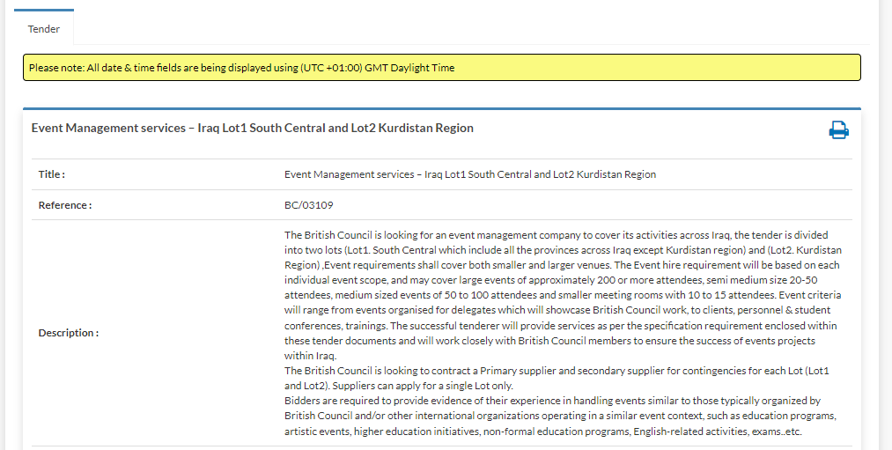

All the best.
MENA Procurement team

