Bid Form
Auction No.: 1. MAG-IQ-AUC-24-001
#Lot | Description | Year of Manufacture | Location | Offered Price (IQD) | Pictures
1 | FORD Ranger Pickup- Registered in Erbil/113828 | 2011 | Erbil |  | 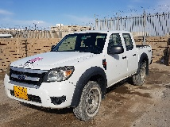
2 | FORD Ranger Pickup - Registered in  Erbil/113827 | 2011 | Erbil |  | 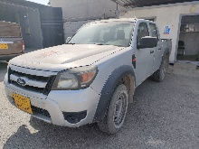
3 | FORD Ranger Pickup - Registered in  Erbil/113632 | 2011 | Erbil |  | 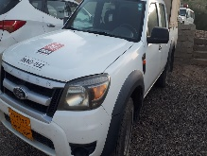
4 | Ssang Yong Korando Sport-Pick up - Registered in  Erbil/177805 | 2016 | Erbil |  | 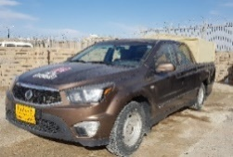
5 | Nissan Patrol 4500 S4x4 Wagon - Registered in  Erbil/330301 | 2002 | Erbil |  | 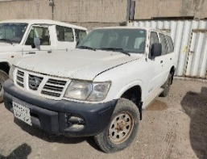
6 | Nissan Patrol 4500 S4x4 Wagon - Registered in  Erbil / 62825 | 2002 | Erbil |  | 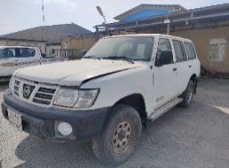
7 | Nissan Patrol 4500 S4x4 Wagon - Registered in  Erbil/64070 | 2002 | Erbil |  | 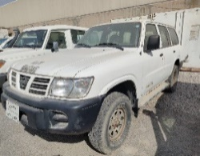
8 | Nissan Patrol 4500 S4x4 Wagon - Registered in  Erbil / 63236 | 2003 | Erbil |  | 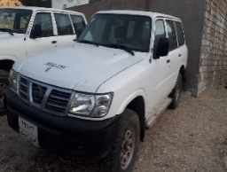
9 | Nissan Patrol 4500 S4x4 Wagon - Registered in  Erbil / 119254 | 2002 | Erbil |  | 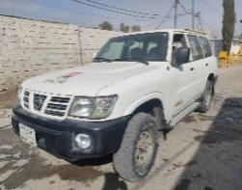
11 | Nissan Patrol 4500 S4x4 Wagon - Registered in  Erbil / 22A 332403 | 2002 | Erbil |  | 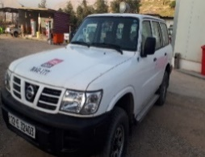
12 | Nissan Patrol 4500 S4x4 Wagon - Registered in  Erbil / 62873 | 2002 | Erbil |  | 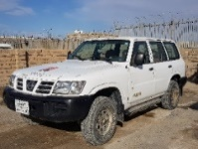
13 | Nissan Pickup 2400 - Registered in  Erbil / 52541 | 2008 | Erbil |  | 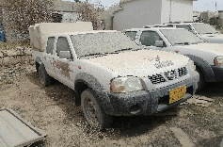
14 | Nissan Pickup 2400 - Registered in  Erbil / 10816 | 2008 | Erbil |  | 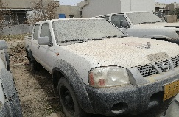
14-B | Ssang Yong Korando Sport-Pick up/2016 – Registered in Erbil / 177658 | 2016 | Erbil |  | 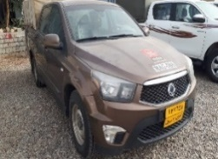

#Lot | Description | Year of Manufacture | Location | Offered Price (IQD) | Pictures
15 | FORD Ranger Pickup - Registered in  Erbil / 113631 | 2011 | Chamchamal |  | 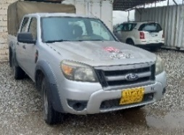
16 | Ssang Yong Korando Sport-Pick up - Registered in  Erbil / 177847 | 2016 | Chamchamal |  | 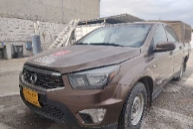
17 | Ssang Yong Korando Sport-Pick up - Registered in  Erbil /165363 | 2016 | Chamchamal |  | 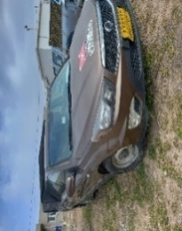
18 | Ssang Yong Korando Sport-Pick up - Registered in  Erbil / 99050 | 2016 | Chamchamal |  | 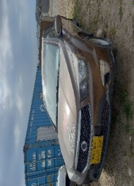
19 | Ssang Yong Korando Sport-Pick up - Registered in  Erbil /177810 | 2016 | Chamchamal |  | 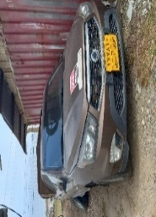
20 | Nissan Patrol 4500 S4x4 Wagon - Registered in  Erbil / 309545 | 2002 | Chamchamal |  | 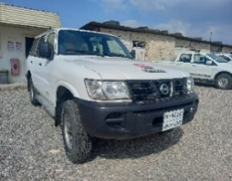
21 | Nissan Patrol 4500 S4x4 Wagon - Registered in  Erbil / 62463 | 2002 | Chamchamal |  | 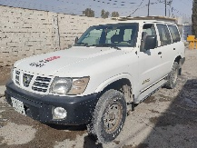
23 | Nissan Patrol 4500 S4x4 Wagon - Registered in  Erbil / 60722 | 2002 | Chamchamal |  | 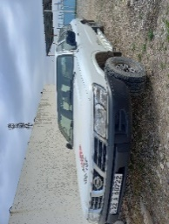
25 | Nissan Patrol 4500 S4x4 Wagon - Registered in  Erbil / 60534 | 2002 | Chamchamal |  | 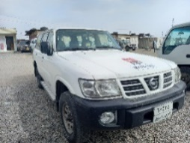
26 | Nissan Patrol 4500 S4x4 Wagon - Registered in  Suly / 43487 | 2002 | Chamchamal |  | 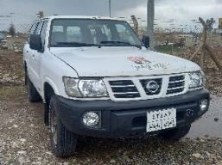
28 | Nissan Patrol 4500 S4x4 Wagon - Registered in  Erbil / 63105 | 2002 | Chamchamal |  | 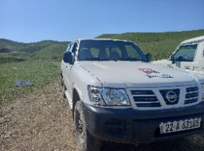
29 | Nissan Patrol 4500 S4x4 Wagon - Registered in  Erbil / 57769 | 2002 | Chamchamal |  | 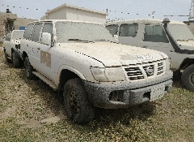
30 | Nissan Patrol 4500 S4x4 Wagon - Registered in  Erbil / 309515 | 2002 | Chamchamal |  | 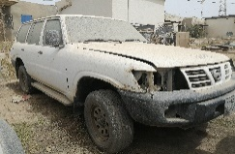
31 | Nissan Patrol 4500 S4x4 Wagon - Registered in  Erbil / 307689 | 2003 | Chamchamal |  | 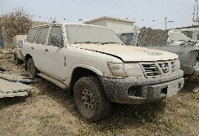
32 | TOYOTA LC Hard top 9 seat Diesel - Registered in  Erbil / 230626 | 2003 | Chamchamal |  | 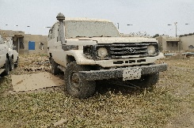
33 | FORD Ranger Pickup - Registered in  Erbil / 113633 | 2011 | Chamchamal
34 | Scania Truck 143M - Registered in  Duhok / 32127 | 1995 | Chamchamal |  | 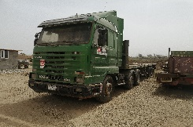
35 | Ssang Yong Korando Sport-Pick up - Registered in  Erbil / 177663 | 2016 | Chamchamal |  | 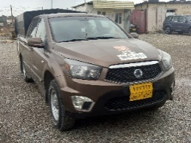
36 | Ssang Yong Korando Sport-Pick up - Registered in  Erbil /177862 | 2016 | Chamchamal |  | 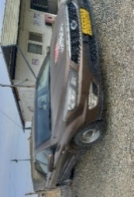
37 | Ssang Yong Korando Sport-Pick up - Registered in  Erbil /47808 | 2016 | Chamchamal |  | 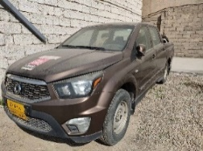
In addition to the quoted bid price, the successful bidder will be required to submit a security deposit of 3,750,000 IQD per vehicle. The successful bidder must also confirm their commitment to transfer ownership of the acquired vehicle to their name within 180 days from the date of vehicle handover. Upon the successful transfer of vehicle ownership, the 3,750,000 IQD security deposit will be refunded.
Bidder can apply for a single or multiple lot(s)
Bidders Comments (If any):
Name:
Address:
Phone Number:
ID Number:
Signature:
Stamp (If any):
Date:

