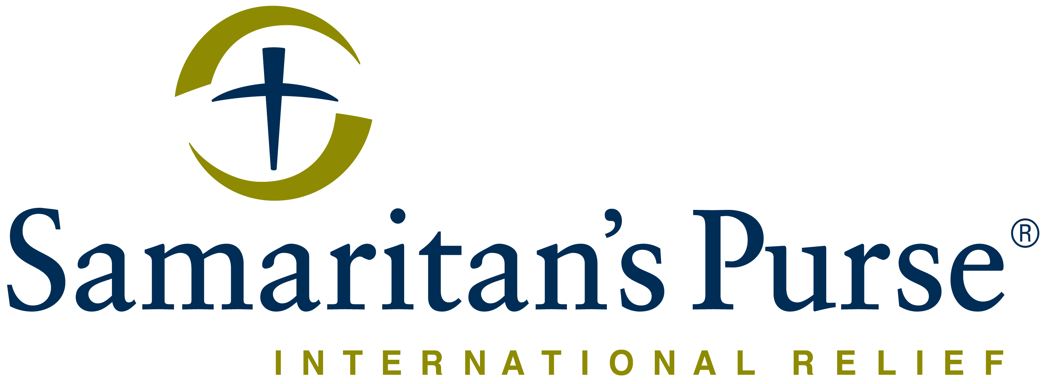

INVITATION SUPPLIER MEETING
Construction and Rehabilitation of Sanitation Structure in Sinjar

Samaritan's Purse – Iraq invites all companies and contractors to participate in tendering to the Construction and Rehabilitation of Sanitation structures in the Sinjar area.
Companies and contractors are to participate in attending the tender meeting and submit a Sealed Quote Bid for consideration.

Brief Project Description:
With this call for tender, Samaritan’s Purse intends to engage the services of a contractor to complete WASH construction projects.
Instructions:
- Samaritan’s Purse Iraq will hold two separate meetings. One in Sinjar on 28th-Mar-2024 and one in Duhok on 3-Apr-2024.
- Samaritan’s Purse staff will be present during the meeting to clarify the work and answer questions. See below for the meeting location.
- These meetings are the same but in 2 different locations. Attending one of these meetings will be mandatory for all interested companies. The bid documents will only be distributed to the companies who attend one of these meetings.
- Each company’s representative must have an appropriate education and work experience in engineering to understand the project.
- MEETING LOCATIONS
  - #1 Sinjar City:
    - Samaritan's Purse Iraq CCC facility in Sinjar City, Alqadsya Neighborhood, near Martyr Majd Altamimi School, In front of the Alqadsya public garden.
    - GPS: 36.3232240, 41.8736373
  - #2 Duhok
    - Samaritan's Purse Iraq Duhok Office located at KRO Street, Near Zada Hotel
    - GPS: 36.8672881, 42.9647334
- Following the meeting, a formal Request for Quotation (RFQ) along with a full advertisement package will be issued via email to each vendor to prepare their sealed bids. A company must attend either the Sinjar or the Duhok meeting to receive the advertisement
- The meeting in Sinjar will start at 11:00 AM.
- The meeting in Duhok will start at 10:30 AM.
- Each meeting should take around 1.5 hour(s).
- Instructions will be given at the meeting on where to submit bids as well as submission deadlines.

WE PRACTICE PROCUREMENT WITH INTEGRITY
The integrity of the Public Tender procurement process is of the utmost importance. Unethical procurement conduct will not be tolerated and will result in immediate dismissal from the Public Tender procurement process. All bids are received directly by the Tender committee. It is not possible to influence the decision or outcome of the Tender. Submit your best value proposal the first and only time. No Samaritan's Purse employee will solicit you outside of this tender. REPORT ALL UNETHICAL BEHAVIOR, FOR CONFIDENTIALITY REPORT TO THE
Samaritan’s Purse HOTLINE (Phone Call/ WhatsApp/ Signal) (Iraq +964 750 863 6742).
If you, the supplier, suspect fraud from an SP employee, are asked to commit fraud or witness an SP employee act deceitfully, please notify Samaritan's Purse leadership by calling our confidential hotline where Arabic and Kurdish speakers are ready to receive your call. Please (Phone Call/ WhatsApp/ Signal) (Iraq +964 750 863 6742).

