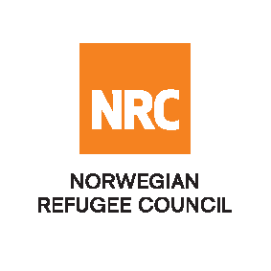

Tender Notice

The Norwegian Refugee Council (NRC) is a non-governmental, humanitarian organization with 60 years of experience in helping to create a safer and more dignified life for refugees and internally displaced people.
NRC advocates for the rights of displaced populations and offers assistance within the Shelter, Education, Emergency food security, Legal assistance, and Water, sanitation, and hygiene sectors.

NRC has been present in Iraq since 2010, with offices located in Anbar province, Baghdad, Anbar, Erbil, Dohuk, Hamam Al Alil, Mosul, and Kirkuk. We have scaled up our response across Iraq to meet the large-scale crisis facing the country, reaching Iraqis with emergency assistance and supporting Syrian refugees as they live in exile. Our goal is to always be prepared to work in new settings, so we are establishing more local partnerships in Iraq.
The Norwegian Refugee Council (NRC) Office in Iraq invites eligible and interested suppliers to participate in the tender, Refer to the table below;

Code# | Description | RFQ Number
 | Provide Barber materials | RFQ/IQ/24/043

Deadline: Tender closing is at 16:00 Hrs (Iraq time) on 5th of May 2024

- To receive the tender package, the supplier has to download the tender package from the eTB system via this LINK .

Inquiries about the tender can be addressed to:
Email: iq.baghdad.procurement@nrc.no
Phone number: 0964 783 447 2687

NRC reserves the right to select/reject any bids, in part or full, as it may deem necessary without providing feedback in this regard. No liability or claim in that respect would be admissible or entertained whatsoever.

