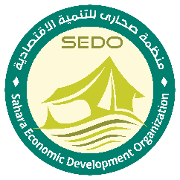

Tender Notice
Sahara Economic Development Organization (SEDO) is Iraqi National NGO, it's established in November 2007 as an independent NGO with its main office in Tikrit city. It focuses on developing the economic sector through providing business management training courses and counseling services to entrepreneurs and potential investors to enable them to efficiently contribute to the local economy. SEDO is considered among the most effective and qualified organizations in Iraq. It has conducted economic studies on the business environment in Iraq, identifying business opportunities and market niches for potential investors in Iraq. SEDO started humanitarian intervention in Iraq to response for the urgent need for our beneficiaries, it's work in WASH, Livelihood, protection, Food security and Education sectors.

Contracting to provide ERP (Enterprise Resource Planning)

Detailed technical specifications are included within the tender documents. If you are interested in submitting a bid, please contact the following address procurement@sedoiraq.org to express your interest and request the tender documents. Tender documents will be sent to you by email .
. procurement@sedoiraq.org
It is recommended to request / collect the tender documents as soon as possible.: Completed tender documents to be submitted to Sahara Economic Development Organization Office in the following locations: - Sahara Economic development Office, Salah Aldin , Tikrit , Al Jawhra Complex
NOTE: Please put this in subject line when requesting tender documents through email - “PR/TIK/2024/0083”
PR/TIK/2024/0083
Completed tender documents are due to be submitted to Sahara Economic Development Organization
Before the 30 of June 2024

