Call for Auction of Vehicles
Auction No.: 1. MAG-IQ-AUC-24-002

Mines Advisory Group (MAG) has been working in Iraq since the past 30 years. MAG Iraq intends to auction the following vehicles on as is where is basis.

A call for this auction was advertised in January 2024 but due to non-convenience with received offers it was decided that this new auction is announced. Bidders who applied to the earlier auction are required to apply a fresh (Should they wish to do so).
Erbil
GPS Coordinates for vehicles inspection: 36.14801242307794, 44.001657355608806
#Lot | Description | Year of Manufacture | Location | Expiry Date of documents | Pictures
1 | FORD Ranger Pickup- Registered in Erbil/113828 | 2011 | Erbil | 18-Dec-23 | 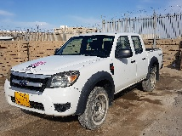
2 | FORD Ranger Pickup - Registered in  Erbil/113827 | 2011 | Erbil | 15-Mar-24 | 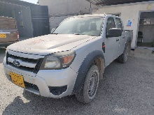
3 | Ssang Yong Korando Sport-Pick up - Registered in  Erbil/177805 | 2016 | Erbil | 29-Nov-23 | 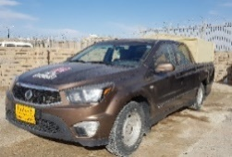
4 | Nissan Patrol 4500 S4x4 Wagon - Registered in  Erbil/330301 | 2002 | Erbil | 17-Sep-21 | 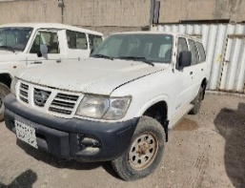
5 | Nissan Patrol 4500 S4x4 Wagon - Registered in  Erbil / 62873 | 2002 | Erbil | 26-Dec-22 | 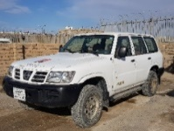
6 | Nissan Pickup 2400 - Registered in  Erbil / 52541 | 2008 | Erbil | 11-Dec-19 | 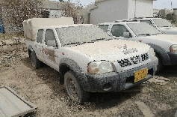
7 | Nissan Pickup 2400 - Registered in  Erbil / 10816 | 2008 | Erbil | 8-Mar-20 | 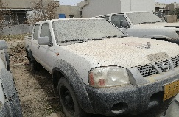
8 | Ssang Yong Korando Sport-Pick up/2016 – Registered in Erbil / 177658 | 2016 | Erbil | 29-Nov-23 | 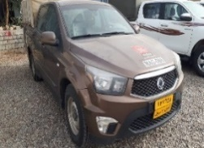
9 | Nissan Patrol 4500 S4x4 Wagon - Registered in  Erbil / 22A 60699 | 2002 | Erbil | 18-Aug-24 | 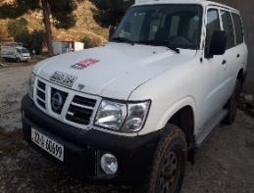

Chamchamal
GPS Coordinates for vehicles inspection: 35.499681466548125, 44.7809445802556
#Lot | Description | Year of Manufacture | Location | Expirey Date of documents | Pictures
10 | FORD Ranger Pickup - Registered in  Erbil / 113631 | 2011 | Chamchamal | 18-Dec-23 | 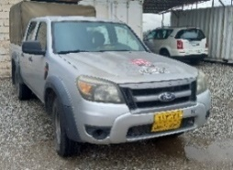
11 | Ssang Yong Korando Sport-Pick up - Registered in  Erbil / 177847 | 2016 | Chamchamal | 29-Nov-23 | 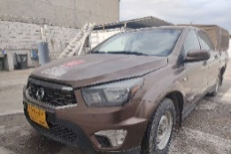
12 | Ssang Yong Korando Sport-Pick up - Registered in  Erbil /165363 | 2016 | Chamchamal | 29-Nov-23 | 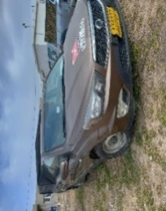
13 | Ssang Yong Korando Sport-Pick up - Registered in  Erbil / 99050 | 2016 | Chamchamal | 29-Nov-21 | 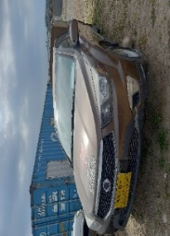
14 | Nissan Patrol 4500 S4x4 Wagon - Registered in  Erbil / 309545 | 2002 | Chamchamal | 5-Oct-23 | 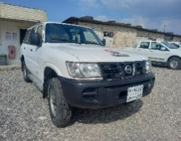
15 | Nissan Patrol 4500 S4x4 Wagon - Registered in  Erbil / 63105 | 2002 | Chamchamal | 19-May-24 | 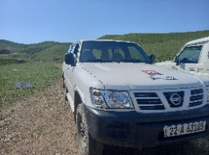
16 | Nissan Patrol 4500 S4x4 Wagon - Registered in  Erbil / 57769 | 2002 | Chamchamal | 18-Aug-21 | 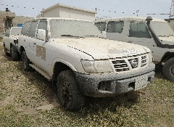
17 | TOYOTA LC Hard top 9 seat Diesel - Registered in  Erbil / 230626 | 2003 | Chamchamal | 19-Dec-19 | 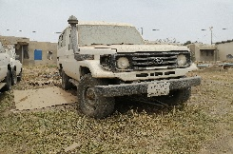
18 | Scania Truck 143M -with attachment MAG-106 Registered in  Duhok / 32127 | 1995 | Chamchamal | 14-Jul-20 | 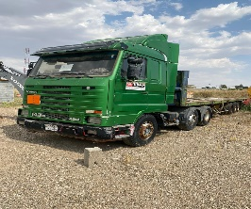
19 | Ssang Yong Korando Sport-Pick up - Registered in  Erbil / 177663 | 2016 | Chamchamal | 29-Nov-23 | 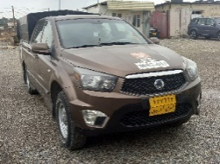
20 | Ssang Yong Korando Sport-Pick up - Registered in  Erbil /177862 | 2016 | Chamchamal | 29-Nov-23 | 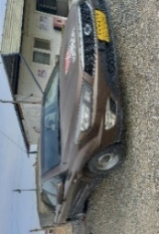
21 | Ssang Yong Korando Sport-Pick up - Registered in  Erbil /177810 | 2016 | Chamchamal | 29-Nov-23 | 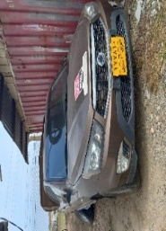
22 | Nissan Patrol 4500 S4x4 Wagon - Registered in  Erbil / 62532 | 2001 | Chamchamal | 25-Jan-23 | 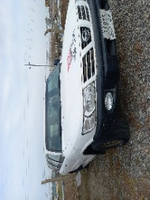
23 | Nissan Patrol 4500 S4x4 Wagon - Registered in  Suly/43269 | 2002 | Chamchamal | 26-May-24 | 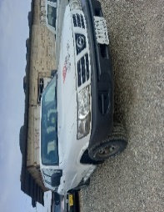
24 | Nissan Patrol 4500 S4x4 Wagon - Registered in  Erbil / 60324 | 2002 | Chamchamal | 25-Jan-23 | 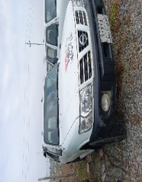

Terms and Conditions:
The vehicles from lot 1 to lot 9may be inspected at the MAG base in Erbil, Adala District with address coordinates below during office hours (Sunday – Thursday / 8:30 –16:00 hrs) from 03 July 2024 up to 14July 2024;

Erbil, Adala: 35.499681466548125, 44.7809445802556
For Vehicles inspection in Erbil, Point of Contact: 07500242425
The vehicles from lot 10 to lot 24 may be inspected at the MAG base in Chamchamal District with address coordinates below during office hours (Sunday – Thursday / 8:30 – 16:00 hrs) from 03 July up to 14 July 2024;
Chamchamal: 35.499681466548125, 44.7809445802556
For Vehicles inspection in Chamchamal, Point of Contact: 07508447496

Submission of Offers
Interested parties may submit their sealed bids at the following location during office hours (Sunday – Thursday / 8:30 – 16:00 hrs) from 03June 2024 up to 16 July 2024;
Erbil: 36.23423182134221, 43.98834463997686
Point of Contact: 07500242425

OR

Chamchamal: 35.499681466548125, 44.7809445802556
Point of Contact: 07508447496

- MAG reserves the right to accept or reject any or all bids without assigning any reason
- The vehicles are offered on as is where is basis therefore it will be the responsibility of the successful bidder/s to remove the vehicles from the MAG bases
- The vehicles will be offered to the highest bidder for the respective lot
- The bidders can apply for a single or Multiple Lots
- Upon the announcement of the successful bidder(s) the said bidder will be required to submit the bid quoted amount to MAG Iraq bank account within 3 working days. If the said amount is not deposited within 3 working days MAG reserves the right to not consider the said bid and offer the goods to the next highest bidder.
- In addition to the quoted bid price, the successful bidder will be required to submit a security deposit of 3,750,000 IQD per vehicle. The successful bidder must also confirm their commitment to transfer ownership of the acquired vehicle to their name within 180 days from the date of vehicle handover. Upon the successful transfer of vehicle ownership, the 3,750,000 IQD security deposit will be refunded.
- Price quoted and accepted will only be in Iraqi Dinar (IQD)
- The quoted bid must be valid for 180 days.
- Interested parties/bidders are required to submit their bid using MAG bidding form
- This Auction is open for both Companies and Individuals to apply.

