It shall be the bidder’s responsibility to carefully examine the following sections and provide Items that are in compliance with the MAG (MINES ADVISORY GROUP) Minimum Requirements.

1. Technical minimum requirements of the Goods

Diesel Fuel/ Minimum Standard Specification required
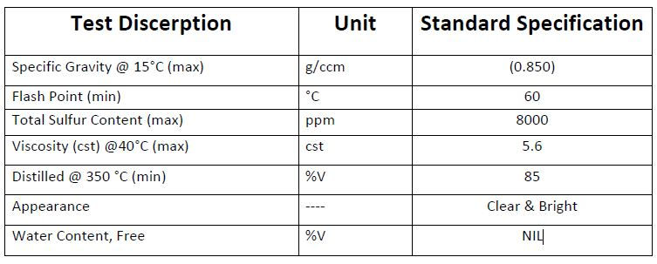

Petrol Fuel/ Minimum Standard Specification required
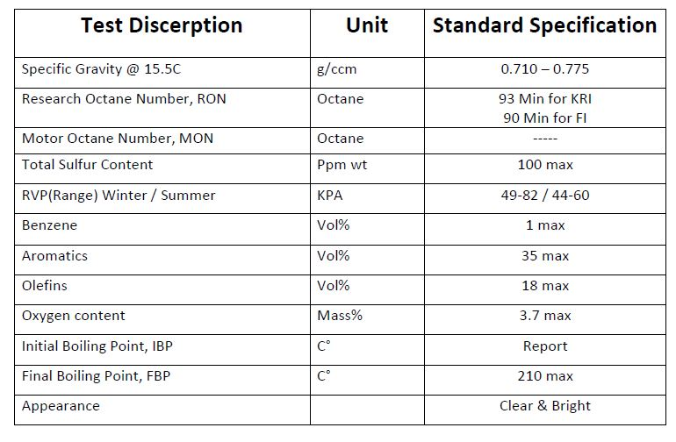

# Lot | Item(s) Description | Specifications | Average estimated monthly consumption in Litter | Are you applying for this LOT? (YES/NO)
1 | Diesel fuel to be delivered in Erbil | Flash point of 60°C and above for diesel fuel | 15000
1 | Petrol fuel to be delivered in Erbil | Petrol should be unleaded with octane ratings of 93 and above | 5000
2 | Diesel fuel to be delivered in Chamchmal | Flash point of 60°C and above for diesel fuel | 18000
2 | Petrol fuel to be delivered in Chamchmal | Petrol should be unleaded with octane ratings of 93 and above | 15000
3 | Diesel fuel to be delivered in Sulaymaniyah | Flash point of 60°C and above for diesel fuel | 2000
3 | Petrol fuel to be delivered in Sulaymaniyah | Petrol should be unleaded with octane ratings of 93 and above | 2000
4 | Diesel fuel to be delivered in Chwarta | Flash point of 60°C and above for diesel fuel | 2000
4 | Petrol fuel to be delivered in Chwarta | Petrol should be unleaded with octane ratings of 93 and above | 2000
5 | Diesel fuel to be delivered in Telkef | Flash point of 60°C and above for diesel fuel | 15000
5 | Petrol fuel to be delivered in in Telkef | Petrol should be unleaded with octane ratings of 90 and above | 5000
6 | Diesel fuel to be delivered in Tel Afar | Flash point of 60°C and above for diesel fuel | 10000
6 | Petrol fuel to be delivered in in Tel Afar | Petrol should be unleaded with octane ratings of 90 and above | 10000
7 | Diesel fuel to be delivered in Sinjar | Flash point of 60°C and above for diesel fuel | 16000
7 | Petrol fuel to be delivered in in Sinjar | Petrol should be unleaded with octane ratings of 90 and above | 6000
8 | Diesel fuel to be delivered in Duhok | Flash point of 60°C and above for diesel fuel | 10000
8 | Petrol fuel to be delivered in in Duhok | Petrol should be unleaded with octane ratings of 93 and above | 6000

Subcontractors and Third-Party Suppliers: Bidders must disclose any subcontractors or third-party suppliers involved in the process of fuel delivery to MAG Iraq. This includes any entities that will participate in or have a role in fulfilling the contract.
Question | Yes/No | 3rd Party details ( If Any)
Do you have or willing to have any subcontractors or third-party suppliers that will be involved in the process of fuel delivery to MAG Iraq? If yes please provide details

Supplier’s Premises Visit / Suppliers Meeting
It is Required for this tender and will be scheduled by the Tender Committee - Yes

Shortlisted bidders which pass the technical evaluation stage will be visited for Due Diligence and capacity evaluation. During the visit the Committee will check the physical existence of the bidder and its office, Number of staffs, quality certification if any, evaluate the capacity to meet MAG’s delivery schedules. This includes assessing ability of the bidder to supply the required quantities to remote field bases efficiently.

2. Purchase Terms

TERMS | COMPLIANCE  Yes/No
- Currency: The main currency of the Framework Agreement will be USD. Do you agree with USD being the currency of the agreement? | Y/N?
Delivery Terms: The supplier is fully responsible for delivering the goods in good quality to the MAG locations specified in the Tender Instructions File. This includes all aspects of the delivery process, such as loading, transportation, offloading, and a one-time Fuel Testing cost for each order.  If the delivery is handled by a third-party transport company, the supplier remains liable for the item until it is safely delivered to MAG’s premises and accepted by MAG. Detailed terms will be included in the framework agreement to clarify the point at which the supplier’s responsibility ends and MAG’s responsibility begins. | Y/N?
- Quotation Validity: The cost quoted by the bidder shall be kept firm and unchanged for a minimum of 30 days. When the quotation’s issued date is not explicit, the deadline of the reception of the bids will be considered.  - In case the bidder does not agree with the above. How many days will the quotation be valid? | Y/N?  Days:
- Payment Method: Bidder agrees to follow the MAG standard, 30 days after the reception of goods / services (Good Reception Note signature date) via bank cheque or bank transfer.  If different payment method:  - Number of days after reception of the goods/services? | Y/N?  Days:
- Advance Payment. Bidder agrees with no advance payment as per MAG standards. | Y/N?
- The Bidder will not be permitted to take advantage of any errors or omissions in this Invitation to Tender or any Purchase Order or Contract thereafter. Should the Bidder discover any errors or omissions, the Bidder must notify MAG accordingly. | Y/N?
- Do you have a business registration with the Ministry of Trade in Federal Iraq? | Y/N?
- Do you have a business registration with the Ministry of Trade in Kurdistan Iraq Region (KRI)? | Y/N?
- Do you have a license of Oil services specialty from the Ministry of Natural Resources (Kurdistan Iraq Region)? | Y/N?

Please note the MAG might shortlist/sign framework agreement with multiple suppliers/bidder and when required, the purchaser (MAG Iraq) shall ask for price quote on a monthly basis/need basis from the contracted suppliers, and issue the MAG purchase order to the best priced supplier. As the delivery of fuel will be required at multiple locations in Iraq (locations mentioned in the title of this tender) MAG Iraq will issue the purchase order/s to the most financially advantageous offer for that respective location.

Bidder Comments, Detailed the Specific Terms in case they are different from MAG Terms

3. Bidder Declaration

The Supplier’s representative accepts in full and without restriction the conditions governing this tender as the sole basis of this competition, whatever its own conditions of sale may be, which we hereby waive.
The Supplier’s representative has examined carefully, understood, and comply with all conditions, instructions, forms, provisions, and specifications contained in this tender dossier including the contract template with its annexes.
The Supplier’s representative is aware that failure to submit a tender containing all the information and documentation expressly required in the form requested and within the specified deadline, may lead to the rejection of the tender at MAG’s discretion.
The Bidder holds no reservation regarding the tender dossier; and are aware that any reservation may result in the rejection of the tender by MAG.

Company name:  Company’s Representative name:  Company’s Representative Job Title: | Representative’s signature  Company Stamp:  City, date:

