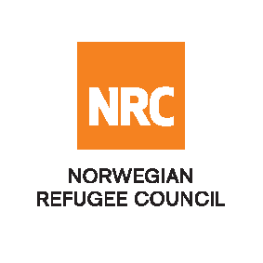

Auction Notice
Invitation to Auction for Selling Electric Diesel Generators (Second hand)

RFQ/IQ/24/089

The Norwegian Refugee Council (NRC) is a non-governmental, humanitarian organization with 60 years of experience in helping to create a safer and more dignified life for refugees and internally displaced people.
NRC advocates for the rights of displaced populations and offers assistance within the Shelter, Education, Emergency food security, Legal assistance, and Water, sanitation, and hygiene sectors.

NRC has been present in Iraq since 2010, with offices located in Baghdad province, Anbar, Erbil, Dohuk, Hamam Al Alil, Mosul, and Kirkuk. We have scaled up our response across Iraq to meet the large-scale crisis facing the country, reaching Iraqis with emergency assistance and supporting Syrian refugees as they live in exile. Our goal is to always be prepared to work in new settings, so we are establishing more local partnerships in Iraq.
The Norwegian Refugee Council (NRC) Office in Iraq invites eligible and interested companies and individuals to participate in the auction, Refer to the table below;

Code# | Description | RFQ Number
 | Selling Electric Diesel Generators (Second hand) | RFQ/IQ/24/089

- Site visit: Sunday 1 September 2024, from 10:00 AM to 15:00 at Nineveh\ Baaj District
- Deadline: Tuesday 3 of September 2024 at 13:00

Submission:
If your company are interested in participating in the Auction, it requires you to download the RFQ package, free of change, using the following Link
NRC reserves the right to select/reject any offer, in part or full, as it may deem necessary without providing feedback in this regard. No liability or claim in that respect would be admissible or entertained whatsoever.
Remark |  | - The offer, as well as all correspondence and documents relating to the Bid shall be written in English.  - Offers must be submitted through the eTB system, and before the Auction deadline expires. It will not be possible to submit your bid after the deadline or outside the eTB system.  - For technical questions about the system, please get in touch with iq.mosul.procurement@nrc.no
Sincerely,
NRC IRAQ Procurement Department

