ANNEX A.1
VEHICLE DETAILS AND DESCRIPTIONS

These vehicles can be inspected from 10.09.2024 to 25.09.2024 between the hours of 9:00 am to 12:30 Noon each working day except the government holidays in DRC. Information on vehicles will be displayed at the inspection site. All interested bidders are requested to visit Danish Refugee Council office as follows:

Star Tower, Block D, Floor 11, Erbil, Iraq
GPS Coordinates: 36.205378358980305, 43.984661333355746
Email: diar.tahir@drc.ngo
Phone: +964 751 169 2749

NOTE THAT THE CONTACT NUMBER IS SOLELY FOR THE PURPOSE OF ENQUIRIES ABOUT LOCATING THE INSPECTION SITES

LOT # 1
Name: Sedan Car Lot # 1
Brand: Chevrolet
Chassis Number: KL1GJ5DU8DB005566
Engine Number: N/A
Make Year: 2013
Colour: Silver
Driven KM: 145262
Model: Chevrolet-Malibu LS
Registration number: 22 C37850
Registration expire date: Sunday, November 28, 2027
Description: Good condition/ Body (Small scratch )
Present Vehicle Location: Erbil, Iraq
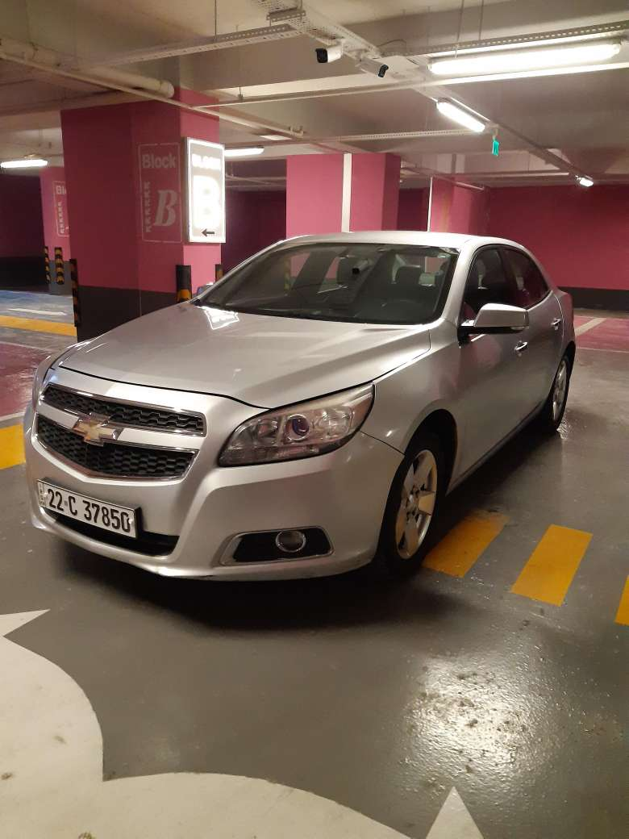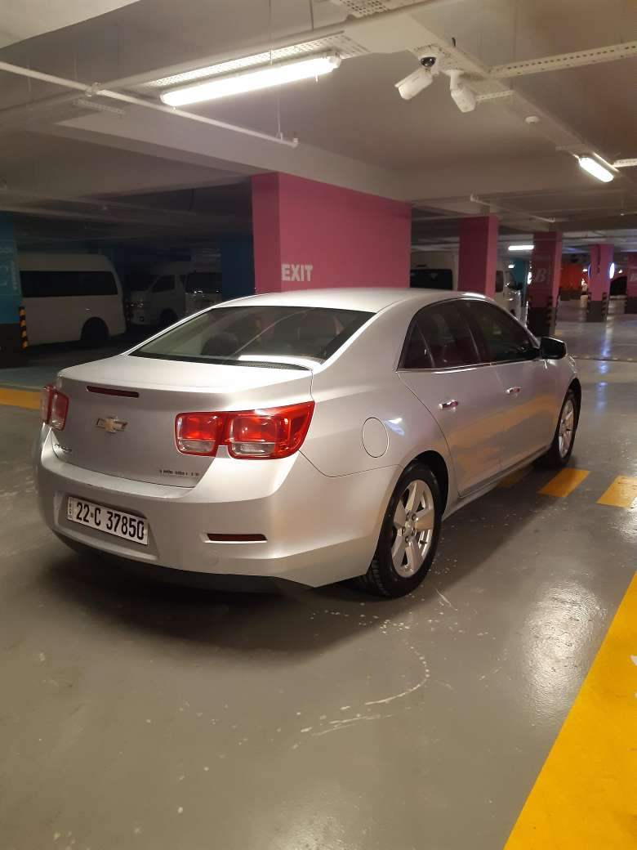

LOT # 2
Name: Sedan Car Lot # 2
Brand: Chevrolet
Chassis Number: KL1GJ5DU2DB007118
Engine Number: N/A
Make Year: 2013
Colour: Silver
Driven KM: 120854
Model: Chevrolet-Malibu LS
Registration number: Erbil-317957
Registration expire date: Saturday, January 21, 2023
Description: Good condition
Present Vehicle Location: Erbil, Iraq
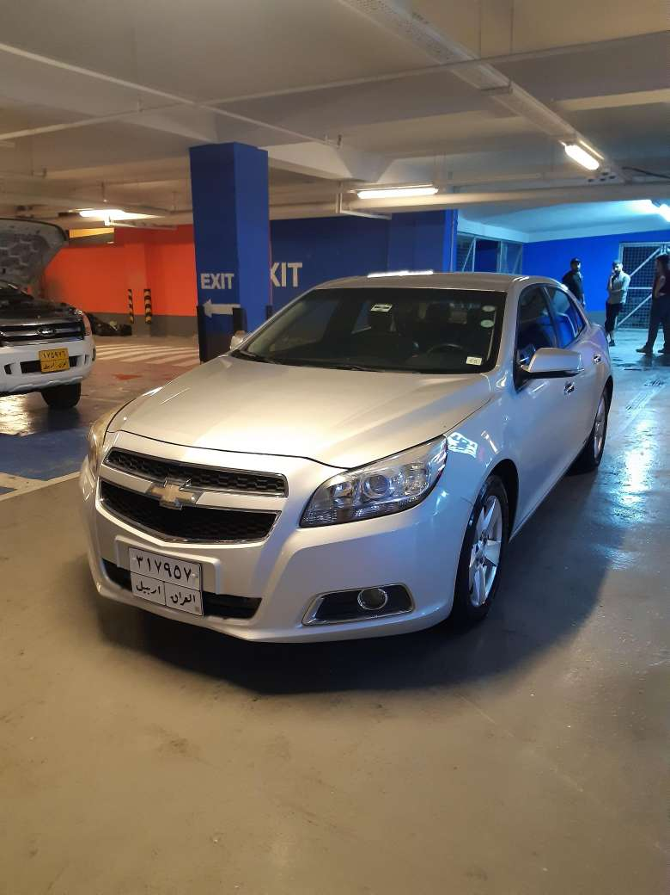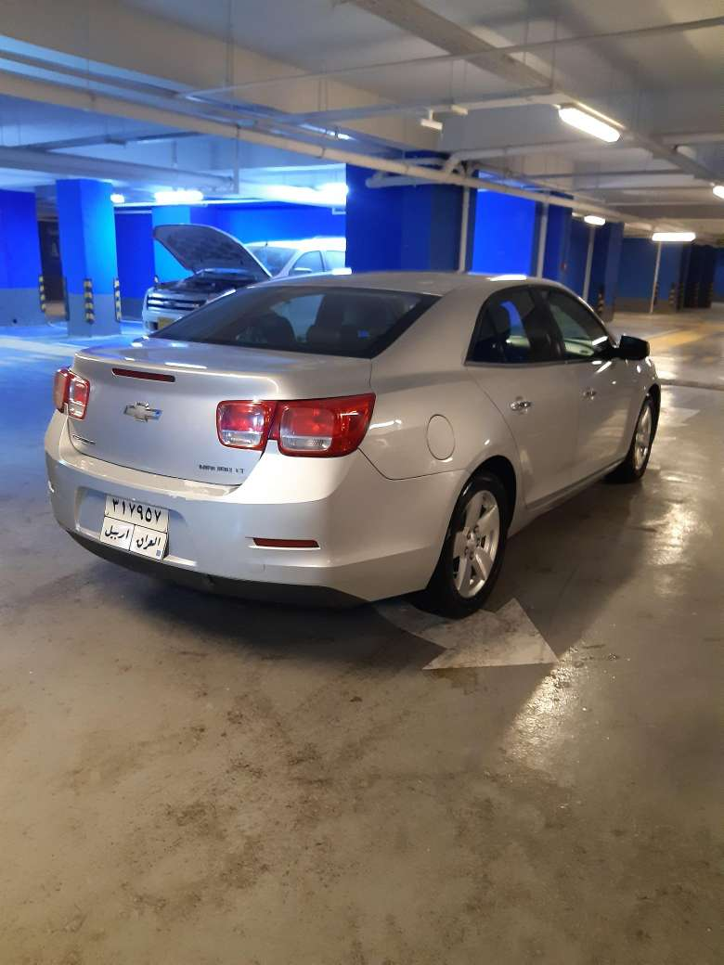z

LOT # 3
Name: Sedan Car Lot # 3
Brand: Chevrolet
Chassis Number: KL1GJ5DU0DB007117
Engine Number: N/A
Make Year: 2013
Colour: Silver
Driven KM: 143522
Model: Chevrolet-Malibu LS
Registration number: Erbil-233590
Registration expire date: Friday, January 20, 2023
Description: Both side (Doors) dent.
Present Vehicle Location: Erbil, Iraq
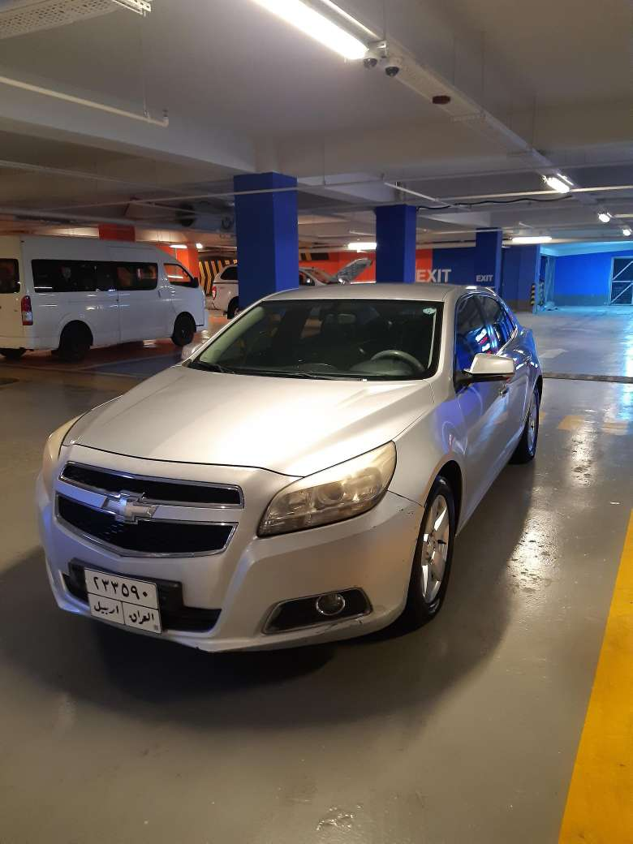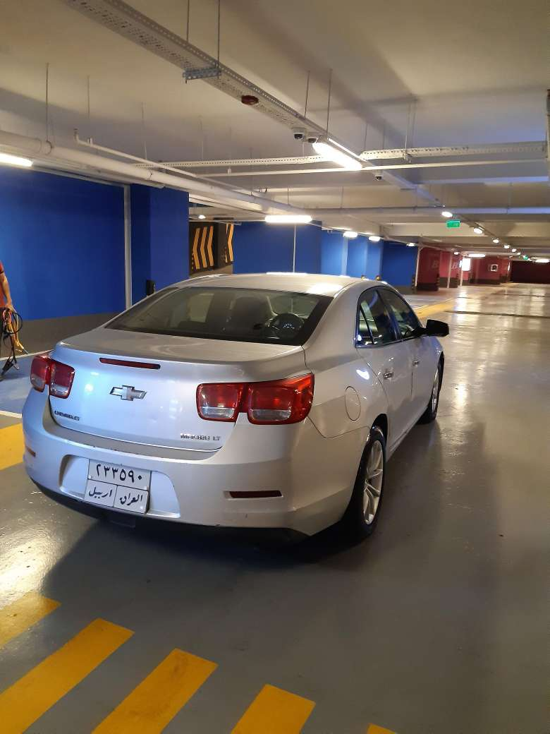

LOT # 4
Name: Sedan Car Lot # 4
Brand: Chevrolet
Chassis Number: KL1GJ5DU2DB006339
Engine Number: N/A
Make Year: 2013
Colour: Silver
Driven KM: 179125
Model: Chevrolet-Malibu LS
Registration number: Erbil-317709
Registration expire date: Thursday, December 1, 2022
Description: Good condition, small scratch on a body
Present Vehicle Location: Erbil, Iraq
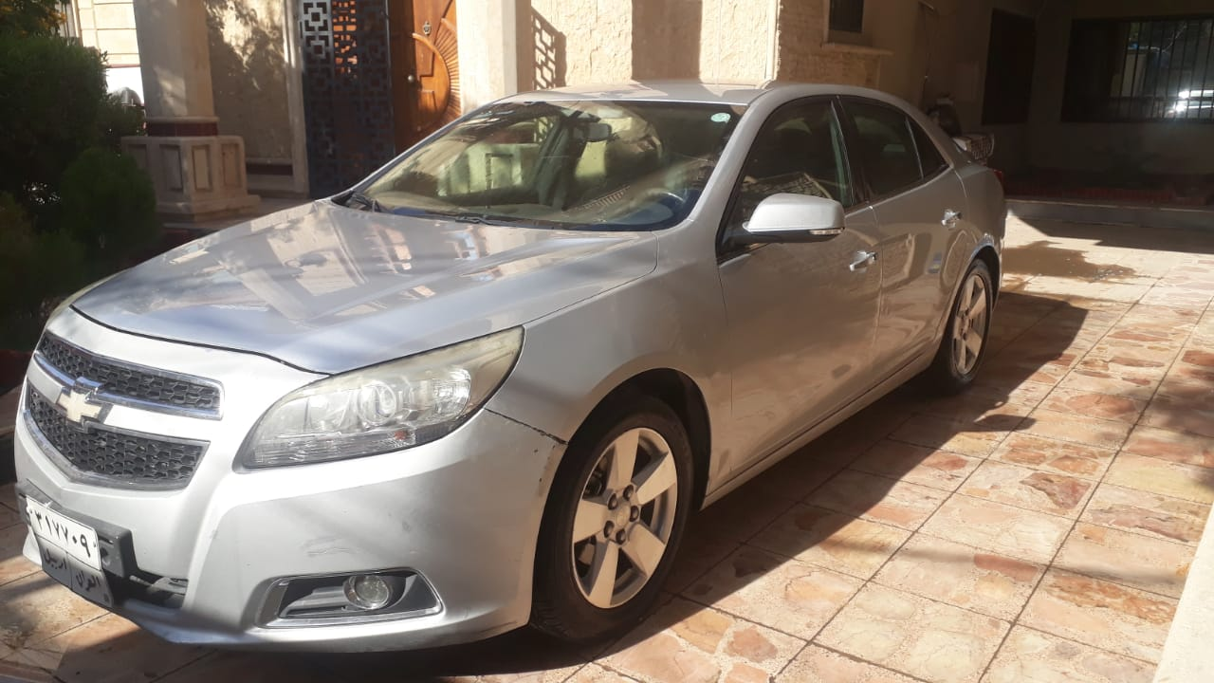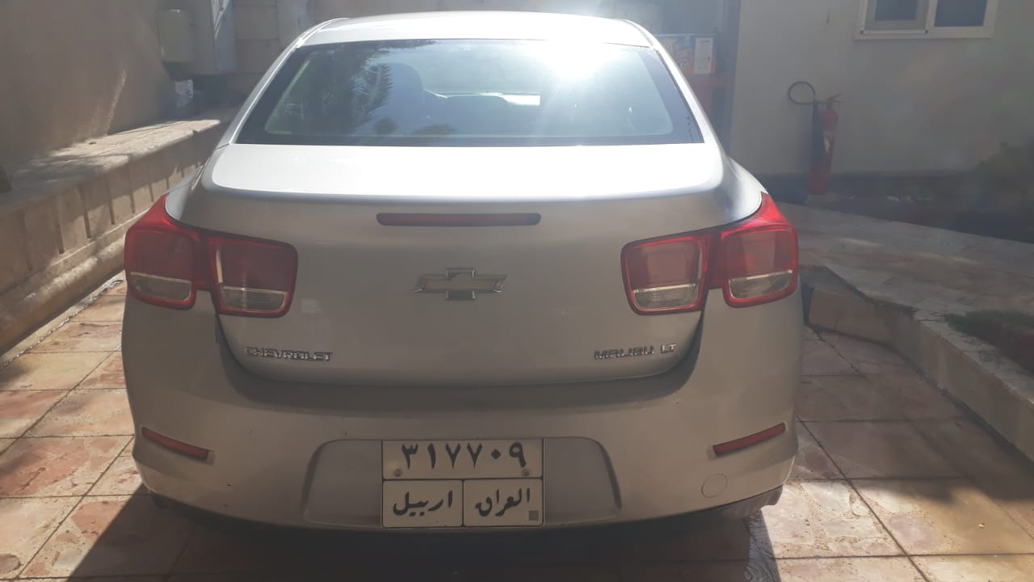

LOT # 5
Name: Minivan Car Lot # 5
Brand: Toyota
Chassis Number: JTGSX23P2H6184071
Engine Number: N/A
Make Year: 2017
Colour: White
Driven KM: 11214
Model: Toyota Hiace
Registration number: Erbil-43113
Registration: Saturday, March 18, 2023
Description: Good condition
Present Vehicle Location: Erbil, Iraq

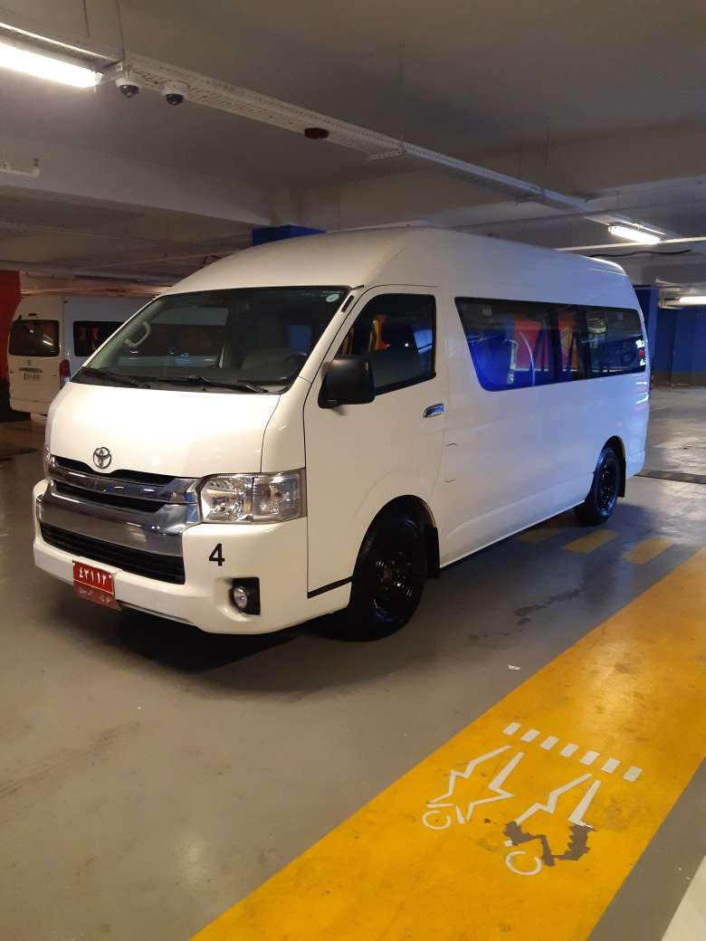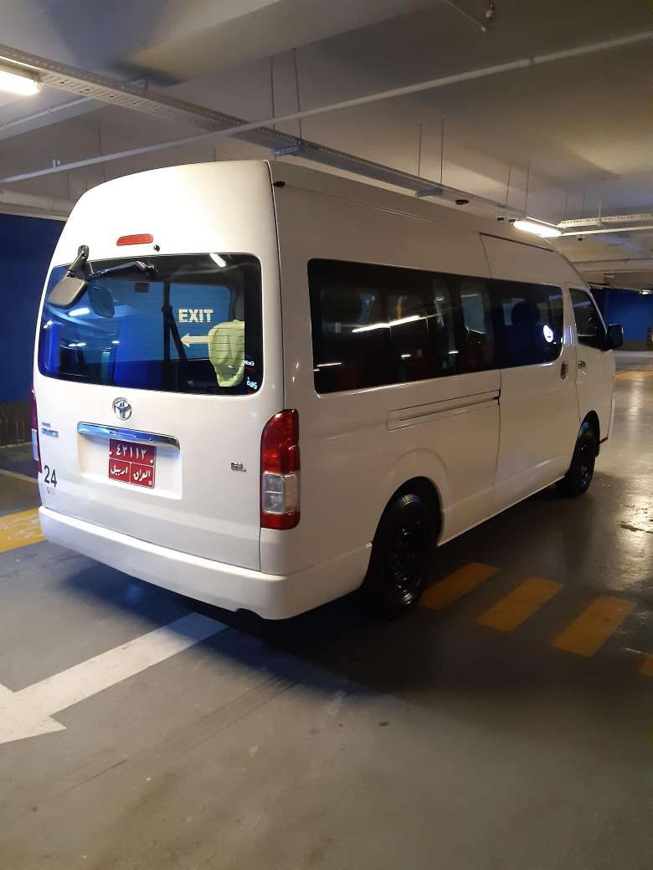

LOT # 6
Name: Minivan Car Lot #6
Brand: Toyota
Chassis Number: JTGSX23P4H6178711
Engine Number: N/A
Make Year: 2017
Colour: White
Driven KM: 36224
Model: Toyota Hiace
Registration number: Erbil-42946
Registration expire date: Sunday, May 21, 2023
Description: Good condition
Present Vehicle Location: Erbil, Iraq

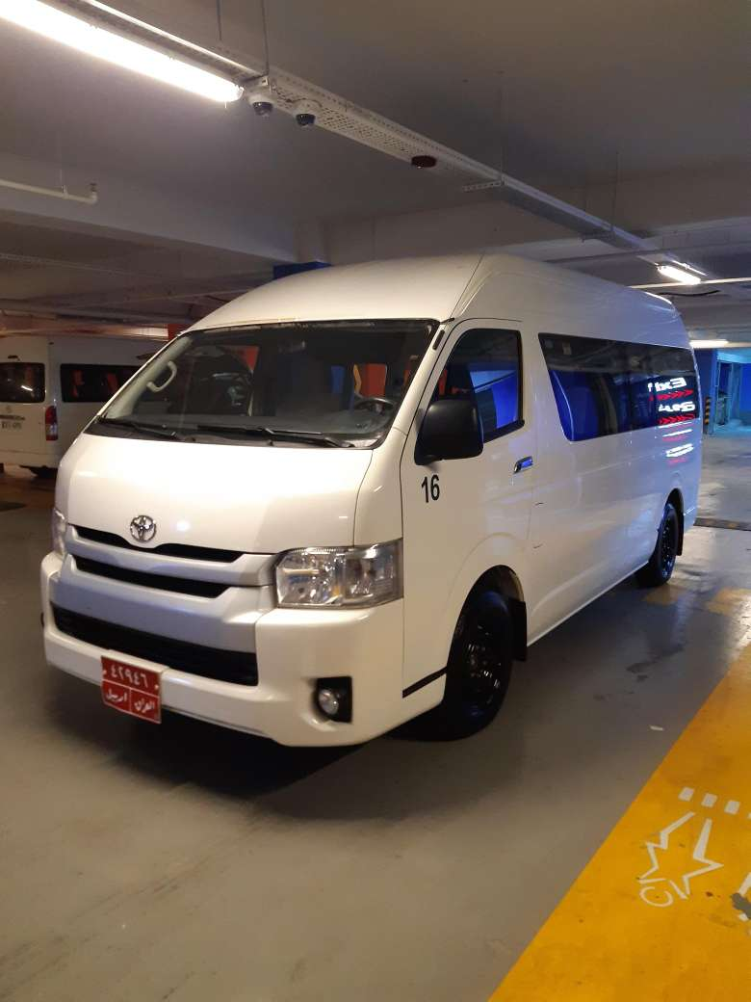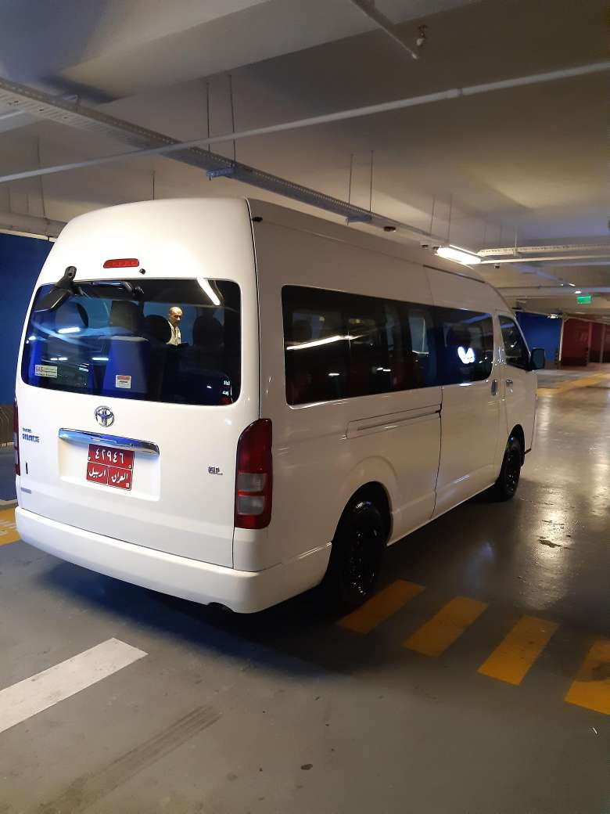

LOT # 7
Name: Pick-up Car Lot # 7
Brand: Ford
Chassis Number: AFAFP4LP3FJA36993
Engine Number: N/A
Make Year: 2015
Colour: White
Driven KM: 72275
Model: Ford-Ranger
Registration number: Erbil-173449
Registration expire date: Tuesday, March 10, 2020
Description: Good condition
Present Vehicle Location: Erbil, Iraq
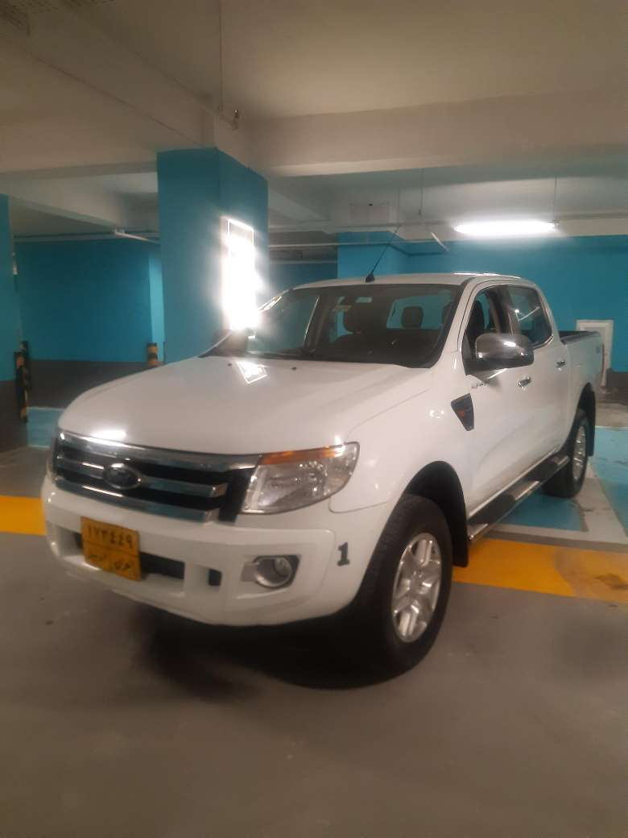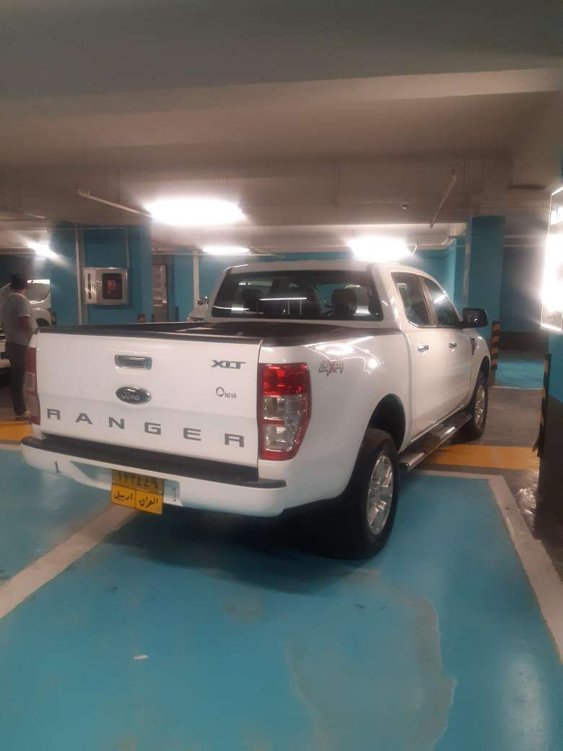

LOT # 8
Name: Pick-up Car Lot # 8
Brand: Ford
Chassis Number: AFAFP4LP5FJA36218
Engine Number: N/A
Make Year: 2015
Colour: White
Driven KM: 62883
Model: Ford-Ranger
Registration number: Erbil-173138
Registration expire date: Wednesday, February 26, 2020
Description: Good condition
Present Vehicle Location
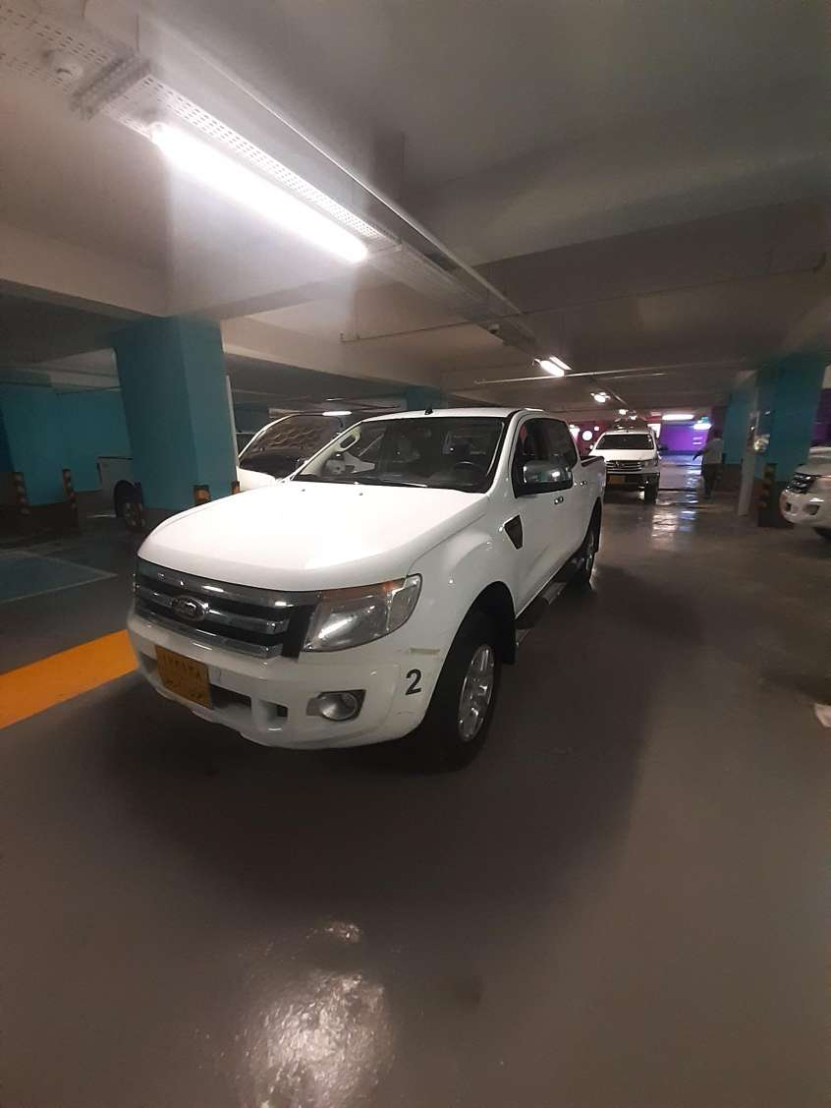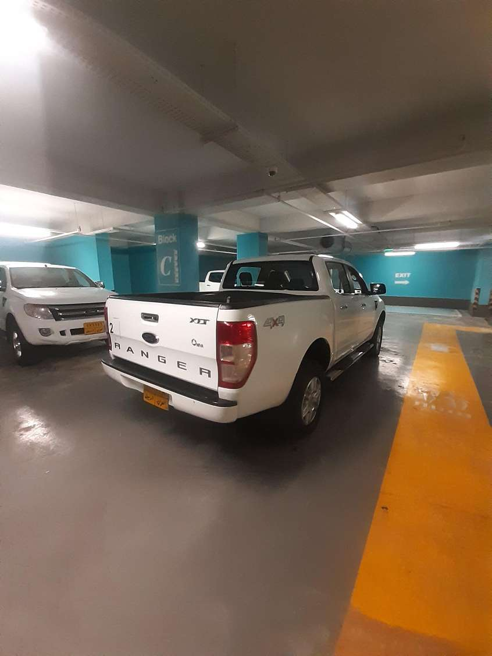

LOT # 9
Name: Pick-up Car Lot # 9
Brand: Ford
Chassis Number: AFAFP4LP3FJA36217
Engine Number: N/A
Make Year: 2015
Colour: White
Driven KM: 61335
Model: Ford-Ranger
Registration number: Erbil-173301
Registration expire date: Monday, March 31, 2025
Description: Good condition/ Body (Small scratch)
Present Vehicle Location: Erbil, IIraq
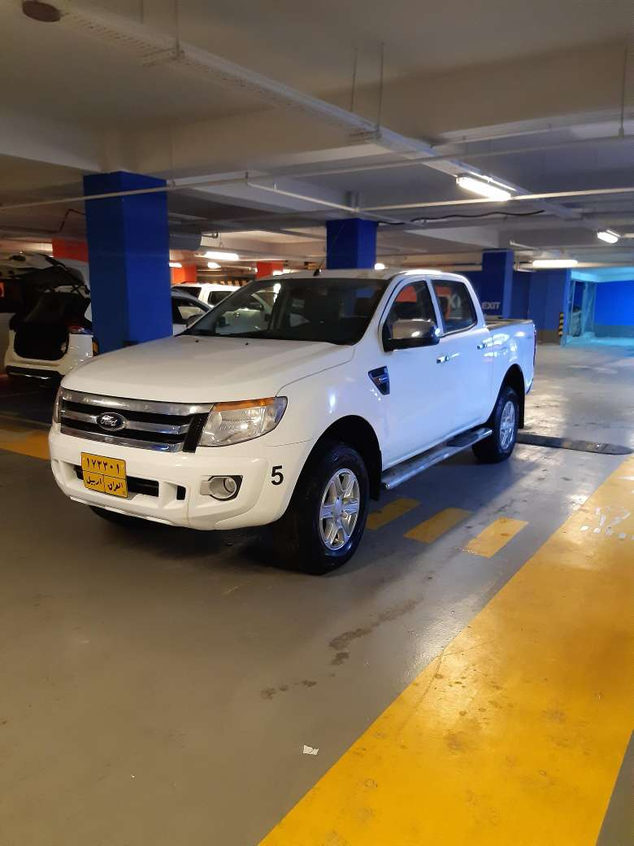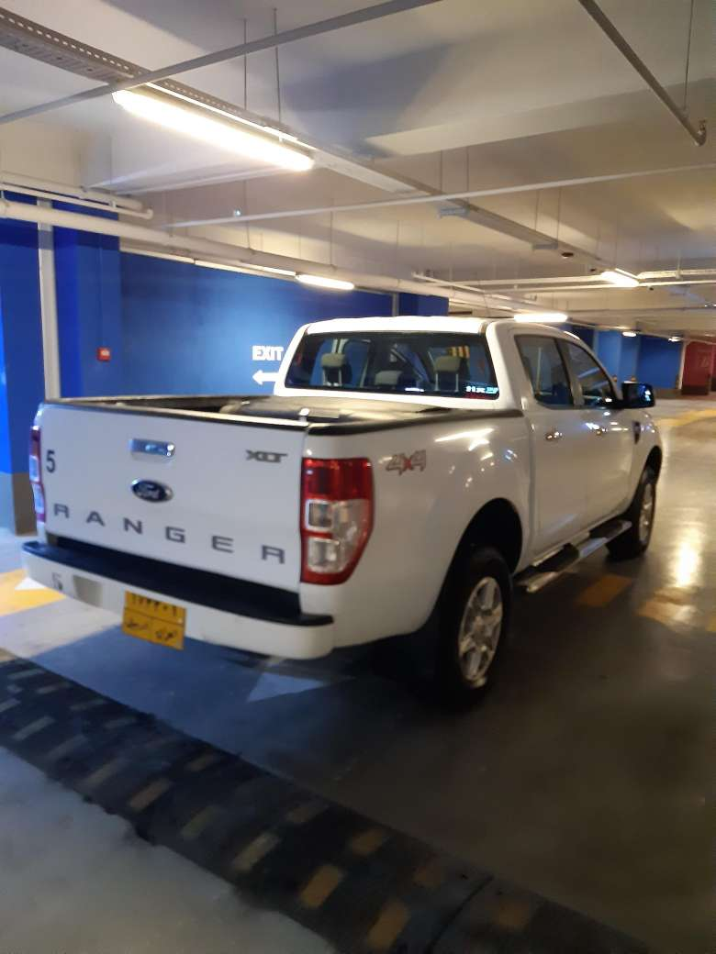

LOT # 10
Name: Pick-up Car Lot # 10
Brand: Ford
Chassis Number: AFAFP4LP6FJA36454
Engine Number: N/A
Make Year: 2015
Colour: White
Driven KM: 43884
Model: Ford-Ranger
Registration number: Erbil-174140
Registration expire date: Tuesday, March 10, 2020
Description: Good condition
Present Vehicle location: Erbil, Iraq
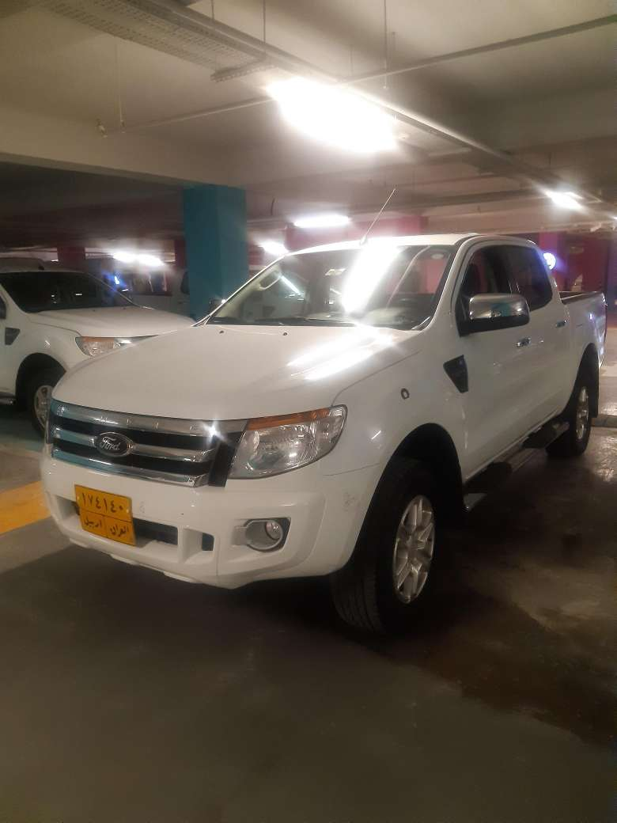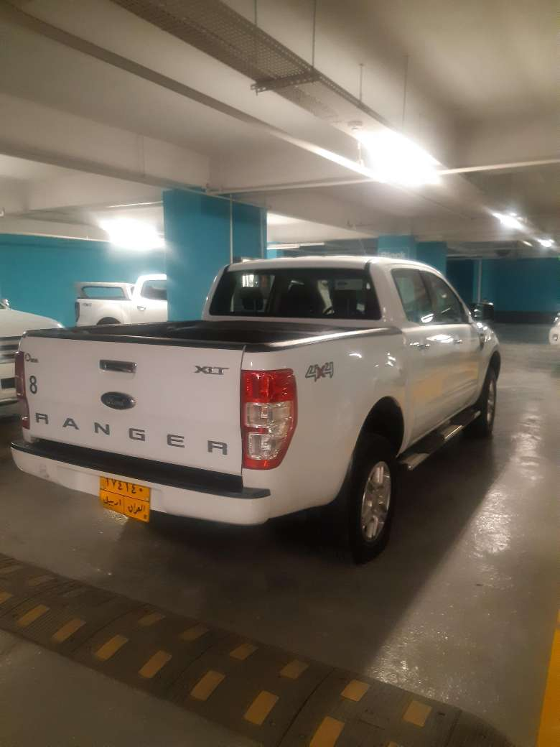

LOT # 11
Name: Pick-up Car Lot # 11
Brand: Ford
Chassis Number: AFAFP4LP8FJA36455
Engine Number: N/A
Make Year: 2015
Colour: White
Driven KM: 70000
Model: Ford-Ranger
Registration number: Erbil-175976
Registration expire date: Tuesday, May 5, 2026
Description: Good condition
Present Vehicle Location: Erbil, Iraq
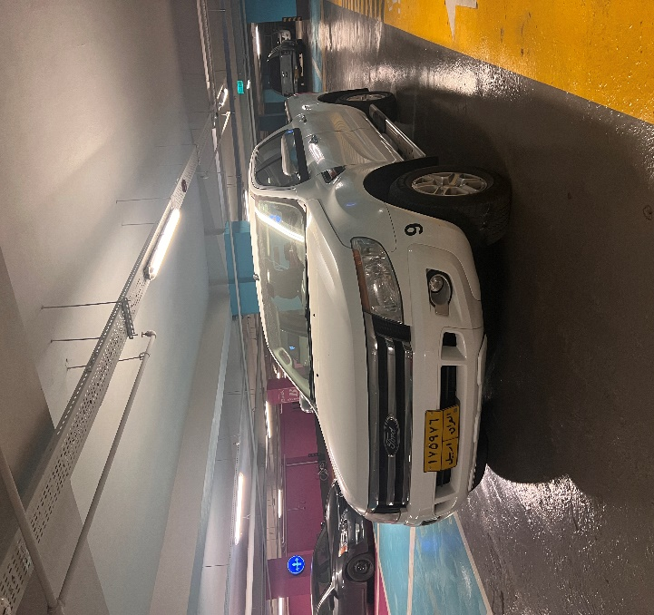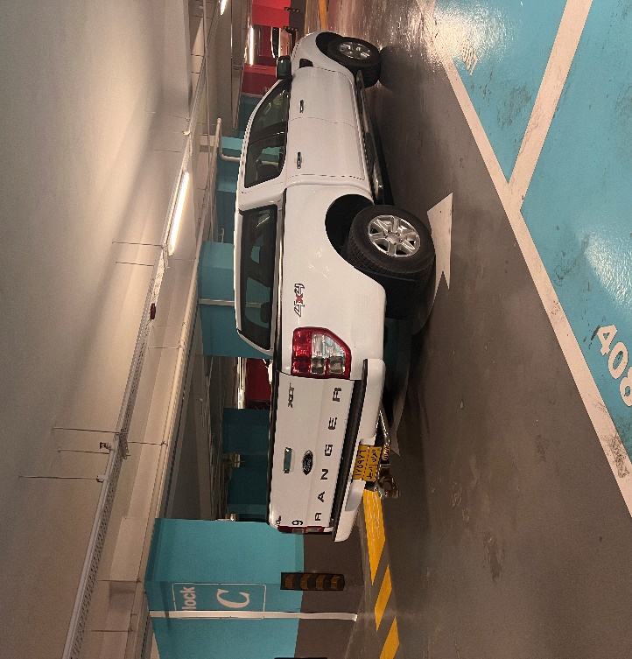

LOT # 12
Name: Pick-up Car Lot # 12
Brand: Ford
Chassis Number: AFAFP4LP4FJA36212
Engine Number: N/A
Make Year: 2015
Colour: White
Driven KM: 61750
Model: Ford-Ranger
Registration number: Erbil-173143
Registration expire date: Tuesday, February 25, 2025
Description: Good condition
Present Vehicle Location: Erbil, Iraq
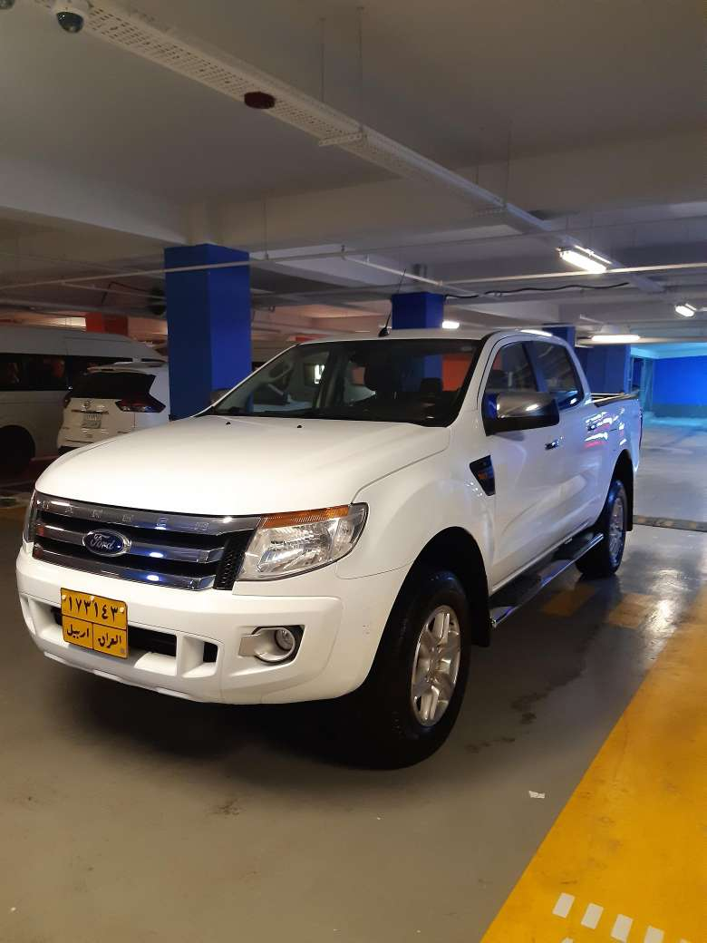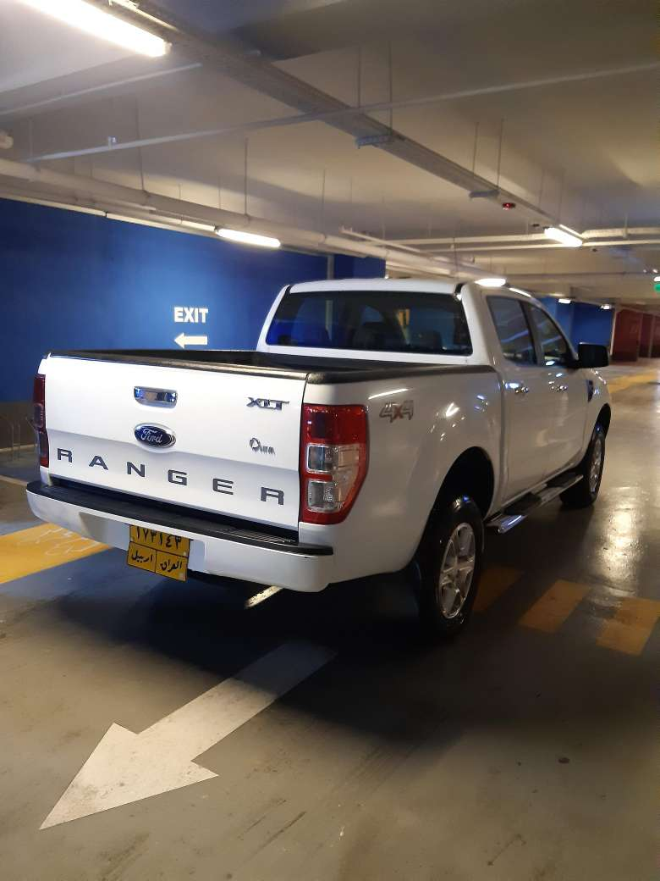

LOT # 13
Name: Pick-up Car Lot # 13
Brand: Ford
Chassis Number: AFAFP4LP7FJA36995
Engine Number: N/A
Make Year: 2015
Colour: White
Driven KM: 81144
Model: Ford-Ranger
Registration number: Erbil-174432
Registration expire date: Tuesday, February 25, 2025
Description: Good condition
Present Vehicle Location: Erbil, Iraq
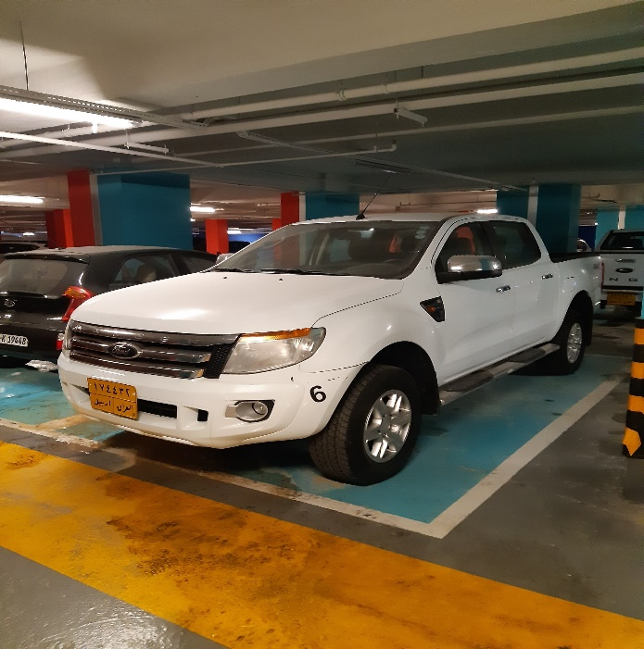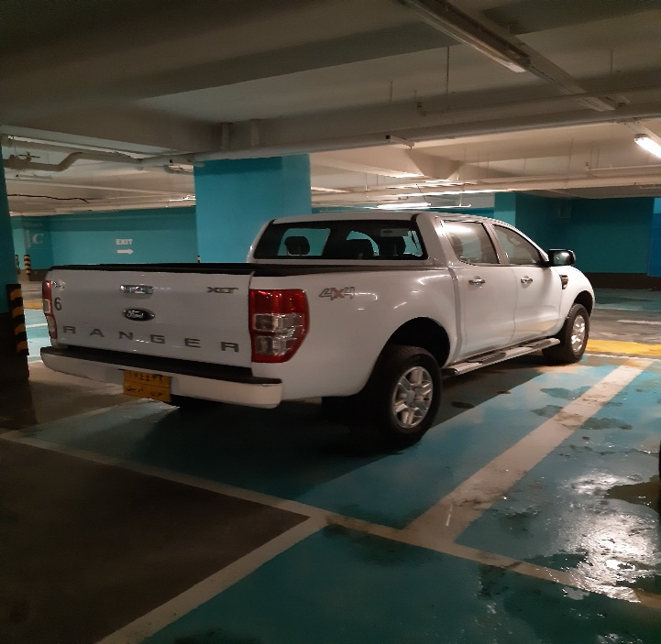

LOT # 14
Name: Pick-up Car Lot # 14
Brand: Ford
Chassis Number: AFAFP4LP4FJA36453
Engine Number: N/A
Make Year: 2015
Colour: White
Driven KM: 44000
Model: Ford-Ranger
Registration number: Erbil 176146
Registration expire date: Sunday, May 17, 2026
Description: Good condition
Present Vehicle Location: Erbil, Iraq
