Request for Proposal
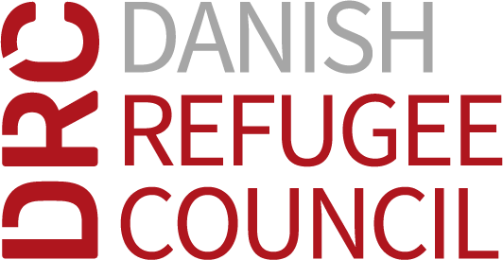

DRC Iraq
Country Office-Erbil
40-meter road, Stat Towers, Building D, Floor 11

12-12-2024

To interested companies/ consultants.

Request for Proposal No.: RFP-IRQ-CO-24-006- Consultancy Service for Federal Iraq Personal Income Tax and Social Security Settlement for DRC Staff.

Dear Sir/Madam:

The Danish Refugee Council has received a grant from various fund for the implementation of the humanitarian aid operation in Iraq. Part of this operation is the consultancy services for Federal Iraq Personal Income Tax and Social Security Settlement.

Interested service provider to send email to procurement.co.iraq@drc.ngo to get the full RFP package.

Tender Details
The Tender details are as follows:

Line | Item | Time, date, address as appropriate
1 | RFP published | 12-12-2024
2 | Technical Meeting Date | 22-12-2024 at 10:00 Iraq Time (07:00 GMT) Via Microsoft Teams  Join the meeting  Meeting ID: 327 206 501 081  Passcode: 2Ks7ZA37  All bidders are strongly encouraged to participate in the technical clarification meeting
3 | Closing date for clarifications | 23-12-2024 -11:00 Iraq Time (08:00 GMT)
4 | Email for Clarifications | bidqueries.irq.co@drc.ngo
5 | Closing date and time for receipt of bids | 26-12-2024 -16:00 Iraq Time (13:00 GMT)
6 | Email for Submission of bids | tender.irq.co@drc.ngo
7 | Tender Opening Location | DRC Office, Iraq, Erbil, 40-meter road, Stat Towers, Building D, Floor 11
8 | Tender Opening Date and time | 29-12-2024 -11:00 Iraq Time (08:00 GMT)

Important information regarding this RFP:
- This RFP is launched for the purpose of establishing a contract with as service provider for consultancy services for Federal Iraq Personal Income Tax and Social Security Settlement.
- DRC may choose to cancel the contract if deemed necessary.
- The expected duration of this consultancy service shall be 4 months from contract signing date
- DRC may terminate the Contract if the supplier fails to deliver services on time.
- No advance payment will be paid to the awarded supplier. The awarded supplier is expected to mobilize its own resources for the provision of the contracted services.
- Payment terms and instalments will be agreed between DRC and awarded consultant upon signing the Contract.
- The technical clarification meeting scheduled for 22-12-2024 at 11:00 Iraq Time (08:00 GMT) is deemed highly crucial for the Request for Proposal process. It is imperative that all bidders attend the meeting via the provided link above

