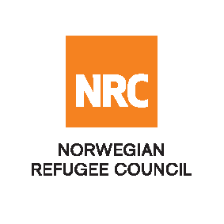
Sale Notice

Invitation to Sell second-hand Office Furniture
RFQ/IQ/24/144
The Norwegian Refugee Council (NRC) is a non-governmental humanitarian organization with 60 years of experience in helping to create a safer and more dignified life for refugees and internally displaced people.
NRC advocates for the rights of displaced populations and offers assistance within the Shelter, Education, Emergency food security, Legal assistance, and Water, sanitation, and hygiene sectors.

NRC has been present in Iraq since 2010, with offices located in Baghdad province, Anbar, Erbil, Dohuk, Hamam Al Alil, Mosul, and Kirkuk. We have scaled up our response across Iraq to meet the large-scale crisis facing the country, reaching Iraqis with emergency assistance and supporting Syrian refugees as they live in exile. Our goal is to always be prepared to work in new settings, so we are establishing more local partnerships in Iraq.
The Norwegian Refugee Council (NRC) Office in Iraq invites eligible and interested companies and individuals to participate in the auction; refer to the table below;

Code# | Description | RFQ Number
 | Sale of second-hand Office Furniture | RFQ/IQ/24/144

Site visit (Mandatory): (29 – 31) of December 2024 from 09:00 AM to 04:00 PM at Erbil, Empire Business Towers, T4 – 9th Floor
Notice: Failure to attend the site visit will disqualify you from the evaluation process.
The deadline for submitting your offer is the 02nd of January 2025 at 12:00 AM

Package Download:
- If you are interested in participating in the auction, it requires you to download the package, free of charge, using this link until “Submission date”.

For technical problems/questions about the eTB system, please get in touch with iq.kirkukprocurement@nrc.no
or
by calling the following mobile phone numbers: +9647701370141

NRC reserves the right to select/reject any offer, in part or full, as it may deem necessary without providing feedback in this regard. No liability or claim in that respect would be admissible or entertained whatsoever.

