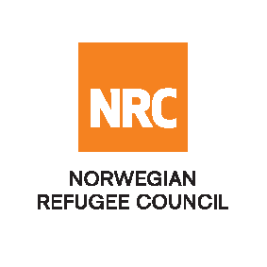
Auction Notice

Invitation to Auction for Invitation to Auction Selling of the used Items in NRC- Salahaddin Province/ Tuz Khurmatu District.
RFQ/IQ/25/020
The Norwegian Refugee Council (NRC) is a non-governmental humanitarian organization with 60 years of experience in helping to create a safer and more dignified life for refugees and internally displaced people.
NRC advocates for the rights of displaced populations and offers assistance within the Shelter, Education, Emergency food security, Legal assistance, and Water, sanitation, and hygiene sectors.

NRC has been present in Iraq since 2010, with offices located in Baghdad province, Anbar, Erbil, Dohuk, Hamam Al Alil, Mosul, and Kirkuk. We have scaled up our response across Iraq to meet the large-scale crisis facing the country, reaching Iraqis with emergency assistance and supporting Syrian refugees as they live in exile. Our goal is to always be prepared to work in new settings, so we are establishing more local partnerships in Iraq.
The Norwegian Refugee Council (NRC) Office in Iraq invites eligible and interested companies and individuals to participate in the auction; refer to the table below.

Code# | Description | RFQ Number
1 | Two Generator 60 KV (Type & Model: AKSA Power, AP66), one Generator 110 KV (Type & Model: TEKSAN, TJ110PE5S), one Generator 3 KW (Type & Model: ASTRA, AST7), two 5000-litre tanks, two 1000-litre tanks, and diesel 2000 Liter | RFQ/IQ/25/020

Site visit (Mandatory): Sunday 27th April 2025 or Monday 28th April 2025, from 09:00 AM to 03:00 PM at Salahaddin government, Tuzkhormatu district, and the GPS coordinates are (34.897379, 44.619957)
Notice: Failure to attend the site visit will disqualify you from the evaluation process.
The deadline for submitting your offer is the 28th of April 2025 at 04:00 PM
Auction Download:
- If you are interested in participating in the auction, it requires you to download the auction package, free of charge, using this link until the “Submission date”.

Auction Submission:
All bidders are required to submit their bids in one of the two ways below:
- By eTB system through the following Link ( Action Upload).
- By hand to the below locations with the auction reference number, clearly indicated, RFQ/IQ/25/020
- Salahaddin Province, Tuz Khurmatu District, Hay Al-Tayyar, the GPS coordinates are (34.897379, 44.619957)
For technical problems/questions about the eTB system, please get in touch with iq.scaoprocurement@nrc.no
or
by calling the following mobile phone numbers: +9647702359131
NRC reserves the right to select/reject any offer, in part or full, as it may deem necessary without providing feedback in this regard. No liability or claim in that respect would be admissible or entertained whatsoever.

