ANNEX A.1
VEHICLE DETAILS AND DESCRIPTIONS
LOT # 1
Name: Sedan Car Lot # 1
Brand: Chevrolet
Chassis Number: KL1GJ5DU0DB006601
Engine Number: N/A
Make Year: 2013-Petrol
Colour: Silver
Driven KM: 152055
Model: Chevrolet-Malibu LS-Automatic transmission
Registration number: 22 C35807/ Registration under DRC name, DRC is not responsible for any costs related to ownership transfer; DRC can only help with administrative support for ownership transfer
Registration expiry date: Sunday, February 6, 2028
Condition: Good condition/ Body (Small scratch ), interested bidder can come and inspect the vehicles before providing quotation and DRC will not be responsible for any issue that maybe raised after the award and moving from DRC compound.
Present Vehicle Location: Erbil, Iraq
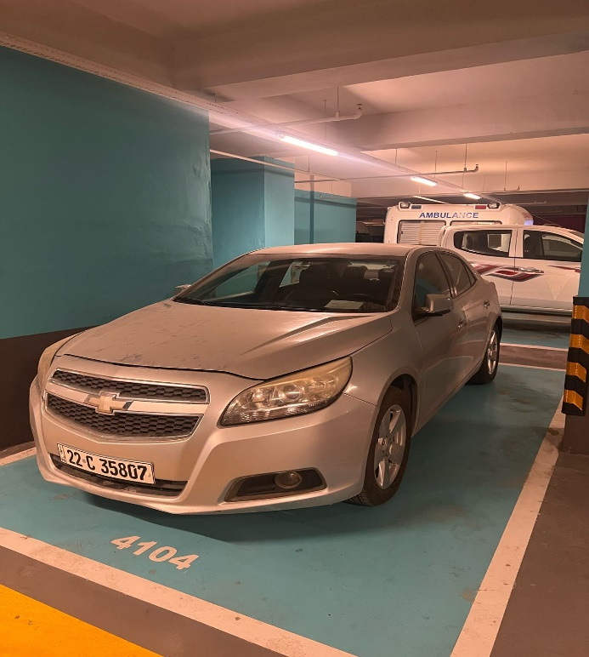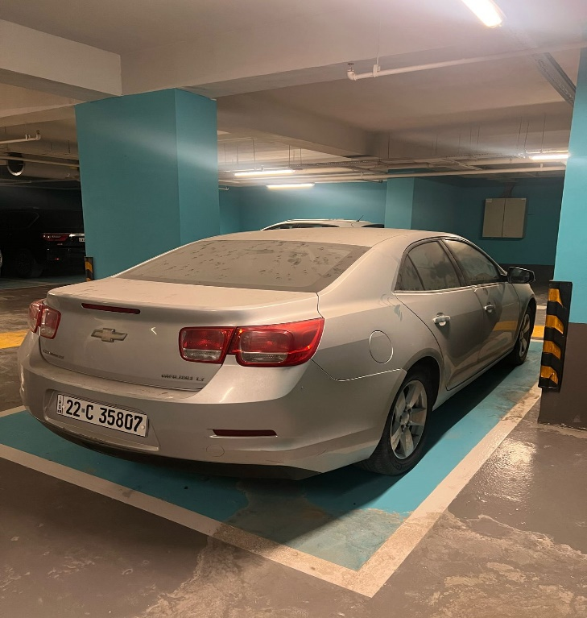

LOT # 2
Name: SUV Car Lot # 2
Brand: KIA
Chassis Number: U5YPH81A7JL310601
Engine Number: N/A
Make Year: 2018-Petrol
Colour: White
Driven KM: 42023
Model: KIA-Sportage- Automatic transmission
Registration number: 22 F42561/ Registration under DRC name, DRC is not responsible for any costs related to ownership transfer; DRC can only help with administrative support for ownership transfer
Registration expiry date: Tuesday, October 10, 2028
Condition: Good condition interested bidder can come and inspect the vehicles before providing quotation and DRC will not be responsible for any issue that maybe raised after the award and moving from DRC compound.
Present Vehicle Location: Erbil, Iraq
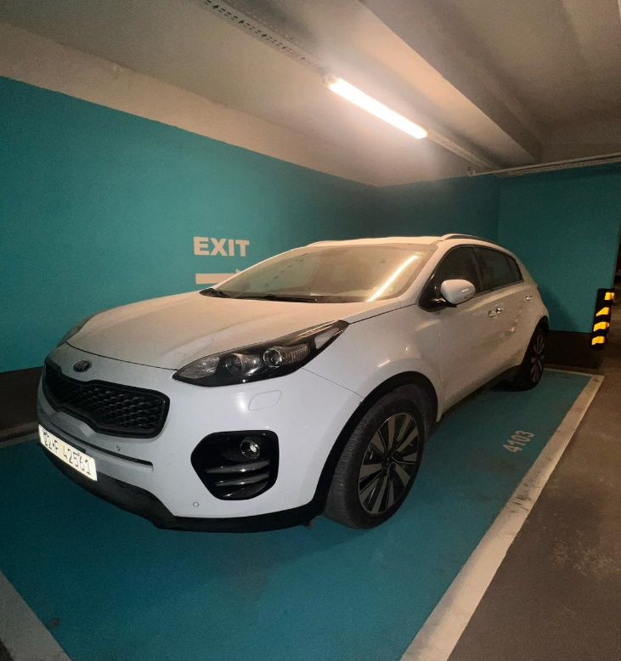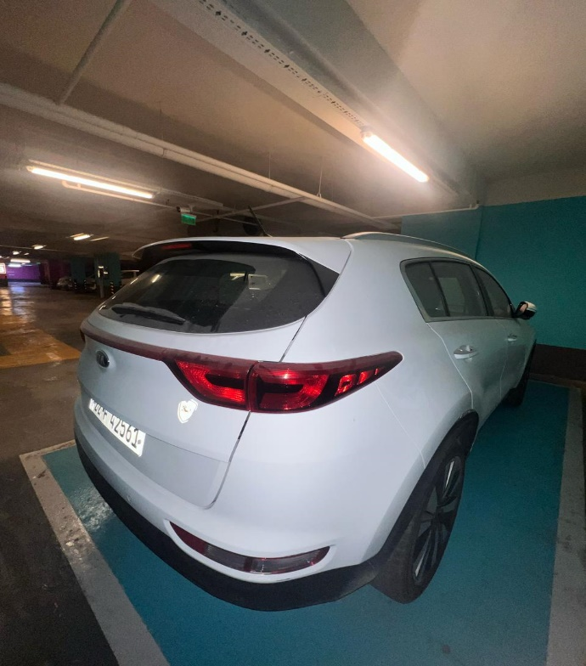

LOT # 3
Name: Minibus Car Lot # 3
Brand: Hyundai
Chassis Number: KMJWA37HAHU882400
Engine Number: N/A
Make Year: 2017-Diesel
Colour: White
Driven KM: 56196
Model: Hyundai-H1- Manual transmission
Registration number: Erbil-42666 Registration under DRC name, DRC is not responsible for any costs related to ownership transfer; DRC can only help with administrative support for ownership transfer
Registration expiry date: Sunday, April 24, 2022
Condition: Good condition interested bidder can come and inspect the vehicles before providing quotation and DRC will not be responsible for any issue that maybe raised after the award and moving from DRC compound.
The vehicle has 30,000 IQD penalty bill from KRI Traffic Directorate, the offered quote shall cover this amount (IQD 30,000) too.
Present Vehicle Location: Erbil, Iraq
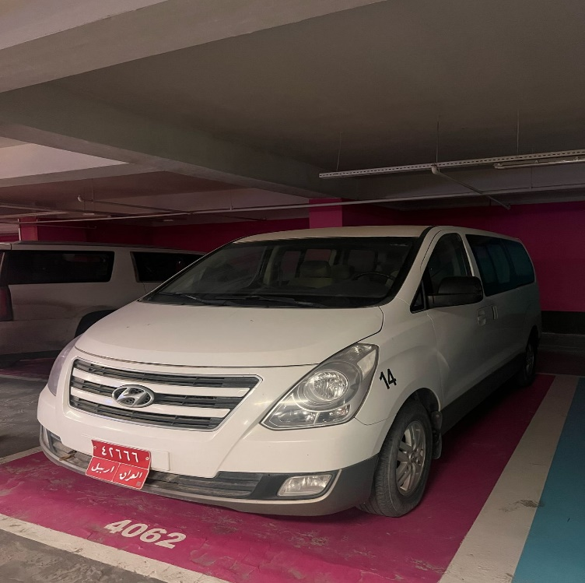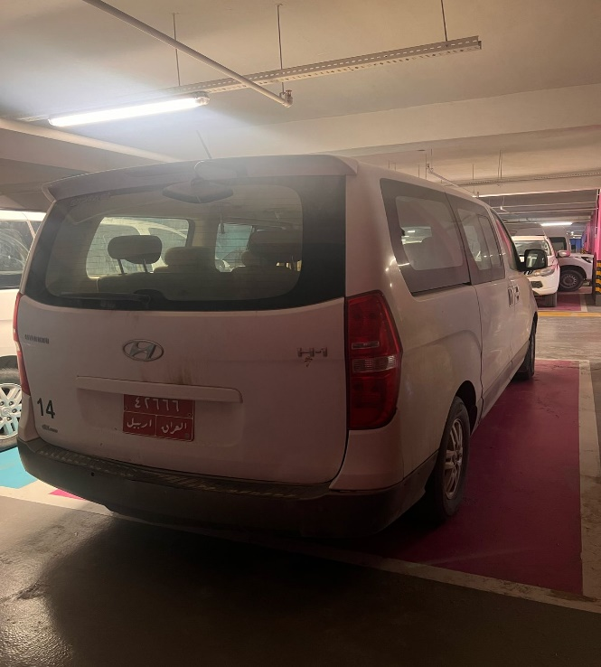

LOT # 4
Name: Minibus Car (Ambulance) Lot # 4
Brand: Hyundai
Chassis Number: KMJWA37HAKU021906
Engine Number: N/A
Make Year: 2019-Diesel
Colour: White
Driven KM: 46771
Model: Hyundai-H1- Manual transmission
Registration number: Erbil-43640/ Registration under DRC name, DRC is not responsible for any costs related to ownership transfer; DRC can only help with administrative support for ownership transfer
Registration expiry date: Monday, November 4, 2024
Condition: Good condition/ Missing two single seats & two double seats. interested bidder can come and inspect the vehicles before providing quotation and DRC will not be responsible for any issue that maybe raised after the award and moving from DRC compound.
Present Vehicle Location: Erbil, Iraq
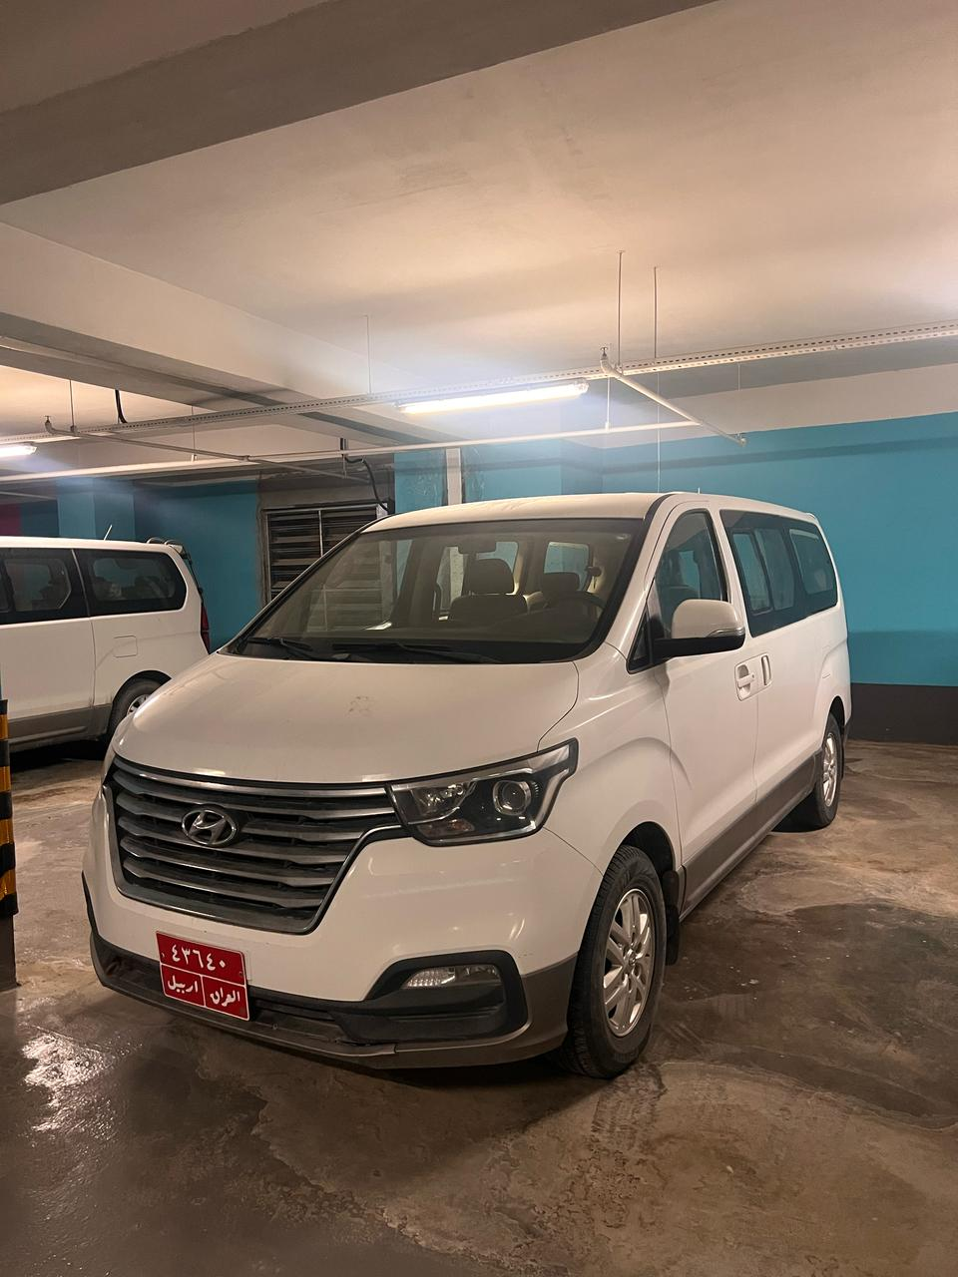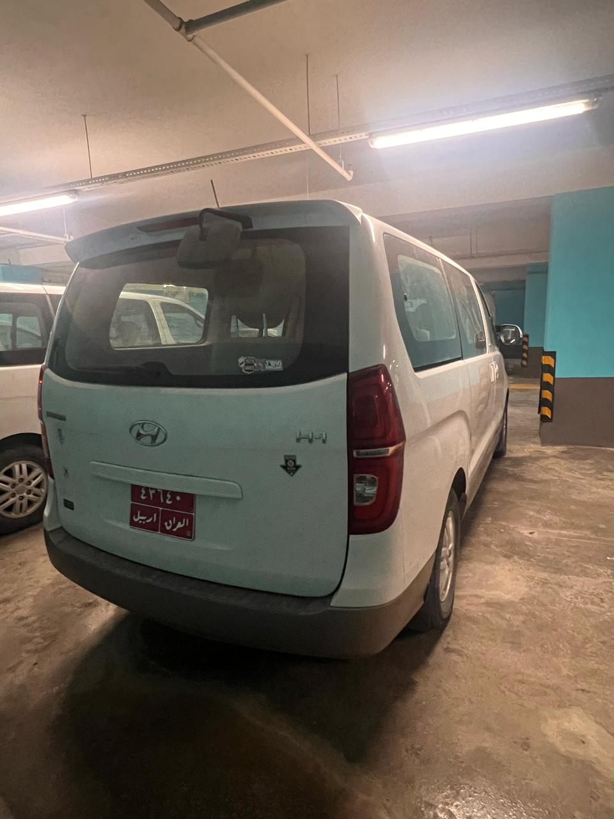

LOT # 5
Name: Minibus Car Lot # 5
Brand: Hyundai
Chassis Number: KMJWA37HALU109389
Engine Number: N/A
Make Year: 2020-Diesel
Colour: White
Driven KM: 61976
Model: Hyundai-H1- Manual transmission
Registration number: Erbil-44329/ Registration under DRC name, DRC is not responsible for any costs related to ownership transfer; DRC can only help with administrative support for ownership transfer
Registration expiry date: Sunday, November 9, 2025
Condition: Good condition. interested bidder can come and inspect the vehicles before providing quotation and DRC will not be responsible for any issue that maybe raised after the award and moving from DRC compound.
Present Vehicle Location: Erbil, Iraq
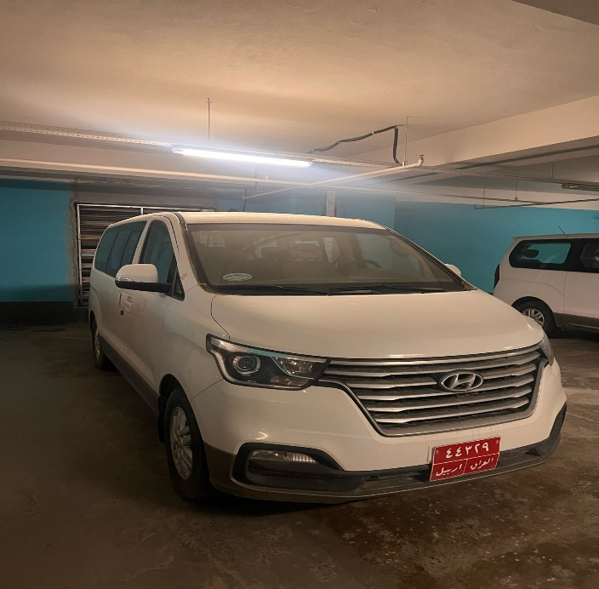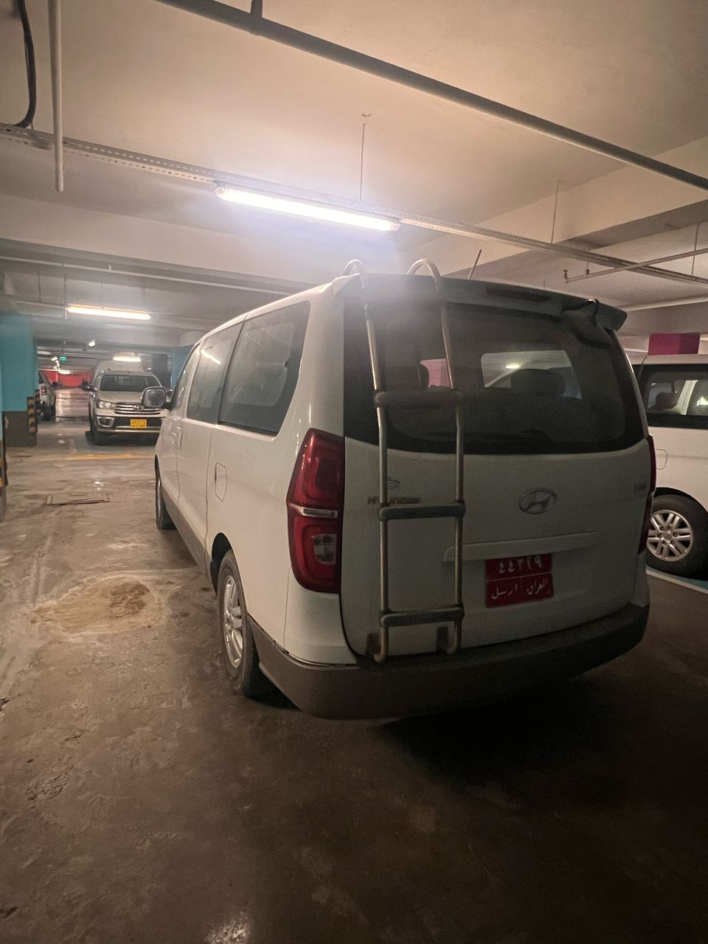

LOT # 6
Name: Minibus Car (Ambulance) Lot #6
Brand: Hyundai
Chassis Number: KMJWA37HAKU013275
Engine Number: N/A
Make Year: 2019-Diesel
Colour: White
Driven KM: 63128
Model: Hyundai-H1- Manual transmission
Registration number: Erbil-43336/ Registration under DRC name, DRC is not responsible for any costs related to ownership transfer; DRC can only help with administrative support for ownership transfer
Registration expiry date: Tuesday, November 19, 2024
Condition: Good condition/ Missing two single seats & two double seats. interested bidder can come and inspect the vehicles before providing quotation and DRC will not be responsible for any issue that maybe raised after the award and moving from DRC compound.
Present Vehicle Location: Erbil, Iraq
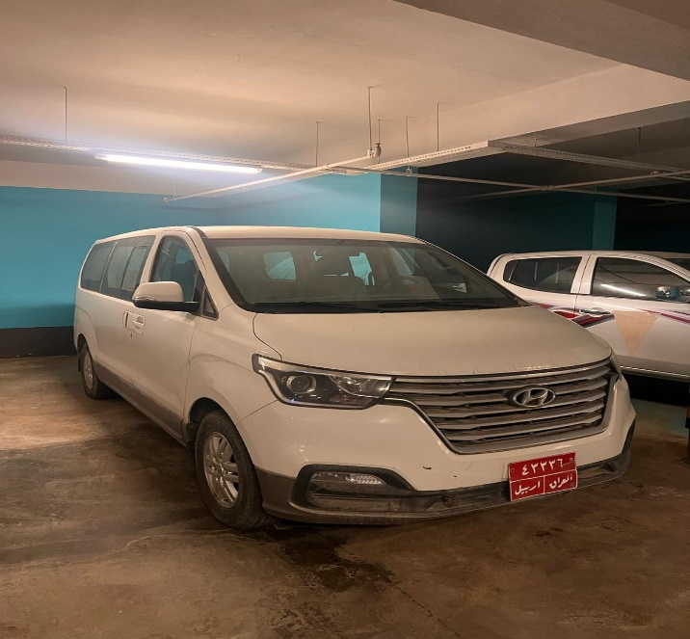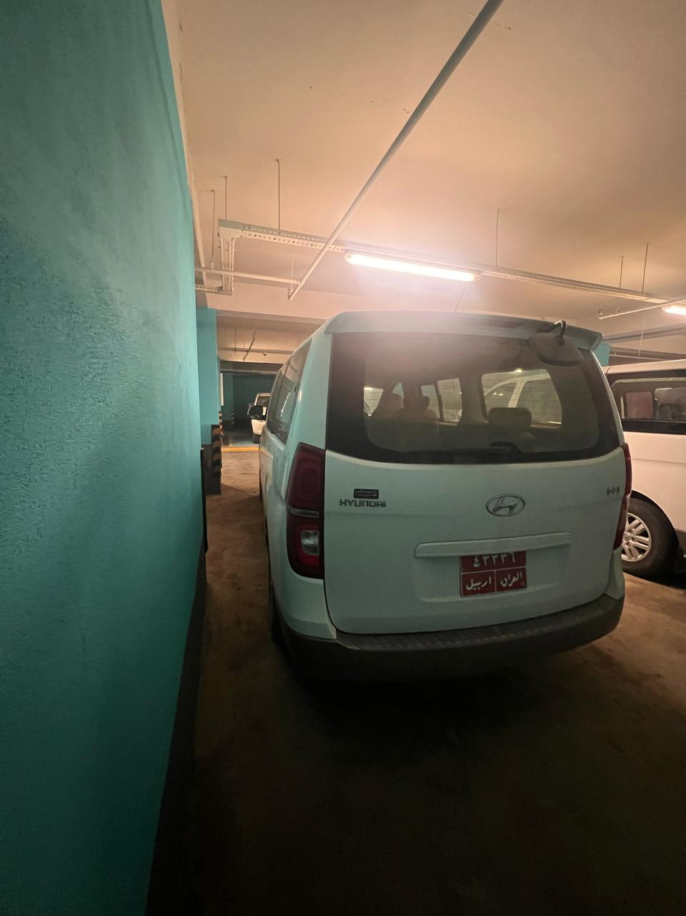

LOT # 7
Name: Minibus Car Lot # 7
Brand: Hyundai
Chassis Number: KMJWA37HAKU021931
Engine Number: N/A
Make Year: 2019-Diesel
Colour: White
Driven KM: 45187
Model: Hyundai-H1- Manual transmission
Registration number: Erbil-43516/ Registration under DRC name, DRC is not responsible for any costs related to ownership transfer; DRC can only help with administrative support for ownership transfer
Registration expire date: Monday, November 4, 2024
Condition: Good condition. interested bidder can come and inspect the vehicles before providing quotation and DRC will not be responsible for any issue that maybe raised after the award and moving from DRC compound.
Present Vehicle Location: Erbil, Iraq
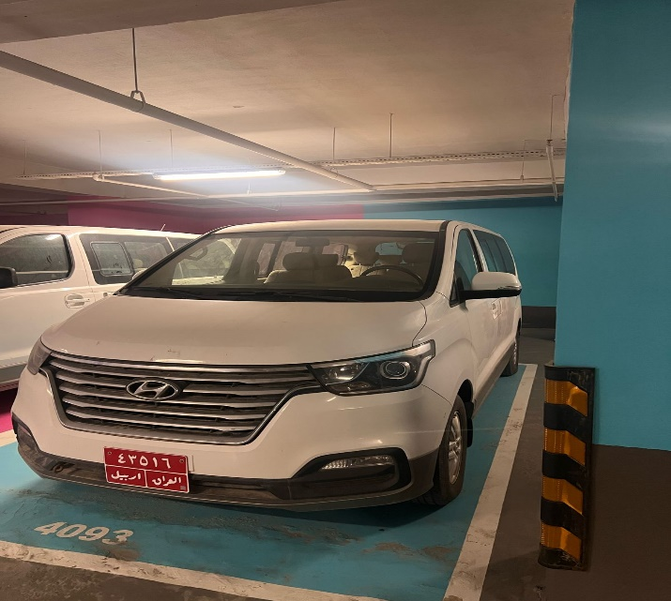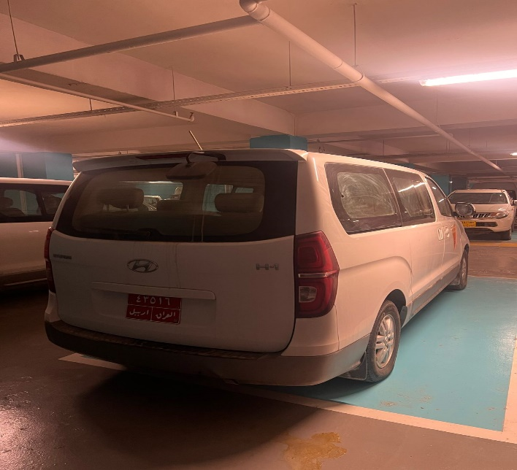

LOT # 8
Name: Minivan -Ambulance Lot # 8
Brand: Toyota-Minivan
Chassis Number: JTFPX22PXH0077154
Engine Number: N/A
Make Year: 2017-Diesel
Colour: White
Driven KM: 22387
Model: Toyota-Hiace-Ambulance- Manual transmission
Registration number: Erbil-43130/ Registration under DRC name, DRC is not responsible for any costs related to ownership transfer; DRC can only help with administrative support for ownership transfer
Registration expiry date: Tuesday, September 19, 2023
Condition: Good condition. interested bidder can come and inspect the vehicles before providing quotation and DRC will not be responsible for any issue that maybe raised after the award and moving from DRC compound.
Present Vehicle Location: Erbil, Iraq
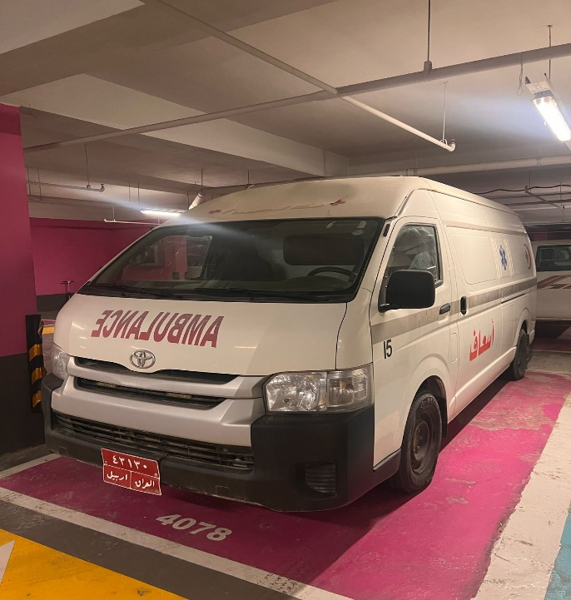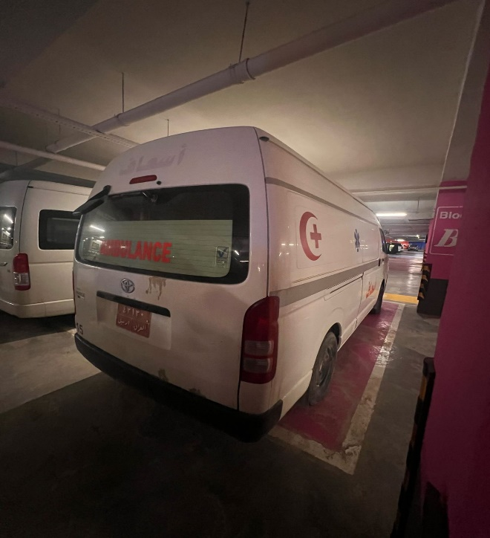

LOT # 9
Name: Minivan Car Lot # 9
Brand: Toyota-Minivan
Chassis Number: JTGSX23P4H6182970
Engine Number: N/A
Make Year: 2017-Petrol
Colour: White
Driven KM: 40963
Model: Toyota-Hiace- Manual transmission
Registration number: 22 A43185/ Registration under DRC name, DRC is not responsible for any costs related to ownership transfer; DRC can only help with administrative support for ownership transfer
Registration expiry date: Sunday, January 23, 2028
Condition: Good condition/ only missing one single seat & one double seat, interested bidder can come and inspect the vehicles before providing quotation and DRC will not be responsible for any issue that maybe raised after the award and moving from DRC compound.
Present Vehicle Location: Erbil, IIraq
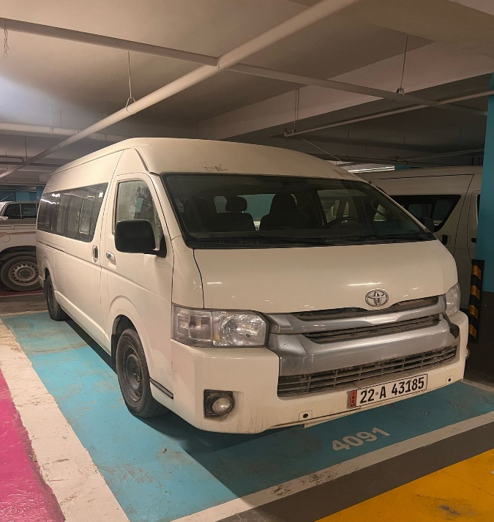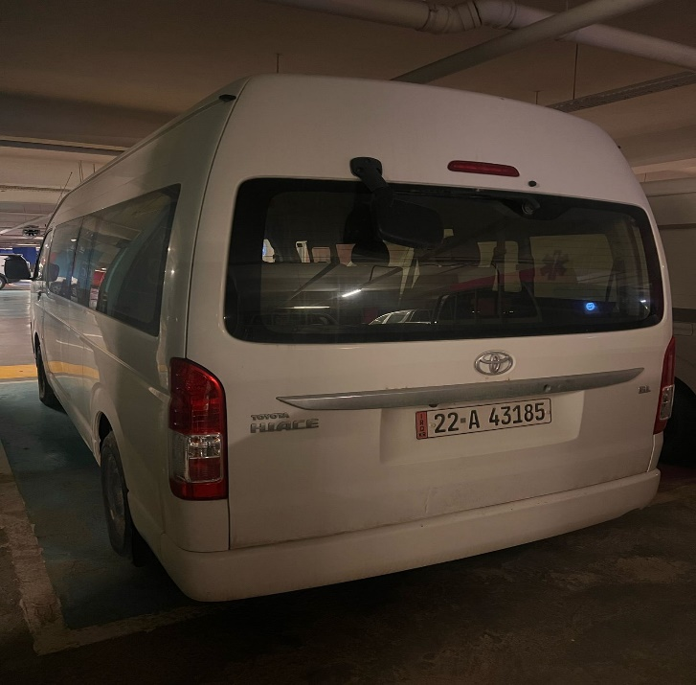

LOT # 10
Name: Minivan Car Lot # 10
Brand: Toyota-Minivan
Chassis Number: JTGSX22P7H6180485
Engine Number: N/A
Make Year: 2017-Petrol
Colour: White
Driven KM: 18816
Model: Toyota-Hiace-Automatic transmission
Registration number: Erbil-149876/ Registration under DRC name, DRC is not responsible for any costs related to ownership transfer; DRC can only help with administrative support for ownership transfer
Registration expire date: Monday, September 9, 2024
Condition: Good condition/ only missing one single seat & one double seat, interested bidder can come and inspect the vehicles before providing quotation and DRC will not be responsible for any issue that maybe raised after the award and moving from DRC compound.
Present Vehicle location: Erbil, Iraq
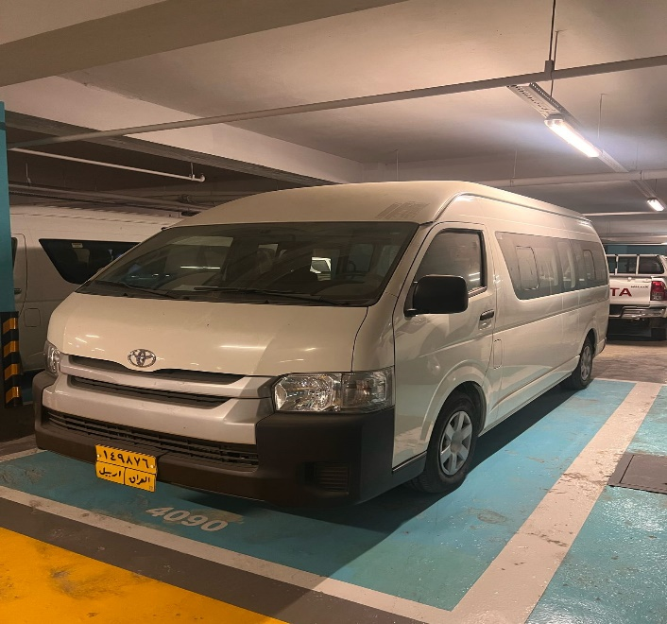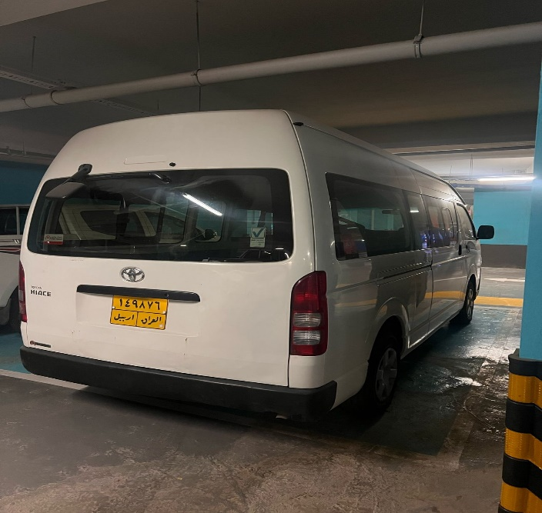

LOT # 11
Name: Pick-up Car (Ambulance) Lot # 11
Brand: Ford
Chassis Number: 6FPNXXMJ2NCE56223
Engine Number: N/A
Make Year: 2012-Diesel
Colour: White
Driven KM: 60840
Model: Ford-Ranger-Ambulance- Manual transmission
Registration number: Erbil-44198/ Registration under DRC name, DRC is not responsible for any costs related to ownership transfer; DRC can only help with administrative support for ownership transfer
Registration expire date: Monday, June 24, 2024
Condition: Good condition. interested bidder can come and inspect the vehicles before providing quotation and DRC will not be responsible for any issue that maybe raised after the award and moving from DRC compound.
Present Vehicle Location: Erbil, Iraq
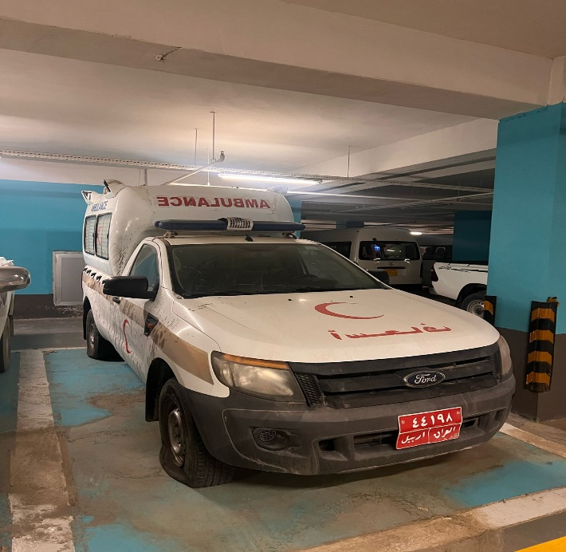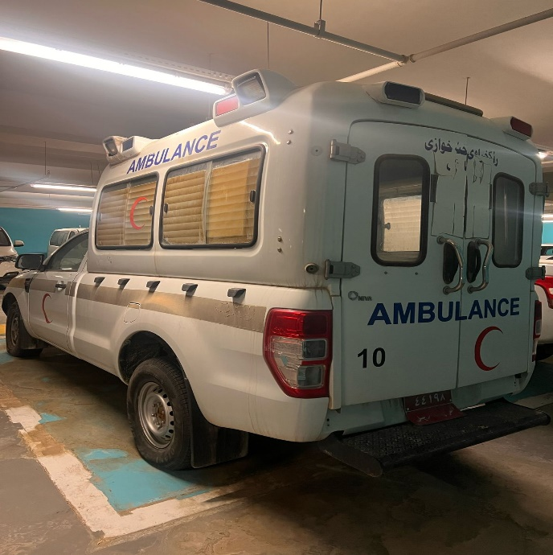

LOT # 12
Name: Pick-up Car Lot # 12
Brand: Ford
Chassis Number: AFAFP4LP6FJA36471
Engine Number: N/A
Make Year: 2015-Petrol
Colour: Silver
Driven KM: 10300
Model: Ford-Ranger- Manual transmission
Registration number: Erbil-179397/ Registration under DRC name, DRC is not responsible for any costs related to ownership transfer; DRC can only help with administrative support for ownership transfer.
Registration expire date: Tuesday, February 16, 2027
Condition: Good condition. interested bidder can come and inspect the vehicles before providing quotation and DRC will not be responsible for any issue that maybe raised after the award and moving from DRC compound.
Present Vehicle Location: Erbil, Iraq
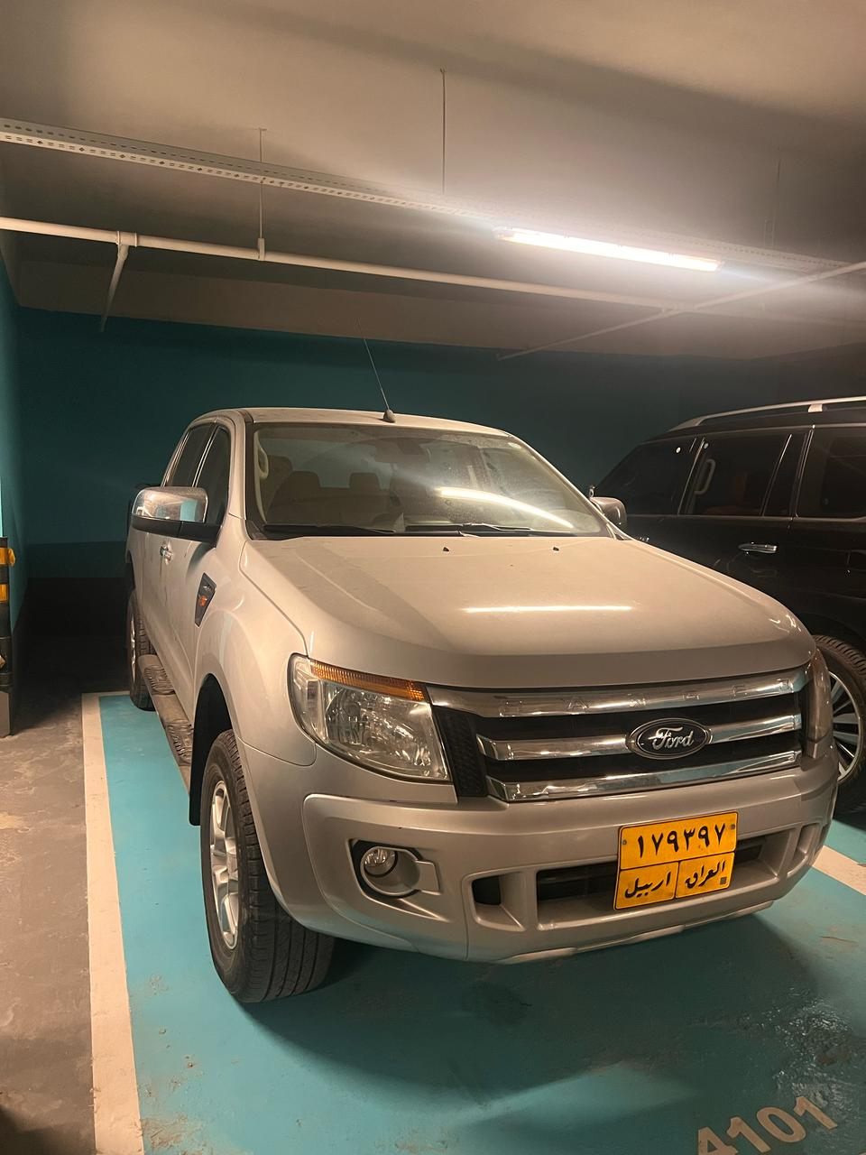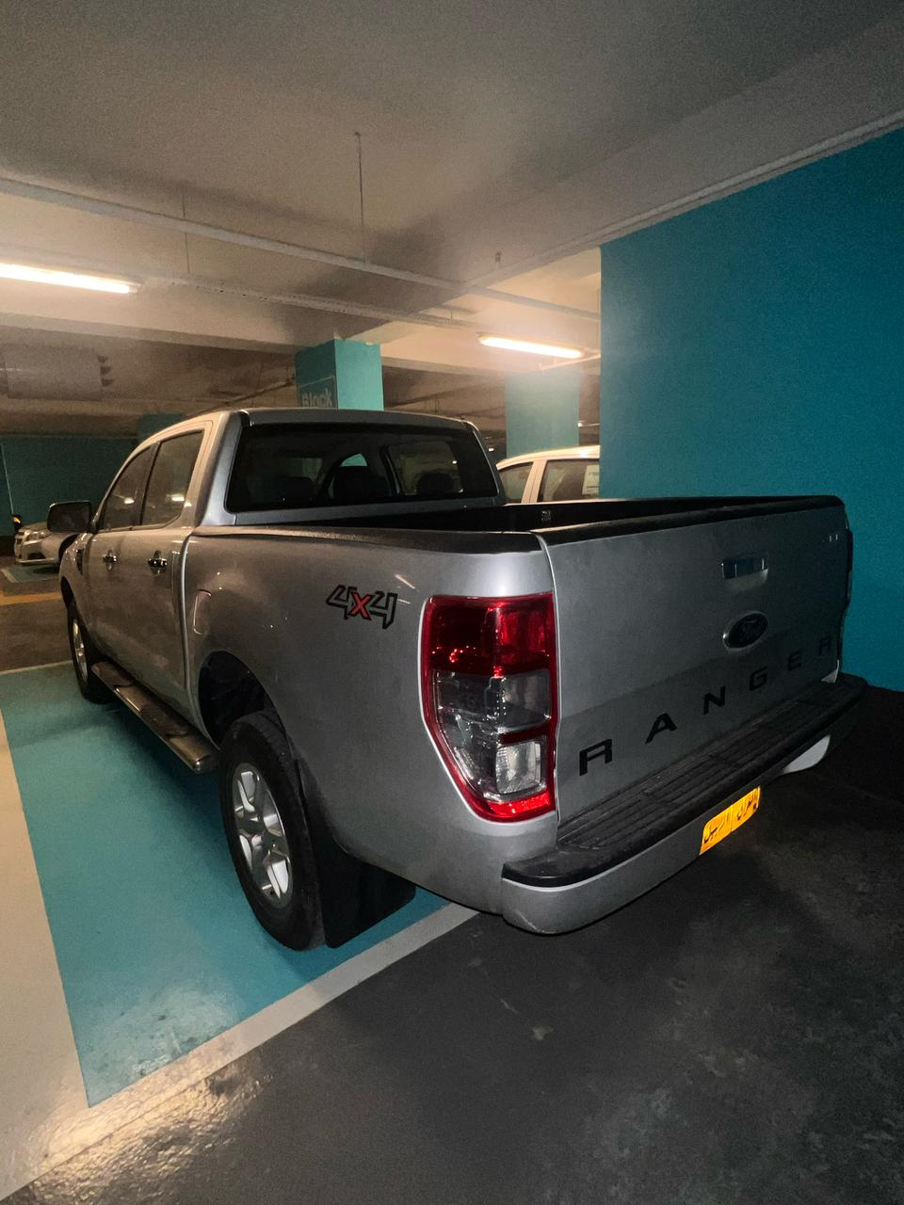

LOT # 13
Name: Pick-up Car Lot # 13
Brand: Toyota
Chassis Number: MR0DB8CD9J0117152
Engine Number: N/A
Make Year: 2018-Diesel
Colour: White
Driven KM: 112615
Model: Toyota-Hilux- Manual transmission
Registration number: Erbil-186107/ Registration is not under DRC name it is under local vehicles trade company; however, DRC has power of attorney from the company to one DRC staff. DRC is not responsible for any costs related to ownership transfer; DRC can only help with administrative support for ownership transfer
Registration expiry date: Saturday, December 23, 2023
Condition: Good condition/ Both back lights is scratched. interested bidder can come and inspect the vehicles before providing quotation and DRC will not be responsible for any issue that maybe raised after the award and moving from DRC compound.
Present Vehicle Location: Erbil, Iraq
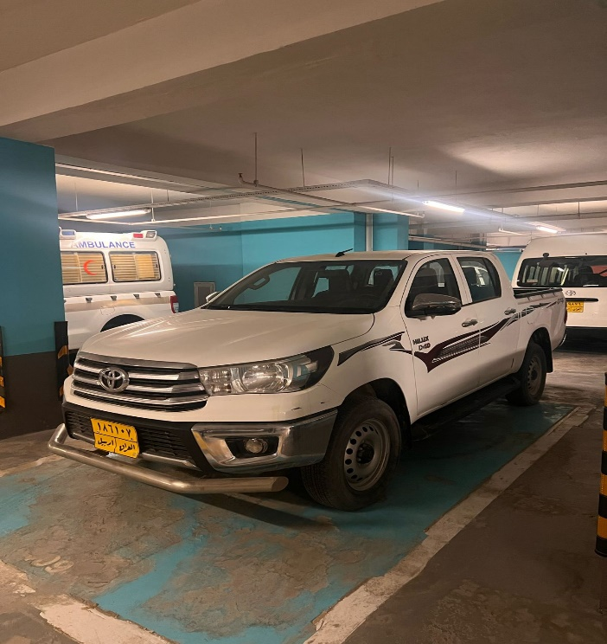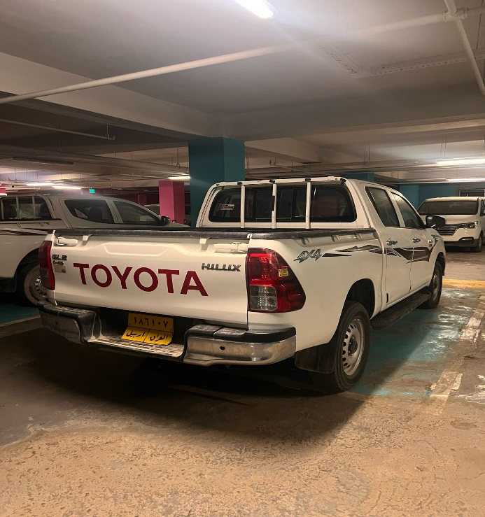

LOT # 14
Name: Pick-up Car Lot # 14
Brand: Toyota
Chassis Number: MR0DB9CD1L5144292
Engine Number: N/A
Make Year: 2020-Diesel
Colour: White
Driven KM: 67471
Model: Toyota-Hilux- Manual transmission
Registration number: Erbil-201178/ Registration under DRC name, DRC is not responsible for any costs related to ownership transfer; DRC can only help with administrative support for ownership transfer
Registration expire date: Sunday, November 9, 2025
Description: Good condition/ Passenger side back light is broken. interested bidder can come and inspect the vehicles before providing quotation and DRC will not be responsible for any issue that maybe raised after the award and moving from DRC compound.
Present Vehicle Location: Erbil, Iraq
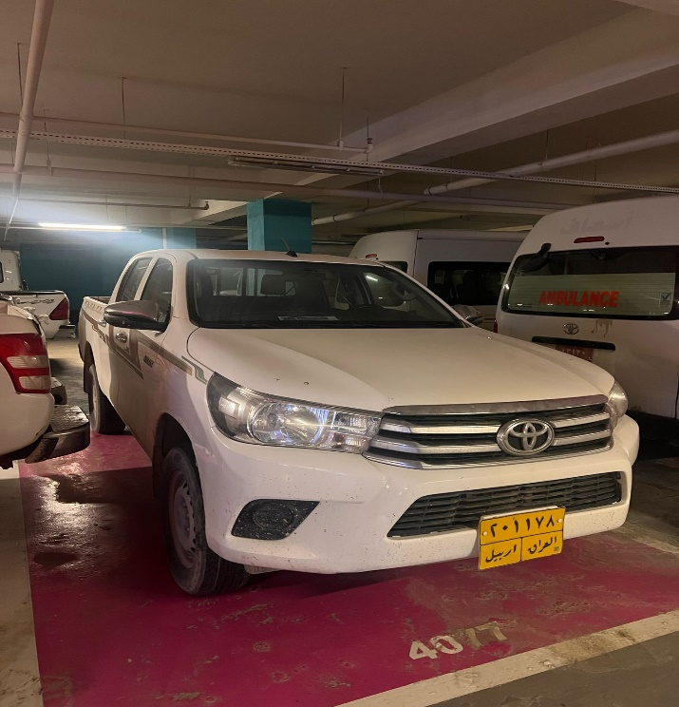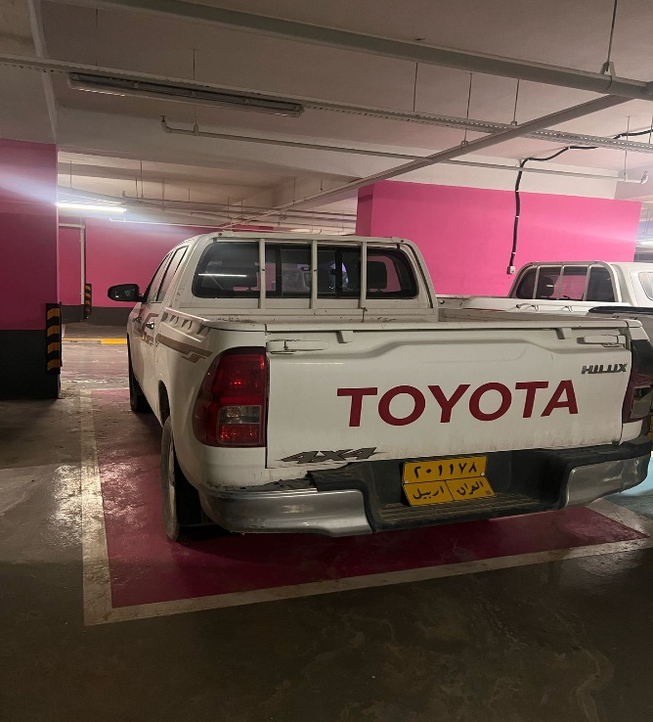

LOT # 15
Name: Pick-up Car Lot # 15
Brand: Toyota
Chassis Number: MR0HX8CD400883419
Engine Number: N/A
Make Year: 2016-Petrol
Colour: White
Driven KM: 96038
Model: Toyota-Hilux- Manual transmission
Registration number: Erbil-182244/ Registration under DRC name, DRC is not responsible for any costs related to ownership transfer; DRC can only help with administrative support for ownership transfer
Registration expire date: Friday, May 14, 2027
Description: Good condition. interested bidder can come and inspect the vehicles before providing quotation and DRC will not be responsible for any issue that maybe raised after the award and moving from DRC compound.
Present Vehicle Location: Erbil, Iraq
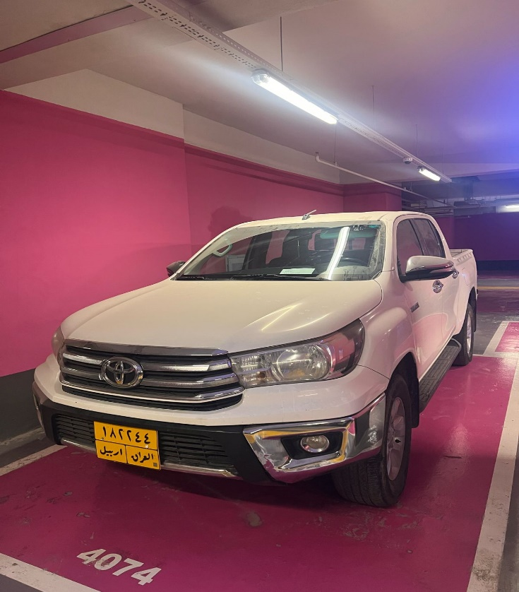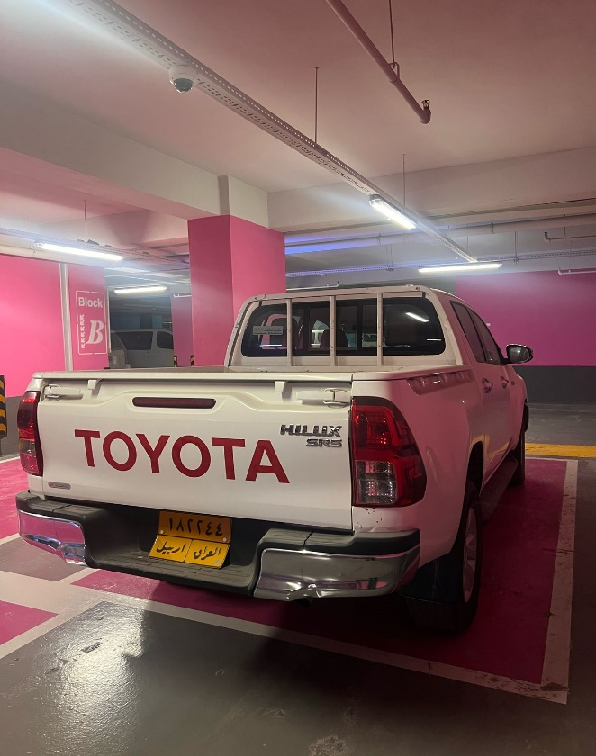

LOT # 16
Name: Pick-up Car Lot # 16
Brand: Mitsubishi
Chassis Number: MMBNG45K8JH420220
Engine Number: N/A
Make Year: 2018-Diesel
Colour: White
Driven KM: 63491
Model: Mitsubishi-L200- Manual transmission
Registration number: Erbil-190652/ Registration under DRC name, DRC is not responsible for any costs related to ownership transfer; DRC can only help with administrative support for ownership transfer.
Registration expire date: Wednesday, June 19, 2024
Description: Good condition. interested bidder can come and inspect the vehicles before providing quotation and DRC will not be responsible for any issue that maybe raised after the award and moving from DRC compound.
Present Vehicle Location: Erbil, Iraq
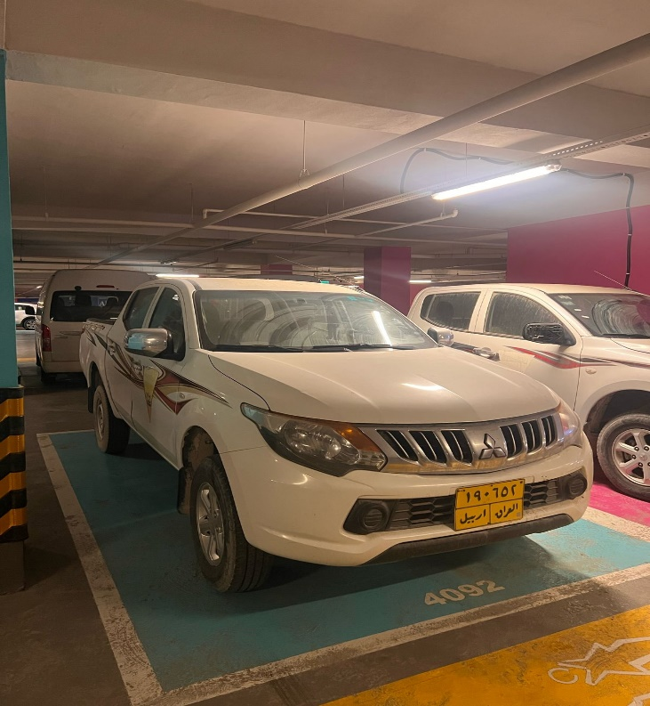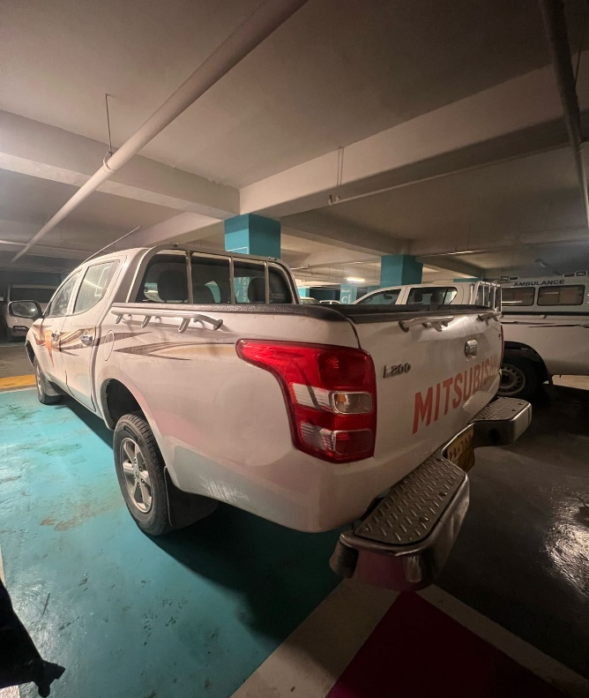

LOT # 17
Name: Pick-up Car Lot # 17
Brand: Mitsubishi
Chassis Number: MMBNG45K2HH053082
Engine Number: N/A
Make Year: 2017-Diesel
Colour: White
Driven KM: 110338
Model: Mitsubishi-L200- Manual transmission
Registration number: Erbil-186458/ Registration is not under DRC name it is under local vehicles trade company; however, DRC has power of attorney from the company to one DRC staff. DRC is not responsible for any costs related to ownership transfer; DRC can only help with administrative support for ownership transfer.
Registration expire date: Monday, January 9, 2023
Description: Good condition/ Passenger side back light is broken. interested bidder can come and inspect the vehicles before providing quotation and DRC will not be responsible for any issue that maybe raised after the award and moving from DRC compound.
Present Vehicle Location: Erbil, Iraq
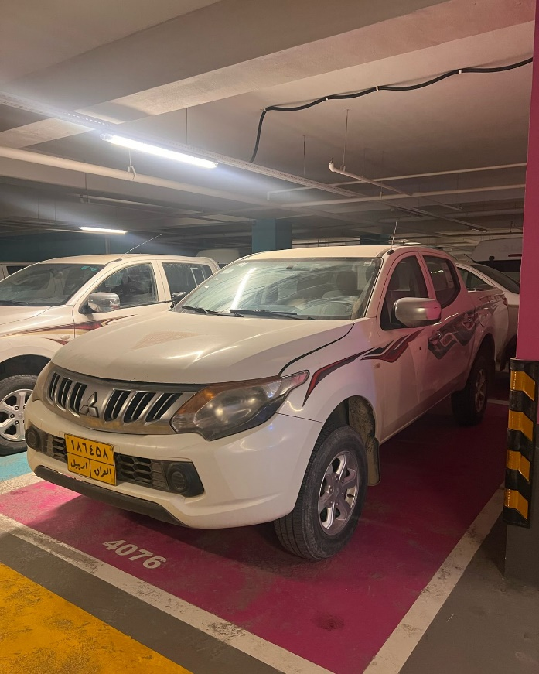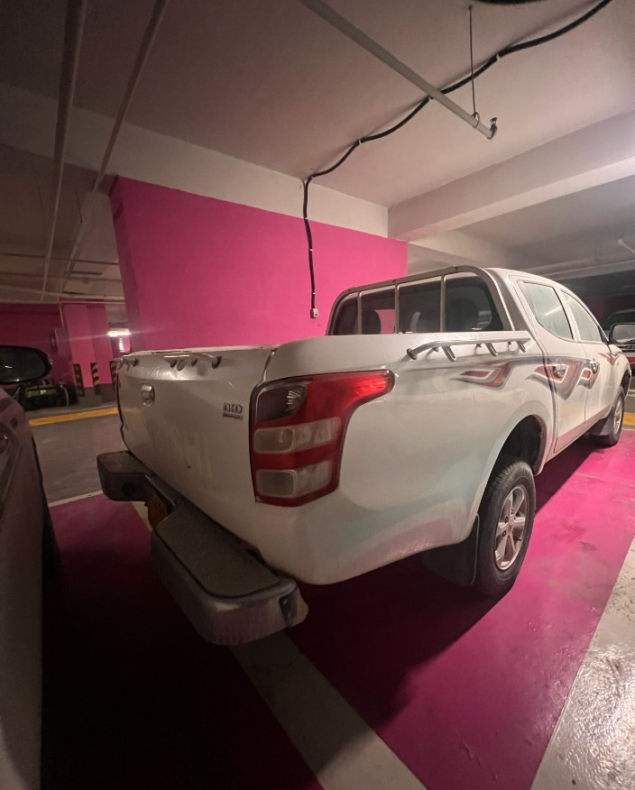

LOT # 18
Name: Pick-up Car Lot # 18
Brand: Mitsubishi
Chassis Number: MMBNG45K3HH053009
Engine Number: N/A
Make Year: 2017-Diesel
Colour: White
Driven KM: 106170
Model: Mitsubishi-L200- Manual transmission
Registration number: Erbil-186408/ Registration is not under DRC name it is under local vehicles trade company; however, DRC has power of attorney from the company to one DRC staff. DRC is not responsible for any costs related to ownership transfer; DRC can only help with administrative support for ownership transfer.
Registration expire date: Monday, January 23, 2023
Description: good condition/ Tailgate dent. interested bidder can come and inspect the vehicles before providing quotation and DRC will not be responsible for any issue that maybe raised after the award and moving from DRC compound.
Present Vehicle Location: Erbil, Iraq
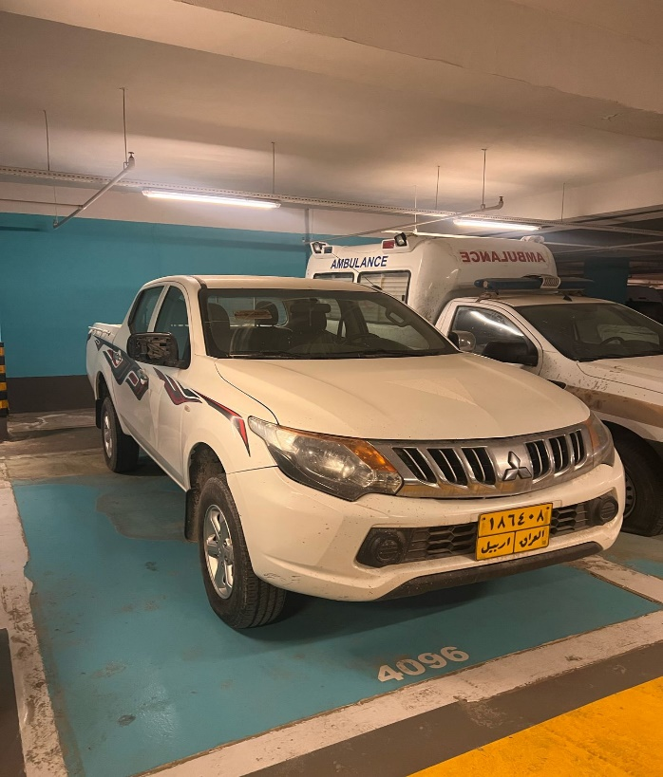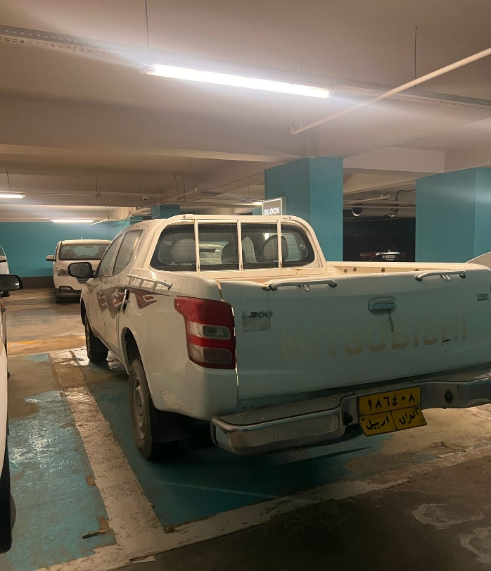

LOT # 19
Name: Pick-up Car Lot # 19
Brand: Mitsubishi
Chassis Number: MMBNG45K6HH053084
Engine Number: N/A
Make Year: 2017-Diesel
Colour: White
Driven KM: 118722
Model: Mitsubishi-L200- Manual transmission
Registration number: Erbil-67903/ Registration is not under DRC name it is under local vehicles trade company; however, DRC has power of attorney from the company to one DRC staff. DRC is not responsible for any costs related to ownership transfer; DRC can only help with administrative support for ownership transfer.
Registration expire date: Wednesday, January 11, 2023
Description: Good condition. interested bidder can come and inspect the vehicles before providing quotation and DRC will not be responsible for any issue that maybe raised after the award and moving from DRC compound.
Present Vehicle Location: Erbil, Iraq
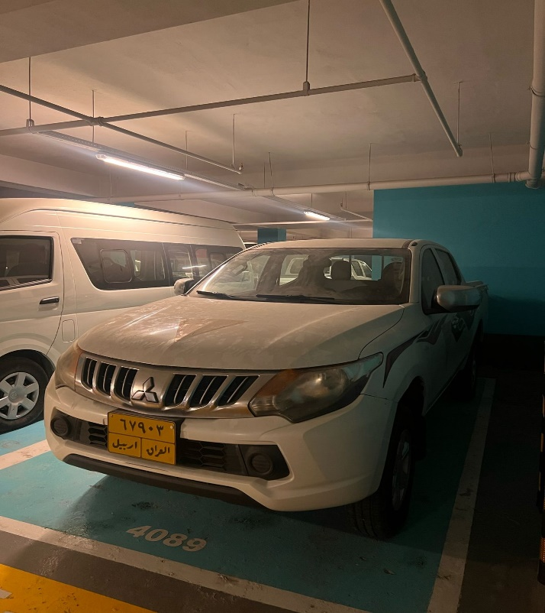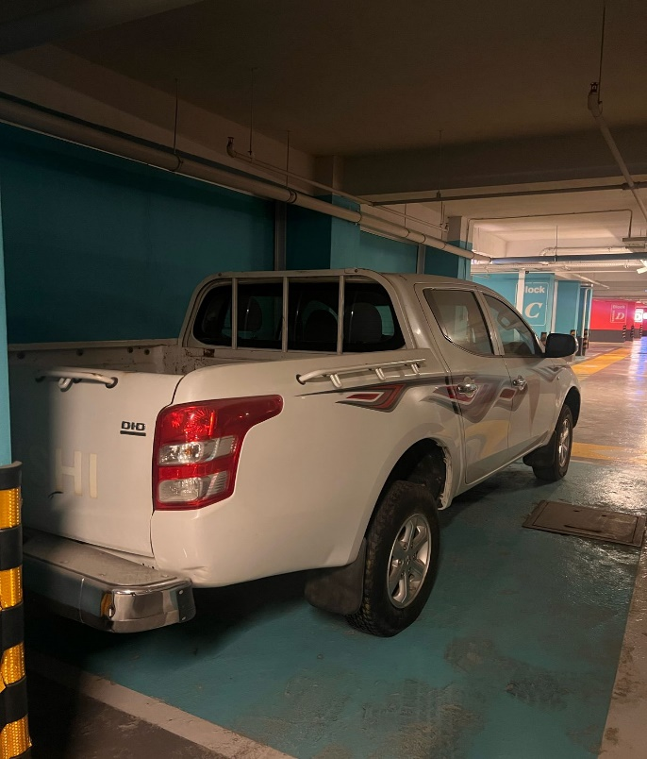

LOT # 20
Name: Pick-up Car Lot # 20
Brand: Mitsubishi
Chassis Number: MMBNG45KXHH053007
Engine Number: N/A
Make Year: 2017-Diesel
Colour: White
Driven KM: 116265
Model: Mitsubishi-L200- Manual transmission
Registration number: Erbil-186405/ Registration is not under DRC name it is under local vehicles trade company; however, DRC has power of attorney from the company to one DRC staff. DRC is not responsible for any costs related to ownership transfer; DRC can only help with administrative support for ownership transfer.
Registration expiry date: Wednesday, January 11, 2023
Description: Good condition. interested bidder can come and inspect the vehicles before providing quotation and DRC will not be responsible for any issue that maybe raised after the award and moving from DRC compound.
Present Vehicle Location: Erbil, Iraq
