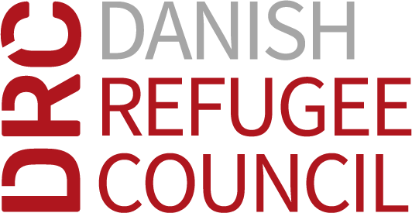

Terms of Reference (TOR)
for

Title: Cash Transfer/Distribution (Hawala System) Service Provider for Humanitarian Assistance in Iraq

- Who is the Danish Refugee Council?
Founded in 1956, the Danish Refugee Council (DRC) is a leading international NGO and one of the few with a specific expertise in forced displacement. Active in 40 countries with 9,000 employees and supported by 7,500 volunteers, DRC protects, advocates, and builds sustainable futures for refugees and other displacement affected people and communities. DRC works during displacement at all stages: In the acute crisis, in displacement, when settling and integrating in a new place, or upon return. DRC provides protection and life-saving humanitarian assistance; supports displaced persons in becoming self-reliant and included into hosting societies; and works with civil society and responsible authorities to promote protection of rights and peaceful coexistence.
- Background:
Although the humanitarian situation in Iraq has changed within the last year, due to previous protracted conflict, political instability, and economic crisis, humanitarian needs persist. Access to basic needs, such as food, healthcare, and shelter, has been limited for many vulnerable groups, including internally displaced persons (IDPs) and refugees. To address this issue, The Danish Refugee Council (DRC) has been providing assistance, including cash transfers, to help people meet their basic needs. However, the traditional banking system in Iraq is not accessible for many, especially those in remote and conflict-affected areas. As such, the use of the Hawala system for cash transfers has become an important option.
- Objective:
The objective of this tender is to identify a qualified and experienced service provider to facilitate cash transfers using the Hawala system for humanitarian assistance in Iraq. The service provider will be responsible for the safe and timely delivery of cash transfers to affected populations, DRC’s suppliers, and to DRC offices in various location across Iraq.
- Scope of Work:
The purpose of this document is to provide clear and detailed information on the responsibilities and expectations of the service provider in the delivery of cash transfer services. The service provider will be responsible for the following:
- Regulatory Requirements:
The service provider must be registered with the Ministry of Trade and provide the necessary documents as outlined in the tender dossier.
- Security and Safety:
The service provider must ensure the security and safety of cash transfers throughout the entire process. This includes the use of appropriate security measures and protocols, as well as acquiring all necessary security clearances to cross security checkpoints.
- Currency Requirements:
The service provider must have the ability to transfer/ Distrbution both Iraqi Dinars (IQD) and United States Dollars (USD) and must provide 100 USD bills printed in 2009 or later, as well as IQD bills in denominations of 250-500-1000-5000-10000-25000 that are in good physical condition. Additionally, the service provider should be prepared to supply small USD banknotes in denominations of 5-10-20-50 upon request by DRC and must ensure they are also in good condition.
- Timeliness of Payments:
The service provider must ensure that payments are delivered no more than 24 hours' notice DRC.
- Record-Keeping:
The service provider must maintain accurate records of all transactions and ensure that they are in compliance with applicable laws and regulations.

- Bank Transfer Capability:
The service provider should have the capacity to receive international and national bank transfers.

- Geographical locations for the required Hawala service:
No | Location
1 | Diyala
2 | Salah Al_Din
3 | Anbar

- Total expected Hawala amount for a period of 6 months is 290,000,000 IQD across all locations.
- Qualifications and Requirements:
The service provider to have the following qualifications and requirements:
- A proven track record of delivering cash transfers safely and efficiently, including experience in managing Hawala agents and networks.
- A deep understanding of the Hawala system, its strengths, and limitations, and a commitment to comply with applicable laws and regulations.
- A clear and well-defined methodology for ensuring the security and safety of cash transfers, including the use of appropriate security measures and protocols.
- Strong monitoring and reporting skills, including the ability to provide timely and accurate reports on the delivery of cash transfers.

